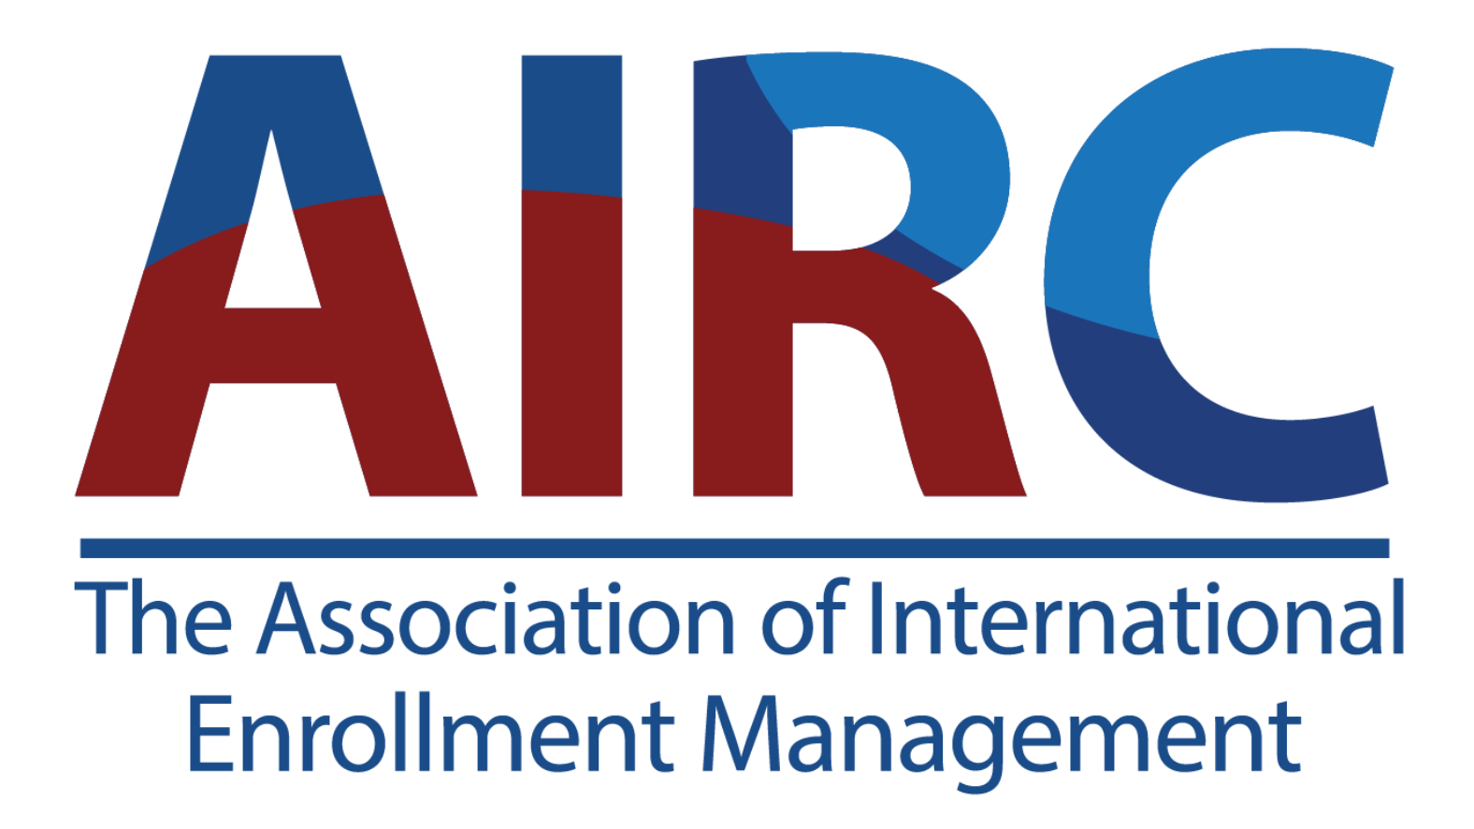

Marjorie Peace Lenn Research Award

Application 2025

AIRC’s Marjorie Peace Lenn Research Award encourages and supports emerging scholars who have completed recent research in the area of international student mobility. Proposals on related international education topics or issues will also be considered. The Award is open to both undergraduate and graduate students who have completed the research within the last year of applying. Research that is close to completion will also be considered. This means, for example, the researcher is working on data analysis, implications, and/or the conclusion.

The Award recipient receives a cash award of $1,000, complimentary registration for AIRC’s 17th Annual Conference, along with airfare and 3 nights accommodation at the conference hotel. Awardees present a summary of their research project at a plenary session at the Annual Conference.

To apply, candidates should complete this application form and email it to staff@airc-education.org. By submitting this form, the applicant agrees to have AIRC contact their research advisor. The deadline for submission is October 10, 2025.

For questions, contact Dr. Clay Harmon, clay.harmon@airc-education.org.

NAME
EMAIL
PHONE
INSTITUTION AND DEGREE SOUGHT (ASSOCIATES, BACHELOR’S, MASTER’S,
DOCTORAL)
ANTICIPATED DATE OF DEGREE
TITLE OF RESEARCH
NAME OF RESEARCH ADVISOR (IF APPLICABLE)
ADVISOR EMAIL
ADVISOR PHONE

Research Application

Abstract:

Research Question(s) and Hypothesis (if any):

Methodology (brief summary):

Results (brief summary):

Implications (brief summary):

