Meeting called to order at 6:30pm. Pledge allegiance. Councilman Hutchison, Councilman Meinking, Councilman Bolen, Councilman Grede, Councilman Howell and Mayor Stahlman —We have a quorum.
Resignation and Appointment: Councilwoman Pucci resigned, Councilman Grede asked do we need to vote on accepting the resignation. Attorney Will King responded with the need to fill the vacancy tonight. Three candidates were interviewed: Teresa Easton, Susan Walling, and Alan Webb. Alan Webb, a former council member with experience in grant writing and city projects, was appointed. Mr. Webb is sworn in by Mayor Stahlman, then took the vacant seat.
Minutes from September 25, 2025: Motion to accept made by Councilman Hutchison, 2nd by Councilman Meinkingo Yes - 6, No - 0. September minutes approved.
Treasurer's Report: The treasurer's report for September 2025 was presented, showing an overall improvement in funds. However, one council member didn't receive the report in advance and couldn't provide input. No motion to accept or decline the report was made.
Department Reports: Reports from the police, fire, streets, and water/sewer departments were submitted. Motion to accept all department reports made by Councilman Howell, 2nd by Councilman Bolen. Yes 6, No —0. Reports passed.
Parks Committee Report: The parks committee reported a successful year with significant gross income and volunteer help. Discussions included the boat ramp revenue, the potential return of the Tin Canners, and plans for swim area anchors. Motion to accept parks report made by Councilman Howell, 2ndby Councilman Grede. Yes — 6, No — 0.
Report passed.
Planning and Zoning - Hotel/Resort Regulations: A significant portion of the meeting was dedicated to clarifying the regulations surrounding hotels and resorts, particularly regarding long-term stays and the acceptance of Section 8 housing vouchers. The city attorney explained that resorts should primarily operate for transient tourists and shouldn't function as apartment complexes. The council discussed the possibility of implementing a licensing fee for resorts offering long-term stays. Motion to table report made by Councilman Meinking, 2nd by Councilman Grede. Yes — 5, No — 1 . Report tabled.
Marion County Sales Tax: A reminder was given about a special election for a sales tax to support the law enforcement center.
Council Member Comments:
The council approved a licensing change for the new owners of the 178 Club.
A motion was made to move forward with high water infrastructure improvements,
including a new ramp and swim area at Browns Beach.
A council member thanked the city attorney for clarifying the resort/hotel issue.
A council member praised a city employee for catching individuals stealing gas pumps.
New Business:**
Ordinance 202542 Third reading by title only regarding clean premises was approved.
Motion to accept made by Councilman Meinking, 2nd by Councilman Bolen. Yes — 6, No - 0.
Resolutions were passed to declare surplus property for the police and street departments.
Resolution 2025 R24, setting a minimum dollar amount for water/sewer on commercial properties that use zero water in a month's billing time, was approved. Motion to accept made by Councilman Meinking, 2nd by Councilman Webb. Yes — 5, No — 1 .
Resolution 2025 R25, Dam Site Host Fee for staying the whole season. Motion to accept fee made by Councilman Meinking, 2nd by Councilman Bolen. Yes — 6, No — 0.Fee for Dam Site campground camp hosts, was approved.
Resolution 2025 R26, amending certain line items of the fiscal year 2025 city budget for the water/sewer department, was approved. Motion to accept amendment made by Councilman Meinking, 2 ^{nd} by councilman Bolen. Yes —8, No - 0.
A motion was made by Councilman Bolen, 2nd by Councilman Meinking. Yes — 6, No—O.
To approve to continue funding the Northwest Arkansas Economic Development District.
Mayor's Comments:
A reminder to register dogs with the city.
Update on Browns Beach swim area,
Approval for disc golf sites at Danuser Park.
Discussion of an issue with undersized pumps installed by an engineering group, and whether the city should pay for part of the replacement cost.
Update on the water tower project and efforts to address sinkholes on Rivercliff.
Discussion of a sign code violation and a request for reimbursement for a destroyed sign,
Conclusions:
The council addressed several important issues, including personnel changes, financial matters, and regulatory clarifications.
The discussion on hotel/resort regulations highlighted the need for clear guidelines to ensure compliance with zoning laws and prevent potential legal issues.
The council demonstrated a commitment to improving city infrastructure and services, as evidenced by the discussions on high water infrastructure, the water tower project, and the camp host incentive program.
The meeting revealed some communication and logistical challenges, such as the distribution of reports and the use of tablets.
The council generally worked collaboratively, although some disagreements and questions arose during discussions.
Adjournment: Councilman Meinking made motion to adjourn, Councilman Bolen 2nd motion. Yes— 6, No —0. Meeting adjourned.
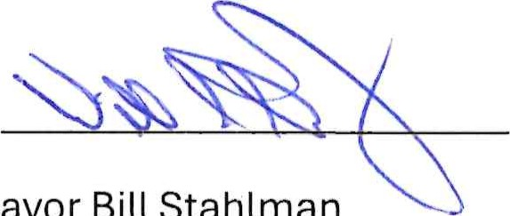
Approved: 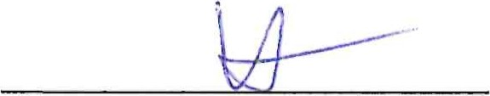
Mayor
Bill
Stahlman
Recorder Paula Reynolds

