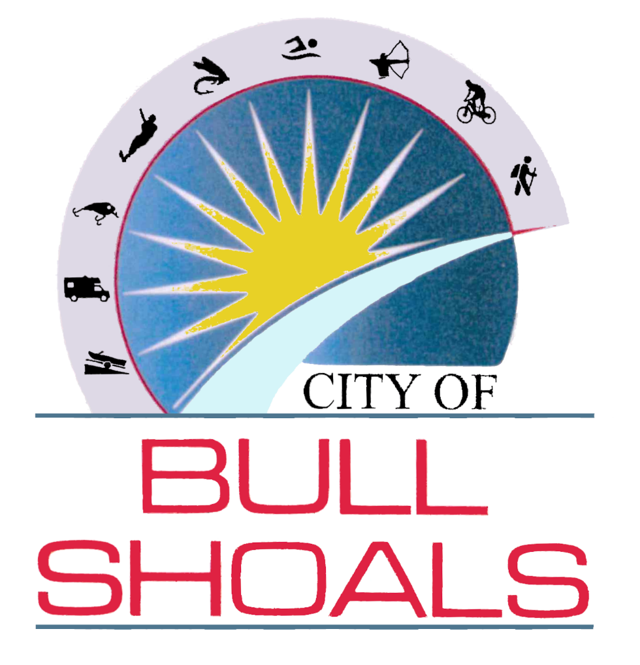

Welcome Pack

Welcome to Bull Shoals, Arkansas; a glistening jewel of the Ozarks. Bull Shoals is a small, friendly town situated on a peninsula jutting out into Bull Shoals Lake.

The town was created by real estate developers C. S. Woods and C. S. Woods Jr. and was officially established in 1954. Bull Shoals Dam is the threshold into the town from the southeast.
Bull Shoals Dam and the town of Bull Shoals developed together. The developers bought several tracts of the former Newton Flat settlement when they learned that the government planned to build a flood-control and power-generating concrete dam at the site. Construction of the dam took four years, from 1947 to 1951, resulting in one of the largest dams built in the nation at that time.
Visitors and locals alike enjoy the grand Bull Shoals Dam which creates the Lake and the world-famous trout fishery, the White River, flowing southward from it. Locally, the Bull Shoals Lake and Norfork Lake area is known as the Twin Lakes. We are also blessed with three different rivers: White River, North Fork River and Buffalo National River, well known for its smallmouth bass fishing.
The whole area is a mecca for the outdoors-loving person. Bass, striped bass, crappie and walleye fishing is year-round on the lakes. Rainbow, cutthroat and brown trout are also abundant year-round in the cool 48–52-degree waters of the White River. Don’t own a boat? No problem! There are several guide services who are more than happy to take you out on the river or lake! The approach of deer season sets off an obsession. Bow hunting, black powder and modern gun seasons are provided to offer all hunters great opportunities.
In the warmer months, bow fishing, spear fishing, swimming and diving are also popular in our clear, pristine lakes. Where Bull Shoals Lakes really shines is with over 1,000 miles of shoreline which gives the pleasure boaters a chance to enjoy the selected water sports; be it skiing, tubing, wake boarding, canoeing, kayaking or just floating around in the bay. Rather enjoy scenery by land? We have many trails for mountain biking and hiking as well! The beauty of Bull Shoals Lake, the mountains and our sunsets are unforgettable.
Bull Shoals also has everything one needs for day-to-day living - with the natural beauty of the area being a sought-after bonus. Located in town are restaurants, a bowling alley, health club, retail and grocery stores, churches, banks, dentist, pharmacy, pickleball and more.
Recreation is the heart of Bull Shoals. With numerous resorts, parks, lake and river access points for fishing and swimming, a live theater, archery range, Historic Bull Shoals Caverns, and a calendar full of events year-round, there’s something for everyone—whether you're seeking excitement or just a peaceful place to unwind.

IMPORTANT NUMBERS
BULL SHOALS, ARKANSAS
City of Bull Shoals- http://www.cityofbullshoals.gov/
City Hall – 706 C.S. Blvd ………………………………………………………………………(870) 445-4775
Front Desk/Water Dept / Erica Harper……………… Ext 1
Recorder/Court Clerk/ Jessica Wilkinson ………….Ext 2
Office Mgr/HR/ Susan Walling………………..……….Ext 4
Treasurer/ Amber Knowles…………………….………..Ext 5
Mayor/ Travis Fancher……………………………………..Ext 6
Police Department
Emergency………………………………………………………………………………………………911
Non-Emergency …………………………………………………………….…………(870) 449-6666
Fire Department
Emergency………………………………………………………………………………………………911
Non-Emergency………………………………………………….…………………….(870) 445-4566
Utilities
Entergy (Electric)…………………………………………………………….…….….(800) 368-3749
AmeriGas (Propane)………….. …………………………………………………….(870) 425-5141
MFA Oil Propane……………………………………………………………………… (870) 425-2737
Waste Connections/Methvin (Trash)…………………………………………....(870) 481-8600
NATCO (Internet/phone)…………………………………………………………….(870) 453-8811
County – Marion – http://marioncounty.arkansas.gov
County Health Unit, 405 W 7th, Yellville…………………………………………….(870) 449-4259
County Clerk……………………………………………………….…………………..(870) 449-6226
County Assessor…………………………………………………………….………..(870) 449-4113
County Surveyor………………………………………….………..………………….(870) 449-4354
County Municipal Court………………………………….……………..………….(870) 449-6030
Sheriff (Non-Emergency)………………………………….……..…………………(870) 449-4236
Tax Collector…………………………………………………………..……………….(870) 449-6253
Treasurer………………………………………………..……………………………….(870) 449-6331
FLIPPIN PUBLIC SCHOOLS – https://flippinschools.com/contact/us/
Flippin District…………………………………………………………………………(870) 453-2270
Flippin Preschool……………………………………………………………………..(870) 453-7445
Flippin Elementary……………………………………………………….…………..(870) 453-8860
Flippin Middle School………………………………………….…………………….(870 453-6464
Flippin High School…………………………………………………………..………(870) 453-2233

Bull Shoals Churches –
Bull Shoals Baptist Church ……………………….701 Broadway Ave -Bull Shoals 870-445-6005
Christ By The Lake Lutheran Church ………..1304 Cs Woods Blvd -Bull Shoals 870-445-4179
Presbyterian Church…………………………………….903 Walnut Ave -Bull Shoals 870-445-4622
United Methodist Church……………………………1001 Lynette Ave -Bull Shoals 870-445-4113
Grace Church of Bull Shoals………………………604 Broadway Ave -Bull Shoals 870-421-1767

Bull Shoals Parks and Recreation
Bull Shoals RV Park and Campground
Dam Site RV Park is maintained and operated by the City of Bull Shoals. We have 33 sites; each site has either 30 or 50 amp. electrical service, water, picnic table, and a fire pit. The park offers WiFi, clean washrooms with showers, plenty of shade at each site, and a dumping station. A playground, various covered picnic tables and large areas for kicking around a ball, Frisbee, and other yard games are available.
The park is located next to Bull Shoals Lake. The boat launch and shoreline fishing access is within walking distance. The park is open April 15th through October 15th.
To reserve your site at Dam Site Park, call 870-405-9619 or to reserve online go to https://parkwith.us/camps/dam-site-park.
Site 1: $25.26 - Tax included (Sewer is included on this site)
30 AMP Hook Up is $19.64 - Tax included
50 AMP Hook Up is $22.45 - Tax included
10% discount for seniors, military, veterans, and handicap.
All sites include Water, Electricity, Picnic Table, Fire pit, WI-FI and Firewood
Point Return
If you are into primitive camping, Point Return Campground is for you! Located on a hill overlooking Bull Shoals Lake, it presents the beauty and peace you desire. There are 22 sites, each with a picnic table, a fire pit and a lot of shade. Point Return is restricted to tent and pop-up camping only. RV's will be referred to Dam Site Park. Point Return is considered primitive because it has no electrical hook ups, no water hook ups, no showers or flushing toilets. It does have an "out-house" style concrete restroom, nicely paved road/walk/bikeways, convenient lake access with shoreline to investigate, and abundant shade trees.
- Point Return Campground is open April 15th through October 15th.
- Reservations are not needed. Point Return camping fee is $15 per night.
- Dues are deposited in a lock box at the entrance to the campground.

Brown’s Beach
- swimming area with a pebble beach
- boat launch with parking, parking/launch passes are $50/year, $25/year for Veterans and seniors age 55 or older.
- shoreline fishing access
- plenty of picnic tables
- Fire pits
- playground
- restrooms (outhouse style)
- large pavilion for family reunions and parties.
Call Bull Shoals City Hall for rental/reservation information.
Useful information
- Citizens are only allowed to own 3 cats and 3 dogs. All pets must be registered with the city. To register your animal, you will need current rabies vaccination records and a fee of $5.00. This affords you a lifetime pet license which you only pay for once. You will, however, need to show vaccination records either every year or every three years depending on type of vaccination your pet received from your vet.

- All permits for construction, including but not limited to fence, carport and deck, are available at Bull Shoals City Hall. Each permit has different requirements. Call City Hall to discuss what you will need to acquire your permits.

- The city of Bull Shoals is governed by ordinances. These ordinances are available upon request at the City Hall office. They are also posted on the city’s website, www.cityofbullshoals.gov/government.

- The City of Bull Shoals does have a Facebook page (City of Bull Shoals). We use this page to provide information pertaining to the city. We also use this page to Live Stream the City Workshop, City Council and Planning and Zoning meetings each month.

Welcome to the
BULL SHOALS WATER & SEWER DEPT.
Online Bill & Payment Portal!
An Easy & Convenient Way to View and Pay Your Bill Online
GO PAPERLESS!! SIGN UP FOR ONLINE BILLING SERVICES AND HAVE INSTANT ACCESS TO YOUR ACCOUNT INFORMATION 24/7
To make a Bull Shoals Water & Sewer Dept. bill payment (even if you have not
registered):
• Go to bullshoals.viewmybill.net (or call 855-483-5729 with company ID
7261911 and your account number.)
• Under the Unregistered Users heading, click where it says “Click Here to pay
your bill.”
• This will take you to the SOFTtelPay payment system where you will enter your
account number, payment amount, and credit card information.
To register so you can view your next bills online:
• Before you begin, make sure you have your current bill in hand because you must enter
your name and account information exactly as it appears on the bill. (If any information is
incorrect, you must contact your utility office through their preferred method.)
• To begin the registration process, go to bullshoals.viewmybill.net and click the
“Register” link. After you submit your registration, you will receive an email where you
must click the link to activate your account. At this point, you can login to your account;
however, this will not allow you to see your bill until the utility company does your next
billing.
• When you register, please be aware that you will still have the option to receive a
paper bill, but you must check the box to opt in. If you opt out of receiving a paper
bill, you will still be able to print a copy from the website after you login.
• After the next billing, you will receive an email notifying you that your bill is ready to be
viewed. Be sure to add the following two email addresses to your Address Book so the
emails do not get blocked: notifications@mail.viewmybill.net and
softtelpay@mail.viewmybill.net
• Once you have received your first bill, you can click the link and login with your email
address and password to view your bill. If you wish, you can pay your bill from your
account screen or from the Bulletin Board screen. You will need the company ID
7261911 and the account number from your bill.
When you sign up for Online Billing Services you will receive a monthly email notification
when your bill is ready for viewing. No more bills to file or shred!! Simply register for
Online Billing Services and you will have instant access to your account information.

City of Bull Shoals Water Department Information
BULL SHOALS, ARKANSAS
The City of Bull Shoals is responsible for providing the water, wastewater (sewer) and contracted trash services for the residents and businesses within city limits. We require a meter deposit of $125.00 for homeowners, $200.00 for renters and $250.00 for commercial before service can be provided. A meter deposit is only refunded when the water meter is disconnected. Refunds are made when billing is processed at the beginning of the month and all balances due to the Water Department will be deducted from that deposit. The billing period for water bills normally runs from the 20th day of the month to the 20th day of the following month. Water meters are read each month on approximately the 20th day. A meter deposit can be transferred from one location to another location within the City of Bull Shoals but only if the transfer is completed within a 24-hour period or over the weekend.
Bills are scheduled to be delivered to you by the 2nd week of the month. You are encouraged to pay by the 20th day of the month to avoid a 12% late charge.
UTILITY PAYMENT OPTIONS
In addition to paying by check, cash or money order at our City Hall office between the hours of 8:00AM to 5:00PM, Monday to Thursday and 8:00AM to 12:00PM on Fridays, or drop them off in our night drop box, you can also pay with a credit or debit card.

Pay online with credit card Visa or Mastercard at http://pay.softtelpay.com or by calling toll free 855-4TELPAY (855-483-5729)
*When asked for your identification code use: 7261911
*You must have your account number________________

***NOTICE***
SoFTtelPay Fee

Payment Amount
$0 - $30.00
$30.01 - $60.00
$60.01 - $90.00
$90.01 - $120.00
$120.01 - $150.00
$150.01 - $180.00
$180.01 - $210.00
$210.01 and above
Convenience Fee
$1.95
$2.95
$3.95
$4.95
$5.95
$6.95
$7.95
4% of payment amount

*SoftTel reserves the right to change fees without notice.*
For hassle-free payment options, we also offer automatic bank drafts. This is done on the 20th of every month. If the 20th falls on a weekend or holiday, the transaction will take place the next business day. Inquire at the Water Department to arrange this service.

You may mail your payment to:
City of Bull Shoals
P.O. Box 390
Bull Shoals, AR 72619

DISCONNECTION FOR NON-PAY – If the bill is not paid on the disconnection day, your water service will be disconnected. To resume service, the full bill plus a $50.00 service fee must be paid before the water service is reconnected. After 8:00 AM the reconnect, fee must be paid even if the water has not been locked off yet. (As we still must go out and read the meter) If your service is disconnected and your meter is locked off, we will turn your water back on at our earliest convenience. If payment is made after 3:00 PM, your service will be restored the following business day.

RETURN CHECK – If a check or auto-draft is returned to the city, you will be notified by phone and given 3 business days to pay the check amount in cash or by money order. If it is not paid within the given time, your service will be disconnected until payment is made in full.

TRASH SERVICE – The city provides residents trash service within City of Bull Shoals city limits and is billed on the water bill. The City of Bull Shoals contracts with Waste Connections/Methvin in Midway (870) 481-8600. Residential trash is picked up Tuesday of each week. Trash needs to be out by 6AM on Tuesday morning. The Roll-Out trash container provided must be used for trash removal. All trash must be in plastic bags sufficient strength, or 30-gallon household containers. Methvin will provide an extra container or extra bag pick ups, however you will need to call them to set this extra service up. No trash will be picked up in paper bags or boxes. The City of Bull Shoals and Waste Connections/Methvin provides spring and fall cleanup to residents within City of Bull Shoals city limits. Watch local newspapers and our website (www.cityofbullshoals.gov) for dates or check with city hall.

General Rules
- The purpose of the Utility is to provide a safe supply of water to the customers within its service area. The supplying and taking of water shall be in conformance with these rules and regulations, and applicable rate schedules of the Utility.

- The Utility agrees to provide service to the point of delivery, and install and maintain at its expense, one metered service connection for each customer point of use, based on a valid Water User’s Agreement.

- The customer will install and maintain, at his/her own expense, service lines from the point of delivery to the point of use. The customer will make repairs on a timely basis as necessary.

- A metered service connection is for the sole use of the applicant or customer. Customer shall not permit the extension of pipes from the purpose of transferring water from one property to another, from one point of use to another, not share, resell or sub-meter water to any other person or entity.

- Multiple Residential and Point of Properties: The standard residential rates of the System shall be applicable to all multiple residential and point of use properties. Multiple residential properties include mobile home parks, apartment buildings, motels, housing complexes, or similar residential developments. The Utility may, at its discretion, choose to serve multiple residential properties through a single master meter, if the property is serviced through a single electrical meter.

- At no time shall any customer or individual connect a non-system water source to any service line or water line that is also connected to the System. Representatives of the Utility shall have the right to enter customers’ premises for the purpose of inspection and enforcement of this policy at all reasonable hours. Violations of this policy shall constitute cause for immediate disconnection of service.

- It is the responsibility of each customer to notify the Utility of any changes in occupancy and to have the service transferred to the new customer in accordance with the policy for obtaining service. Until service is formally transferred, the original customer shall be responsible for payment of service. The Utility may refuse to transfer service until all past-due bills and charges have been paid. Any customer leaving a past due balance with the Utility will not be permitted to reconnect service with the Utility until all past due amounts are paid in full.

- Customers agree to pay the established fees for water service in accordance with applicable rate schedules at the time service is provided by the Utility.

- Representative of the Utility shall have the right at all reasonable hours to enter the customers’ property in order to: read water meters, inspect piping, and to perform other duties for the proper maintenance and operation of service by either the customer or the Utility.

- The Utility shall make all reasonable efforts to supply continuous, uninterrupted service. However, it shall have the right to interrupt service for the purpose of making repairs, connections, and extensions or for other necessary work. Efforts will be made to notify customers, who may be affected by such interruptions, but the Utility will not accept responsibility for losses, which might occur due to such necessary interruptions. The Utility does not accept responsibility for losses due to interruptions beyond its control.

OBTAINING WATER SERVICE

- Applications for service shall be available at the office of the Utility and must be accompanied by a deposit of $125.00 for homeowners, $200.00 for renters or $250.00 for commercial businesses. This deposit shall be maintained in a special account to ensure payment of water charges. When service is discontinued, any portion of the deposit remaining after current bills are paid will be returned to the customer within 60 days. Customers with service termination due to non-payment will have their deposit applied to their account to satisfy past-due amounts prior to actual termination of water service. The return of service will require a new deposit.
- Before installing a service, connection and providing water available for use, the Utility may require the applicant to pipe his/her home and be ready to accept service.
- Customers shall arrange for a licensed plumber to make connection between the service line and meter. The System Operator will inspect all work of the plumber prior to completion of the work.

CUSTOMER BILLING
- Customers will be billed once a month in accordance with the rate structure of the Utility. Failure to receive a water bill by the customer does not exempt them from payment by the due date of penalties.
- Water meters will be read during or near the 20th of each month.
- Bills will be mailed on or about the first day of each month.

PAYMENT TERMS
- Payment is due by the twentieth (20th) of each month.
- Payment made after the twentieth (20th) will incur a penalty equal to twelve percent (12%) of the water bill.
- Three (3) returned checks will result in the customer having to make water payments in cash only at the Utility office(Bull Shoals City Hall) for a period of one (1) year.

TERMINATION OF WATER SERVICE
- When a customer’s water bill is not paid by the last day of the month a shut-off service order will be generated at the department and a red tag will be issued immediately. A $50.00 service fee will also be added to the account.
- Customers who receive a red tag will be given 6 additional days to pay the balance of the account.
- Customers may avoid termination of service by (1) paying the past due amount in full at the Utility office before the scheduled shut-off date.
- Customers may appeal a notice of termination of water service. The Utility’s Water or Sewer Operators or the Mayor of Bull Shoals is designated as the Utility representative for hearing appeals of notice of termination of water service. The representative is authorized to correct errors of the Utility and adjust the amount due to the Utility, receive payment to satisfy the amount in arrears, and negotiate deferred payment plans.

DEFFERED (TIME) PAYMENT PLAN FOR HARDSHIP CASES
Payment plans may be arranged at the office of the Utility. Customers must fill out an application and it shall be reviewed by the Mayor and/or the Water or Sewer Supervisor.
RECONNECTION OF WATER SERVICE AFTER TERMINATION FOR NON-PAYMENT
Customers desiring restoration of water service after termination for non-payment must (1) pay arrears in the full amount, plus any additional deposit in accordance with the fee schedules of the Utility and pay the service fee for reconnection in accordance with the Utility’s fee schedule.

METERS
- Meters shall be furnished, installed, owned, inspected, tested and kept in proper operating condition by the Utility. A $5.00 maintenance fee shall be added to each month’s water bill. A complete record of tests and histories of meters will be kept. Meter tests will be made according to methods of the American Waterworks Association by the Utility as often as deemed necessary.
- Service meters whose errors do not exceed 2% fast or slow shall be considered as being within the allowable limits of accuracy for billing purposes. The percentage of error will be considered as that percentage arrived at by taking the average of the error at full load and that at 10% load, unless a customer’s rate of usage is known to be practically constant, in which case, the error at such constant use will be used.
- Meters shall be set in an accessible outside location extending from the main service line to the nearest point of property line of the customer. The Utility will determine location of the meter box. All meters shall be set horizontally and never connected to a vertical pipe. The meter box will be furnished and installed by the Utility. Meters will not be placed inside of buildings, unless otherwise directed by the Utility.
- Meter tests requested by the customers shall be performed without cost to the customer if the meter is found to be in excess of 2% fast. Otherwise, the customer who requested the test will be charged for the total cost of conducting the test.
- The customer shall be responsible for any damage caused by other than normal wear and tear to the meter/meter box installed for his/her service.

MAIN EXTENSIONS
In extending a water main to serve an applicant, the Utility may, at its discretion, exercise one of the following options:

- If the per connection cost of the extension is less than the average per connection cost of the extension elect to make the extension upon the applicant’s payment of the required connection fee and meter deposit.
- If the cost of the extension is greater than the average per connection cost of the System, but funds are available to the extent of such average cost, the Utility may elect to contribute to the extension in the amount of such average cost and require the applicant to deposit, in cash, the additional cost plus the connection fee. If additional customers are connected to the extension and as funds become available, all or part of the original customer’s deposit may be returned to him/her. Any portion of the original deposit remaining after the expiration of a five-year period shall become the property of the Utility. In no case shall interest be paid on such deposits.
- In the event the Utility does not have funds available to pay for construction in the amount of the average cost per user, it may require, as a condition of extending service, that the applicant deposit in addition to the charge of a connection free, and amount which may equal the entire cost of the extension. In such an event, the Utility may, as funds become available, return to the customer that portion of his/her deposit equal to the average cost of the System per user. No interest shall be paid on such deposits.
SERVICES
The Utlity shall install and pay for all water service pipes from its main to the meters on property abutting the travel way along which the main is installed. The service pipe shall not be less than ¾” in size. The Utility shall also install and pay for the Utility cock, meter and meter setting.

APPLICANTS WITH EXCESSIVE NEEDS
In the event an applicant has water requirements that exceed the Utility’s ability to supply from the existing plant without adversely affecting service to other customers, the Utility will not be obligated to give such service unless and until suitable self-liquidating financing is arranged to cover necessary investment in expanding the plant.
AVAILABILITY OF RECORDS FOR PUBLIC INSPECTION
Utility records, including minutes of meetings and financial records, are available for inspection by the public during office hours.
NOTICE OF MEETINGS OF THE COUNCIL
- The Council meets in regular session on the LAST Thursday of each month at 6:30pm except November and December when it will be the week before the Holiday.
- The agenda for all regular and special meetings shall be posted in the Utility office at least 24 hours before the meeting.

