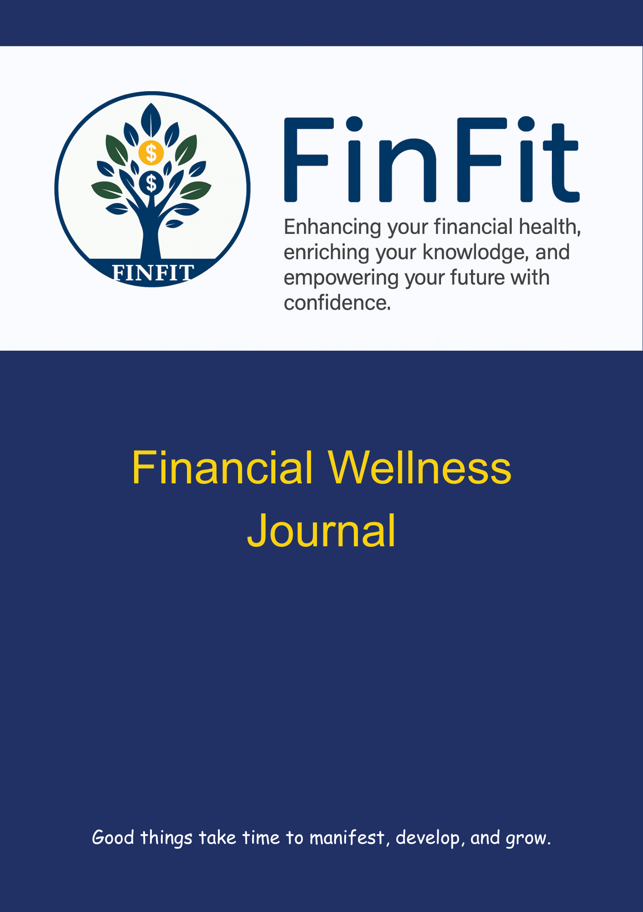

Introduction
Welcome to your FinFit Journal! This journal is designed to be your personal guide on the journey to financial well-being. Whether you are just starting out or looking to refine your financial strategies, this journal will help you set clear goals, track your progress, and make informed decisions.

The purpose of this journal is to provide you with a structured approach to managing your finances. By documenting your financial goals, budgeting plans, investment strategies, and progress, you will gain a deeper understanding of your financial situation and be better equipped to achieve your objectives.

One of the key elements of financial success is having a strong support system. This is where FinFit comes in. FinFit offers a range of resources, tools, and community support to help you stay on track and motivated. With FinFit, you will have access to expert advice, educational materials, and a network of like-minded individuals who are also working towards financial fitness. This support can make a significant difference in your journey, providing you with the encouragement and guidance you need to succeed.
===
To achieve financial fitness, it is important to focus on three key principles:
- Being Financially Healthy: This involves managing your money wisely, reducing debt, and building a strong financial foundation. Understanding your relationship with money and how your family and past experiences inform your interactions with money is crucial. By recognizing these influences, you can make healthy financial changes that lead to a more financially healthy life.
- Setting Financial Goals: Clear, specific, and achievable financial goals are essential for guiding your financial decisions. Whether it is saving for a major purchase, planning for retirement, or building an emergency fund, setting goals helps you stay focused and motivated.
- Remaining Financially Knowledgeable: Continuous learning and staying informed about financial matters are crucial for making smart decisions. By educating yourself and staying up to date with the latest financial trends and strategies, you can make informed choices that align with your goals.

Remember, financial fitness is not just about numbers; it is about building a secure and fulfilling future. Use this journal as your roadmap and let FinFit be your companion along the way. Together, you can achieve your financial goals and enjoy the peace of mind that comes with financial stability.
Reflect and Envision
Take a moment to reflect on your financial journey so far. What did your financial life look like before? Consider your spending habits, savings, investments, and any financial challenges you faced. Write down your thoughts and experiences in detail.

Now, envision what you want your financial life to look like in the future. Get specific about your goals and aspirations. How do you want to manage your money? What financial milestones do you want to achieve? Think about your ideal financial situation and describe it vividly.

Feel free to draw or write your intentions. Use this space to create a clear and inspiring vision for your financial future.

Part 1. Financial Health
Step 1. Assessing your relationship with money

What are your first memories about money? | Were these memories positive or negative?

Now let us reframe the negative ideas to something more positive. You can keep the positive statements from above and reframe the negative statements.

How do you want to look at money and your financial wellness?

Part 2. Personal Financial Goal/Plans

Step 2

Assess Your Current Financial Situation
- Net Worth: Calculate your net worth by subtracting your liabilities (debts) from your assets (savings, investments, property, etc.). Regularly track changes in your net worth.
- Budget Review: Analyze your income and expenses. Identify areas where you can cut costs or allocate more funds toward savings and investments.
- Track Your Spending: Use tools like spreadsheets, apps, or budgeting software to monitor your expenses.
- Allocate Funds Wisely: Prioritize essentials (housing, food, utilities) and allocate a portion for savings and investments.

Complete the following worksheet (Included with this journal)

You want to aim for the following percentage of Net Income (take home pay):
Total expenses 50% to 65%
- Housing costs (mortgage/rent + utilities) 20% to 25%
Investments 5% to 10%
Saving 5% to 10%
Free Money 15% to 20%
How are you feeling after completing the Financial Wellness Plan?
Are you on track to meet your goals? Need any changes?

Set Clear Financial Goals
- Short-Term Goals: Define specific financial objectives for the next 1-2 years (e.g., emergency fund, paying off high-interest debt).
- Medium-Term Goals: Plan for 3-5 years (e.g., saving for a down payment, funding a vacation).
- Long-Term Goals: Aim for financial independence, retirement, or other major milestones.

Financial Goals

*Financial Goals: Are your goals specific, measurable, achievable, relevant, and time-bound (SMART)?

• Specific
- Your goal should be clear and specific, answering the questions: What do I want to accomplish? Why is this goal important? Who is involved? Where is it located? Which resources or limits are involved?
• Measurable
- You need to be able to track your progress and measure the outcome. Ask yourself: How much? How many? How will I know when it is accomplished?
• Achievable
- Your goal should be realistic and attainable. It should stretch your abilities but still remain possible. Ask: How can I accomplish this goal? How realistic is the goal, based on other constraints?
• Relevant
- The goal should matter to you and align with other relevant goals. Ask: Does this seem worthwhile? Is this the right time? Does this match my other efforts/needs?
• Time-bound
- Every goal needs a target date, so you have a deadline to focus on and something to work toward. Ask: When? What can I do six months from now? What can I do today?

Example of a SMART Financial Goal:
“I want to save $5,000 for an emergency fund within 12 months by setting aside $417 each month from my salary.”

Sample Monthly Financial Fitness Plan

Monthly Financial Fitness Plan
Net worth | Person 1 | Person 2 | Total
Property (home & vehicle(s) |  | $457,067.00 | $457,067.00
Investments (retirement & others) | $750,000.00 | $192,000.00 | $942,000.00
Savings | $3,000.00 |  | $3,000.00
Credit Card Debt | $1,000.00 | $4,000.00 | $5,000.00
Loans (home, student loans & etc.) |  | $217,522.00 | $217,522.00
Total Net worth | $752,000.00 | $427,545.00 | $1,179,545.00
Income |  |  |  | Annual Income
Monthly Income (before taxes) | $7,275.00 | $7,465.46 | $14,740.46 | $176,885.52
Net Income (After tax income) | $3,833.64 | $3,531.67 | $7,365.31 | $130,763.76
Monthly Expenses |  |  |  | Percentage of Net Income
Rent/Mortgage | $847.00 | $633.00 | $1,480.00 | 20.09%
Utilities (gas, electric, water, internet, cable, and etc) | $319.00 | $231.00 | $550.00 | 7.47%
Insurance (home, car, life, pet, etc.) | $106.14 | $86.81 | $192.95 | 2.62%
Car (loan payment, gas and fees) | $58.00 | $42.00 | $100.00 | 1.36%
Credit payments (credit cards, student loans, and other loans) | $100.00 | $200.00 | $300.00 | 4.07%
Groceries | $500.00 | $500.00 | $1,000.00 | 13.58%
Phone | $82.09 | $54.72 | $136.81 | 1.86%
Subscriptions (Netflix, gym membership, meal services, Amazon, etc.) | $82.17 | $54.78 | $136.95 | 1.86%
Miscellanious (add 15% of net expenses) | $314.16 | $270.35 | $584.51 | 7.94%
Total Expenses | $2,408.56 | $2,072.66 | $4,481.22 | 60.84%
Investments (not automatically taken out of pay check)
Post-tax Retirement Savings (Roth IRA) | $0.00 |  | $0.00 | 0.00%
Stocks |  |  | $0.00 | 0.00%
Other investments |  |  | $0.00 | 0.00%
Total Investments | $0.00 | $0.00 | $0.00
Savings
Emergency Fund (12-6 Mo of expenses) | $400.00 | $400.00 | $800.00 | 10.86%
 |  |  | $0.00 | 0.00%
Vacation and Gifts | $400.00 |  | $400.00 | 5.43%
Household Savings |  |  | $0.00
Total Savings | $800.00 | $400.00 | $1,200.00 | 16.29%
Free Money
What's left | $625.08 | $1,059.01 | $1,684.09 | 22.87%

Step 3

Debt Management
- Pay Off High-Interest Debt: Focus on credit cards, personal loans, or any debt with high interest rates.
- Snowball or Avalanche Method: Choose a debt repayment strategy that works best for you.

Snowball Method is when you put more money towards paying off the smallest debt amount first, paying the minimum on the rest until that is paid off and then you move on to the next until they are all paid off.

Avalanche Method is when you put more money towards paying off the debt with the highest interest rate, paying the minimum amount on all the rest and then moving on to the next until they are all paid off.

Name of debt | Total owed | Interest %
Total debt
Automate Debt payments: Sign onto your credit cards and loans and set up automation of your payments. Pick a date that works for you and an amount that you have determined.

Which method are you going to use?
How much do you plan to put towards your debt?
How long will it take to pay each of your debts in order?

After you pay off your first debt you can apply that amount to your second amount along with the minimum amount, until all your debt is paid off.

Step 4

Future Planning

Develop a Savings Plan
- High Yield Savings Accounts: Do research on savings accounts that allow you to have a high yield each month and pick one that works for you.
- Build an Emergency Fund: Aim for 3-6 months’ worth of living expenses in a separate account.
- Other Savings goals: Are you planning a vacation, wedding, or purchase of a home, you can also allocate money towards these goals as well.
- Automate Contributions: Set up automatic transfers to your emergency fund and other savings each month.

Savings Goal | Amount to save | Duration

Step 5

Develop an Investment Plan
- Learn About Investing: Educate yourself on different investment vehicles (stocks, bonds, real estate, etc.).
- Start Early: Take advantage of compound interest by investing as soon as possible.
- Diversify: Spread your investments across various assets to manage risk.
- Maximize Retirement Contributions
- 401(k) or IRA: Contribute the maximum allowed. Take advantage of employer matches.
- Tax-Advantaged Accounts: Explore Roth IRAs, HSAs, and other tax-efficient options.
- Automate Contributions: Set up automatic transfers to your investment accounts each month.

Investment Accounts | Current Balance | Monthly Contribution

Investment Strategies: Are the strategies well-researched and explained? Are there any risks mentioned?

Use the Retirement Calculator in the Money Confidence section of the FinFit website to understand how your savings can build over time. Most investment in a mutual fund connected to the S&P 500 makes about 7% to 8% in annual interest over the long run.
Part 3. Financial Knowledge
Step 6
Increase Your Income
- Side Hustles: Consider additional income streams (freelancing, part-time work, online businesses).
- Skill Development: Invest in learning new skills that can boost your earning potential.

Side Hustle ideas

Learning Opportunities

Step 7
Review Family Plan
- Life insurance: Do you have life insurance to cover funeral costs, pay debt, and cover your family's expenses after you pass?
- Health Care Directive and a living will
- Will/Trust: Do you have a will and/or trust that outlines where your assets will be distributed, your plans for when you pass away?

Family Plan

Step 8

Review and Adjust Regularly
- Quarterly Check-Ins: Revisit your goals, budget, and progress.
- Celebrate Milestones: Acknowledge achievements along the way.

Plan for Check-in (what do I need to review)

Celebration Milestones – what are ways I want to celebrate

Step 9

Stay Educated and Inspired
- Read Financial Books and Blogs: Continuously learn about personal finance and investment strategies.
- Join Communities: Connect with like-minded individuals pursuing financial independence.

List of books, blogs, and communities

List of Books, Blogs, and Communities: Are these resources up-to-date and relevant? Are they properly categorized and described?

Closing

As you close this chapter of your Financial Fitness Journal, remember that every step you take towards financial well-being is a step towards a brighter future. Your dedication to understanding your finances, setting clear goals, and continuously learning is commendable.

Stay motivated and keep pushing forward, even when challenges arise. The journey to financial fitness is not always easy, but with perseverance and the support of FinFit, you can achieve your dreams. FinFit offers a range of resources, tools, and community support to help you stay on track and motivated. With access to advice, educational materials, and a network of like-minded individuals, FinFit provides the encouragement and guidance you need to succeed.

Believe in yourself and your ability to create a secure and fulfilling financial future. Keep this journal as a testament to your hard work and progress. Revisit it often, celebrate your achievements, and continue to set new goals. Your financial fitness journey is a lifelong commitment, and every effort you make brings you closer to the peace of mind and stability you deserve.

Here's to your continued success and a financially healthy life!

