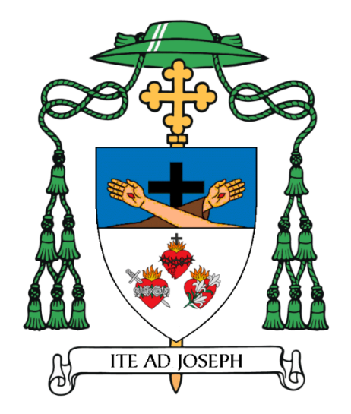

MOST REV. EMILIO BIOSCA AGÜERO, O.F.M.CAP. BISHOP OF VENICE
Blazon: Per fess Azure and Argent; in chief the arms of the Franciscan Order: upon a Latin cross Sable two arms in saltire, the one to dexter uncovered and the one to sinister habited on the Order of Saint Francis, both hands displaying the Stigmata, all Proper; in base the Sacred Heart of Jesus between and above on the dexter side the Immaculate Heart of Mary and to the sinister the Chaste Heart of Saint Joseph, one and two, all Proper.
Motto: ITE AD JOSEPH
Explanation In the upper portion of the shield, the two crossed arms before a cross represent the bare arm of Jesus Christ crucified, the hand bearing the wound of crucifixion, reminding believers of Christ’s sacrificial love and redemption, and the arm of Saint Francis of Assisi clothed in simplicity, emphasizing poverty, humility, and discipleship. Saint Francis also bears the stigmata, the wounds of Christ, which he received on Mount La Verna in 1224. The cross behind the arms signifies that both Christ and Francis are united through the mystery of the Cross. It reflects the Franciscan desire to follow Christ completely, especially in humility, suffering, and love.
In the lower portion of the shield, the silver background represents transparency, truth, and justice. The Sacred Heart of Jesus symbolizes Christ’s divine love for humanity, self-sacrificing, merciful, and redemptive. It is usually shown aflame, in the passion, pierced, and crowned with thorns. The Immaculate Heart of Mary represents her pure and immaculate love, her obedience to God, and unity with her son’s mission. It is usually depicted pierced by a sword, recalling her sorrow and joy. The Chaste Heart of Saint Joseph signifies the faithful, protective, and self-giving love, marked by chastity, humility, and loving obedience to God’s will. The three hearts together symbolize that the human person is revealed through love and is made for self-gift and communion. It expresses that human love, marriage, and the family is a communion of persons, central to the new evangelization, that truth, goodness, and beauty are united. The red hearts also recall the first Franciscan Missionary Martyrs in 1220. When Saint Francis of Assisi heard of their deaths, he declared, “Now I can truly say that I have five Friars Minor,” recognizing in them the authentic spirit of humility, sacrifice, and evangelical love that he desired for his brothers.
The Bishop’s motto, ITE AD JOSEPH, is from Genesis 41: 55, “Ite ad Ioseph; et quidquid ipse vobis dixerit, facite.” (Go to Joseph; and whatever he says to you, do.” “Vayan a José y hagan lo que él les diga.”)
The coat of arms was devised by Bishop Biosca with advice from Very Rev. George E. Stuart and Georgina Wilkinson.

