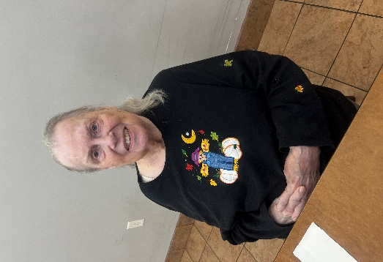

We are proud to recognize Joan as our Resident of the Month at Tender Hearts! Joan brings warmth and a peaceful spirit to our community and shares that what she loves most about Tender Hearts is the people who live here, the fun they have together and the nice company they provide. Joan is a proud mother of three children, two boys and one girl, and if she could have any superpower, it would be to be a mother all over again, showing just how much her family means to her. She also has a sister and brother-in-law who are special parts of her life. One of Joan’s most vivid childhood memories is traveling to Grand Rapids with her mom and dad. She enjoys classic music, loves apple pie, and looks forward to summer each year because of the beautiful weather and all the activities you can enjoy. If Joan had a personal motto, it would simply be peace and quiet. Congratulations, Joan, we are so grateful to have you as part of our Tender Hearts family!

Resident of the month
300 And 320 Cardinal ln, green bay, wi, 54313
Tender Hearts
March

2026

Celebrating March
Irish American
Heritage Month
Mad for Plaid Month
Women’s History Month
Employee Appreciation
Day
M
arch 6
Iditarod Begins
March 7
Daylight Saving Time
Begins
March 8
Plant a Flower Day
March 12
St. Patrick’s Day
March 17
World Poetry Day
March 21
International Hug a
Medievalist Day
March 31

March 2026

A Legacy of Laughs


Funny how men often think themselves funnier than women. Studies on humor between the genders have found that men’s jokes are sometimes rated slightly funnier—but often it’s other men who are laughing. Women, meanwhile, may
quietly have the last laugh
on March 31, She’s Funny That Way Day, a day celebrating comedians past and present.
Carole Lombard was a leading lady of old Hollywood, a natural beauty whose charm and comedic timing shone even when she took the occasional pie in the face. Barbara Stanwyck could play any role: glamorous dame, femme fatale, tough feminist, and yes, the madcap comedian. Both women were nominated for Oscars yet never won.
Any discussion of funny women must include Lucille Ball, often called the Queen of Comedy. Ball once told a Rolling Stone reporter, “I am not funny,” though her millions of fans would beg to differ. Not only was she hilarious, she mentored another extraordinary comedian, Carol Burnett.
Many of these performers also changed the business behind the scenes. They pushed for better roles, wrote their own material, and shaped shows that reflected their voices rather than someone else’s idea of what women should be. Their influence extends well beyond their punchlines, reminding us that real comedic power comes from having the freedom to tell your own story.
Like many of the men who came before them, no topic is too bold for these daring women. From Phyllis Diller to Joan Rivers to Whoopi Goldberg, to modern comedians such as Tina Fey, Kristen Wiig, Melissa McCarthy, Sarah Silverman, Mindy
Kaling, Amy Poehler, Wanda Sykes, and Maya Rudolph, the list of talented women is truly endless—and so are the laughs.


Stitched Across the World


Quilters all around the world will be piecing together fabric into wonderful creations on March 21, Worldwide Quilting Day.
During its heyday in the American mid-19th century, quilting was a utilitarian craft. According to Emporia State University’s Center for Great Plains Studies, westward homesteaders, inheritors of many great European quilting traditions, fashioned blankets, door and window covers, and play mats for children out of whatever scraps of fabric they could find. Quilters learned to arrange fabric to make wonderful works of art. And because blankets were always needed to protect against the elements, quilting never went out of style.
A number of quilting bees will no doubt be held on March 21, so be ready to cut your favorite patterns—Irish Chain, Log Cabin, Bear’s Paw, or Tree of Paradise.
March 2026
Courtesy Counts


Many lament that common courtesy is not so common anymore. If someone you know is acting less than civil, March 21, Common Courtesy Day, is the perfect opportunity to tactfully share a few tips and reminders on how to treat others with respect.
March Birthday’s
- 03/02/1955 Joseph I
- 03/07/1935 Shirly W
- 03/09/1941 Kathryn T
- 03/30/1952 Christine P

Some point to technology as a major culprit in the decline of courtesy, especially as we’ve grown more tethered to our screens. Others see a broader cultural shift: When people feel rushed, stressed, or isolated, empathy tends to shrink. Researchers continue to note that young adults report feeling more pressure and less connection than in previous generations. Etiquette experts also observe that norms have loosened over time, sometimes in ways that make everyday interactions feel less considerate.
Across many countries, parents and teachers are trying to balance freedom with guidance, and the line can get blurry. When expectations around behavior become too vague, kids can miss out on learning how their actions affect others. The result can be the same everywhere: a little more self-focus, a little less awareness. Renewed interest in teaching social skills and emotional literacy suggests that people are recognizing the need to rebuild those habits.
If we don’t practice empathy every day, we may have to rely on others to pass laws of courtesy for us. Restaurants declare “No Cell Phone Zones.” Sports stadiums regulate fan conduct. New York City even imposes a fine on those who prop their feet on a subway train seat. Psychologist Marie Hartwell-Walker believes that even “faked” manners can teach empathy, that cornerstone of courtesy. Simple acts such as holding doors open, returning phone calls, treating clerks and cashiers with respect, and saying please and thank you— these daily reminders to consider others’ feelings lay a foundation for building empathy.

Webs of Wonder
For many, the first reaction to seeing a spider is to squash it. Spider advocates celebrating Save a Spider Day on March 14 want you to think before you squish, and they have some pretty compelling reasons.


Lots of folks, experts and novices alike, think spiders are just plain cool. The Goliath bird-eating tarantula fits in your palm and was named by an explorer who saw it eating a hummingbird. The pinktoe tarantula, named for its pink-tipped legs, can
climb trees and swim. Not impressed? Another reason not to squash spiders is that many of them carry their newly hatched babies on their backs. One whack can disperse hundreds of tiny spiderlings. Still not convinced? Spiders benefit humans in many ways. They eat lots of bugs. Their venom can be used for making medicine.
Spider silk, which is stronger than steel, inspires technological innovation. So before your arachnophobia takes over, think twice about squishing a spider on March 14.

March 2026 Blast the Birthday Horn
On March 2, don’t just wish Dr. Seuss a happy birthday. Do as they do in Dr. Seuss’ fictional land of Katroo and let loose a “big blast on the big Birthday Horn!”

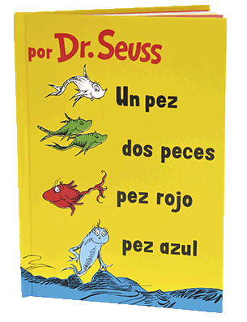
Theodor Seuss Geisel, known as Dr. Seuss, was never a doctor of anything. He called himself “doctor” because his father wanted him to study medicine. Thankfully, he pursued children’s literature and in 1937 wrote his first book, And to Think That I Saw It on Mulberry Street, debuting the pen name Dr. Seuss. The idea for the book struck Geisel while on an ocean voyage. The rhythm of the ship’s engines inspired him to write the lines:
And that is a story that no one can beat.
And to think that I saw it on Mulberry Street.
No fewer than 20 publishers rejected the book before Geisel showed it to an old college classmate, who was editor of children’s books at the publishing house Vanguard Press. Dr. Seuss went on to write over 60 children’s books (including some under the name Theo LeSieg), selling over 600 million copies in over 20 different languages.
What makes Dr. Seuss’ books so enduring? Children’s literature expert Ann Neely believes it is the books’ readability. “Children can read Dr. Seuss books many, many times without tiring of the rhythms, the plot, or the art.” Furthermore, Seuss’ moral lessons appeal to young and old alike. Journalist Melissa Breyer believes adults have plenty to learn from Dr. Seuss. Did I Ever Tell You How Lucky You Are? teaches us that self-pity is an unnecessary indulgence. The Lorax reminds us that it’s up to us to give a voice to the voiceless. Truly, Dr. Seuss’ children’s books may be more valuable to adults than his odd adult work, a humorous, slightly scandalous take on the legend of Lady Godiva, full of illustrations of the seven nudist Godiva sisters. That book, perhaps understandably, was Seuss’ only major flop.

Reports still recommends keeping a landline: sound quality is often better, and because numbers are directly linked to a home address, emergency calls from landlines remain highly reliable. When power goes out, some landlines continue to work, thanks to backup batteries, though these are becoming less common. Telephone companies, however, are shifting to digital networks that are cheaper to maintain. So enjoy landlines while you can—before they disappear.

