



FALL SEMESTER
2026

OUR MISSION STATEMENT:
CONNECTING YOUR STORY WITH CHRIST AND OTHERS.
We accomplish this mission by:
Reaching - Who are we Reaching?
Teaching - What is the Impact of our Teaching?
Training - What is the Result of our Training?
Sending - Who are we Sending?
OUR VISION:
TO REACH TEACH TRAIN AND SEND
We strive to live out this vision by being a fellowship that:
Encounters God through worship and the Word
Engages the lost through outreach
Exhorts others through discipleship
Edifies ourselves through fellowship
Expands His Kingdom through service and ministry

INVOLVEMENT
Small groups are the best way to develop true friendships with other people in our church. As these friendships grow, you can move into authentic fellowship with your friends. Fellowship is when you stop doing life Around others, and you start doing life With others.
COUPLES GROUPS

MARRIED WITH CHAOS 1 - Group Leaders: Dustin and Erin Wilbanks along with Steve and Jenny Mott. Meets every Sunday at 6:00 pm in a private home in the Harbins area. This group will focus on growing in their personal walk with Jesus, in their marriage and in raising kids. Begins August 16th

MARRIED WITH CHAOS 2 - Group Leaders: Michael and Rachel Davis along with Nic and Amanda Brown. Meets every Sunday at 6:00 pm in The Cross Café. This group will focus on growing in their personal walk with Jesus, in their marriage and in raising kids. Begins August 16th

MARRIED WITH CHAOS 3 - Group Leaders: Chris and Julie Moore along with along with Kyle and Autumn Ledbetter. Meets every Sunday at 6:00 pm in The Cross Café. This group will focus on growing in their personal walk with Jesus, in their marriage and in raising kids. Begins August 16th

FAITHFUL FOUNDATIONS - Group Leaders: Tim and Robin Cummins along with several other couples rotate homes and leaders. Meets every other Sunday at 5:30pm in a private home. The goal of this couples group is to help each other get through the craziness of life and continue to remain committed to their marriages. Begins August 23rd

ADULT GROUPS

SALT (Senior Adults Living Triumphantly) – Group Leader: Steve Joiner. Meets every Sunday at 9:30 am in the Kitchen. This is an energetic group of men and women 55+ who dive into God’s Word on a weekly basis. Ongoing Group

WHO ARE YOU? – Group Leaders: Chad and Elaine Daniell. Meets every Wednesday at 7:00 pm in Tara upstairs office. This is a group for any age or season, couples or individuals. We will study and discuss Identity in Christ and the New Covenant. Begins August 12th.

NEW CONNECTIONS – Group Leaders: Rick and Sandra Burgess Meets every Thursday at 6:30 pm in a private home. This is a group for any age, newcomers or unconnected individuals who would like to do life and Study God’s Word together. Fellowship, prayer and a deep dive into the prior Sunday’s message will be our weekly goal. Ongoing Group

BECOMING MORE LIKE JESUS – Group Leaders: Drew and Teresa Mobley. Meets 1st and 3rd Sundays at 5:00 pm in a personal home. This group of young adults 18-30 (individuals or couples) will focus on their journeys to be more like Jesus. Ongoing Group

PURPOSE DRIVEN – Group Leaders: Spencer and Carrie Pratt Meets 2nd and 4th Sundays at 5:30 pm in the kitchen. Transforming Lives, One Act of Love at a Time. Focusing on growing our faith together with small actions with eternal impact. Begins August 23rd

WOMEN’S GROUPS
PRAYERS FOR OUR PRODIGALS - Group Leader: Lisa Clotfelter. Meets every other Tuesday at 1:00 pm in the Tara Conference Room. This group will meet to pray with and for one another whose adult children are not fully surrendered to Jesus. They will focus on growing in their relationship with Jesus and supporting one another. Begins August 11th

MOSAIC GLORY – Group Leaders: Kay Dunams, Marty Rhodes, and Sheila Chalmus. Meets 1st and 3rd Tuesdays at 6:30 pm in the Tara conference room. This group shares and declares God’s promises, joining together to build an extended family for Christ. They will be studying Essentials of Faith “What is the Church”. Begins August 18th

DIGG (Digging into God’s Grace) – Group Leader: Julie Blair. Meets every Wednesday at 10:30 am in the Kitchen. This group of ladies gathers for fellowship and to study God’s word together. This semester they will begin with the study Joshua by Jen Wilkin. Begins August 5th

SISTERS OF HOPE – Group Leaders: Marty Rhodes and Sheila Chalmus. Meets every Wednesday at 7:00 pm in a private home. This group will study the book of Daniel. Begins September 2nd

SAFETY SISTERS – Group Leaders: Diane Cosby and Mary Stahnke. Meets every Wednesday at 7:00 pm in Tara Conference Room. This group will be reading and discussing the book 2 Chairs by Bob Beaudine. Begins August 12th

WHEN THE HURT RUNS DEEP – Group Leader: Sandra Burgess Meets every Wednesday at 7:00 pm in the preschool area. Using wisdom from the book, When The Hurt Runs Deep, by Kay Arthur they will discuss how the deep pain of trauma affects our lives in earth shattering ways. Did my pain make me this way? Can we truly be healed on this earth? Can our hidden pain be used for good? God's role in our pain. Our role in our pain. The role shame plays in our lives. These are just some of the issues they will tackle together. Begins August 12th

DAUGHTERS OF THE KING– Group Leader: Sandra Epps. Meets every Wednesday at 7:00 pm in the preschool area. This group is for any woman of any age, single, divorced, married, married with children, etc. The focus this semester will be, becoming aware of who we are in Christ and who God says we are by understanding our intrinsic value. They will use scripture, books and a Right Now Media study by Max Lacado, from his book, "Tame your Thoughts". Begins August 12th

THE ART OF RELATIONSHIPS– Group Leader: Rena Knoblock Meets every Wednesday at 6:45 pm in the preschool area. What is love? How do I know God loves me? How am I supposed to love my neighbor? Together we will dive deep into scripture to understand love, how we are to love others and how God loves us. Come ready to learn, share and deepen your relationships through both God’s word and understanding of his commandments to love Him and our neighbor. Begins August 12th

MEN’S GROUPS
KINGDOM MEN – Group Leader: Steve Traylor. Meets every other Wednesday night at 6:45 pm in the Kitchen. This is a men’s group meeting for fellowship and talking through challenges men encounter. Begins August 12th

ROUGH AROUND THE EDGES – Group Leader: John Mackrell and Jimmy Mackel. Meets every Wednesday at 7:00 pm in the Tara basement. This men’s group meets for growth and refining in the rougher parts of their lives. They will be working through foundations of discipleship. Begins August 12th

DISCIPLESHIP 101 – Group Leader: James Allen and Kyle Ledbetter. Meets every Wednesday at 7:00 pm in the back room of the Tara basement. "The world has told you who you are and how to be. But who does God say you are?" If a man knows who he is, he will know what to do. There will be honest conversation, scripture and brotherhood built around God’s definition of a man. Begins August 12th

FRIDAY MORNING MEN’S GROUP – Group Leader: Nic Slade. Meets every Friday morning at 7:00 am in the Cafe. This men’s group meets early in the morning to study God’s word one book at a time. Ongoing Group
Strategic Groups

DIVORCE CARE – Group Leaders: Mike & Lisa Clotfelter. Meets every Sunday evening at 5:00 pm in the Tara conference room. This is a 13-week video driven support group for those who are going through separation or divorce. Find help from hurt and healing with a group that understands what you are going through. For more information go to www.divorcecare.org. Begins January 18th

FINANCIAL PEACE – Group Leaders: Steve Traylor, Drew Mobley and Crystal Mackrell. Meets in the Tara basement Sunday Mornings at 9a.m. This 9-week study uses Dave Ramsey's Financial Peace University curriculum based on biblical truths to help you manage your financial resources and move toward financial freedom. Begins September 13rd

GRANDPARENTING MATTERS – Group Leader: Steve Joiner. Meets every Thursday from 5:30 – 7:30p.m. in the Kitchen building. Open to any Grandparent, single or couple. This 8-week study uses a video series from the Legacy Coalition and workbook ($12). Begins October 1st

TOOLBOX TEAM - Group Leader: Mike Clotfelter. This group of workers will gather as needed to help complete projects such as construction, cleaning, landscape, building etc. on the church campus or to help church partners or those in our community.

GRIEF SHARE – For information about this program reach out to Bob Kowal or email info@thecrossloganville.org with your contact information and we will have him reach out to you.

Additional Opportunities for Community

COME TO THE TABLE – Sign up to host or attend a night of food, fun and fellowship with a group of couples or singles as you share your stories and grow in relationships together. Sign up for hosts in Connect Center. Guests sign-ups will be coming soon.

PICKLEBALL – Group Leader: Marty Rhodes. Schedule is listed on the Student Center door. Opportunities to play daily. Beginner and advanced.

LINE DANCING– Group Leader: Lisa Clotfelter. Meets Tuesday evenings at 7 pm and Thursday mornings at 11am in the kitchen. Fun and upbeat beginner line dance. Classes last one hour. Begins August 11th

LADIES GAME NIGHT - Group Leader: Linda Nelson. Meets every other Friday night from 6pm to 9:30pm We will have a wide variety of games available. Begins August 14th

VOLUNTEER OPPORTUNITIES
IMPACT TEAM - Group Leader: Lisa Clotfelter. Be a part of our greeter team, parking team or first responders if you have medical training. Serve once every 3 weeks or as you are available. Email lisa@thecrossloganville.org for more details.

TECH MINISTY - Group Leader: Teresa Mobley. Volunteer behind the scenes to help with cameras, sound, slides, lyrics, etc. We will train you. Email teresa@thecrossloganville.org for more details.

CROSS KIDS - Group Leader: Mary Calderhead. Invest in the next generation on Sundays or Wednesdays, once or twice a month. Snuggle babies, play with toddlers or participate in lessons, snacks and crafts with our school age kiddos. Email mary@thecrossloganville.org for more details.

Cross Kids Ministry (CK) Birth – 3rd Grade
Sundays at 9 am & 11 am
Wednesdays at 7 pm (August 5th will be at 6:30 pm in the kitchen.)
CROSS KIDS WEDNESDAYS BEGIN August 12th, 2026
Mission 456 Preteen Ministry 4th - 6th Grade
Sundays at 9 am & 11 am
Wednesdays at 7 pm (August 5th will be at 6:30 pm)
Mission 456 WEDNESDAYS BEGIN August 5th, 2026
Cross Student Ministry (CSM) 7th – 12th Grade
Sundays at 9 am & (11 am start date TBD) - CSM Reads
Wednesdays at 7 pm (August 5th will be at 6:30 pm)
CSM in the Student Center
CSM WEDNESDAYS BEGIN August 5th, 2026

IMPORTANT DATES
July 26th – August 9th: Small Group Sign-Ups
August 5th: Adult and Cross Kids Small Group Hotdog Kickoff. Mission 456 and CSM begin

August 12th: Fall Semester Begins
October 12th – 16th: Walton County Fall Break
October 25th: Fall Churchwide Potluck 5p.m.
November 1st: Daylight Savings Time Ends Fall Back
November 18th: Fall Semester Ends

VISIT OUR WEBSITE
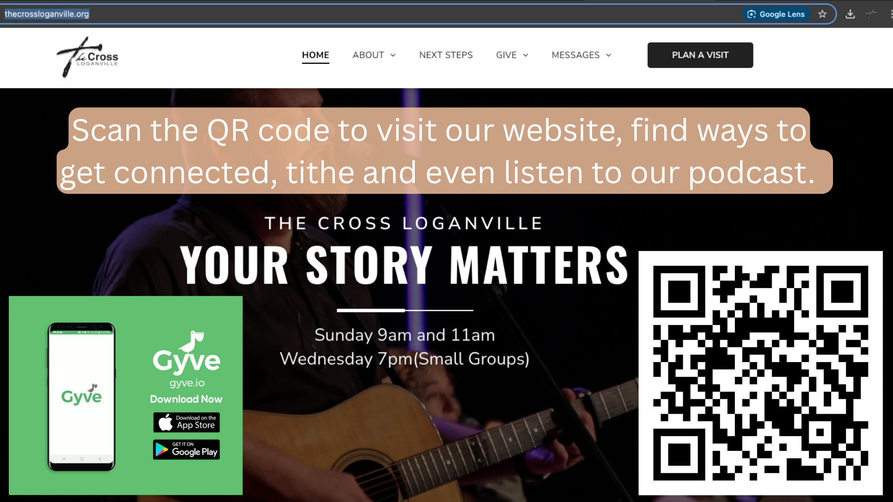
STAY CONNECTED



The Cross Loganville


Crossloganville
The Cross Sisterhood
Thecross_sisterhood

Contact Us

For questions or more information on
The Cross Loganville Small Groups, email Lisa Clotfelter:
lisa@thecrossloganville.org

The Cross Loganville
3275 Tig Knight Road, Loganville, GA 30052
770-554-3322
www.thecrossloganville.org

