Confirmation Handbook
2026-2027


Sacred Heart Church, Murdock
St. Francis Church, Benson
St. John, Appleton
St. Isidore the Farmer Area Faith Community

(Jesus) said to them again, “Peace be with you. As the Father has sent me, so I send you.” And when he said this, he breathed on them and said to them, “Receive the Holy Spirit.“ John 20:21-22



Preparing for the Sacrament of Confirmation is a process of discovery that welcomes young Catholics into a deeper relationship with God and into the life and mission of the Catholic community. The purpose of our Confirmation Program is to “mentor youth toward an intimate relationship with Jesus Christ, the Holy Spirit, and the Catholic Church.” The Confirmation preparation process is designed to fulfill this purpose by focusing on the following aspects: Mentorship, Faith Formation, Spiritual Renewal, and Discipleship.

Table of Contents
Mentorship:
Roles of the Parents, Sponsor, and Area Community 3
Faith Formation/Sacramental Preparation:
Faith Formation Classes, Mass Attendance 5
Spiritual Renewal:
Retreats 8
Discipleship:
Service Opportunities 9
Extra Notes 12
Confirmation Saint List 13
What Every Confirmed Catholic Should Know 18

Forms
All paperwork to be completed will be given to students kickoff night. They can also be found on the website www.stisidorethefarmerafc.org Please read through this handbook to answer all your questions!

Mentorship

Role of the Parents (Life-Long Mentors)
Parents are the first and primary catechist of the faith and are a vital role model for their children. Parents are encouraged to be strong leaders by continuing to learn, grow, and be active in their own faith. Within the sanctity of the family a child learns all about the family relationships that foreshadow the loving relationships within God's family. The Pope reminds Christians that "being family" means more than having dignity; it means taking responsibility and realizing the mission of the Catholic family. Children learn what they live, but first and foremost, they learn what their parents live.

During the preparation process we are asking teens to make a journey of discovery. A journey to discover the faith of our ancestors, the truth of God’s Word, and the reality of our faith lived out daily. We hope candidates will discover their own purpose and respond to God’s outpouring of love and the gifts of the Holy Spirit that are received in the Sacrament of Confirmation.

Expectations for Parents:
- Make time to pray for their son/daughter each day.
- Attend and participate fully in weekly/Holy Day Masses together.
- Help their son/daughter choose a suitable sponsor (see below).
- Help their son/daughter research a Saint/choose a Confirmation name.
- Help monitor their son/daughter’s progress toward completion of the Confirmation preparation commitments.
- Model Christian charity (love) and discipleship.

Role of the Sponsor (Spiritual Mentors)
Sponsors at Confirmation represent the believing Christian Community. Thus, it is required that they be a practicing Catholic in good standing with the Church and have themselves received the Sacraments of Initiation, which are Baptism, Holy Eucharist and Confirmation and have reached the age of 16. If you are having trouble choosing a sponsor please reach out to the faith formation director or Father Brian.
In addition to the above, sponsors must also meet the following criteria:
- They regularly participate in Sunday Mass and Holy Days of Obligation at their Catholic Church.
- They are an active member in the life of their parish to the best of their abilities.
- They are faithful to the teachings of the Catholic Church.
- Sponsors will continue to serve as a Spiritual mentor to their Candidate for their lifetime by being involved in their life of faith and being in regular contact, for example praying for and with their candidate regularly after Confirmation.

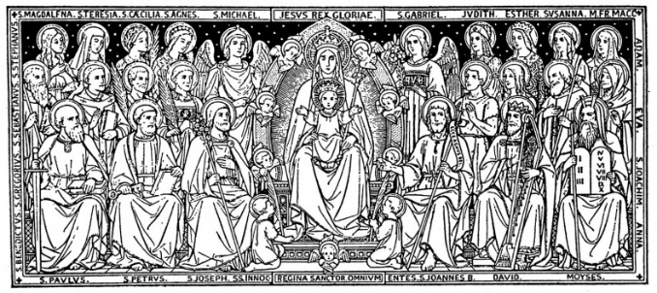
Saints (Unseen Mentors)
Candidates for confirmation are asked to choose a name of a saint in which they would like to be confirmed. A saint is someone who has gone before us marked with the sign of faith. They are a disciple of Christ who has lived a life of exemplary fidelity to the Lord, a life of heroic virtue. A patron saint provides us with a model of charity, and we are assured of their prayers for us. (CCC 2156) Choose a saint that is a patron and model that you would like to look up to. Candidates should choose a patron saint's name because of the attractiveness of the Christian life that that person led. The chosen Saint’s name will become the candidate’s Confirmation name.
This year we are asking all confirmands to complete a Saint Project. On the Hallow App, listen to the Confirmation Saints sessions and complete the accompanying worksheet for each session. Saint Project as well as your Saint Report are due on October 28. Pick up a Saint Project packet on kickoff night or you can find them on the faith formation website.

Candidates seeking the Sacrament of Confirmation commit to completing the following Mentorship milestones:

Select a Sponsor – Candidates will be given direction on methods to discern a sponsor who will guide them on their faith journey and help them complete the Confirmation Interview Questions Handbook.
Faith Sharing – Candidates & Sponsors will meet frequently throughout the preparation time, working to complete the handbook.
Select a Confirmation Name – Candidates will be given directions to research Saints, complete the packet, and discern and complete the saint report with a Confirmation name of significance to them.

Faith Formation –
Sacramental Preparation

Ongoing Faith Formation
As candidates prepare for Confirmation it is vitally important for them to continue to grow in knowledge and understanding of God’s word as well as the traditions, teachings, and practices of the Catholic Church. Our Catholic faith is vast in scope, rooted in centuries of theology, and rich in symbol, prayer, and practice.
One could study for a lifetime and still not fully know all that can be known about the Catholic Church or its teachings and traditions. During this preparation, Year 1 and Year 2 candidates will be participating in the CARITAS program.
Since class attendance is the main formation students receive, it is imperative that they are at all classes. If students miss a class for any reason, they are expected to make up the class on their own time. If students do not make up these class sessions, their Confirmation date may be delayed.
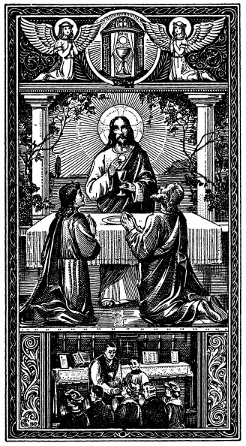
Mass: The “Source and Summit” of our Faith
For all Candidates and every Catholic, the Eucharist is an inexhaustible mystery to be loved and lived. It is a sacrament; it is a sacrifice; it is a meal; it is a liturgical celebration, a public proclamation of our faith in sign and symbol; it is the “source and summit” of our Christian experience (where we are fed for the journey and it is our destination). To become the person of faith that God has called us to be, we must seek Christ in the sacraments; we must seek Christ in the Eucharist at Mass.

Because the Mass is so important, it is an essential part of the Confirmation preparation. Thus, we want to help our Confirmation students to come to appreciate the beauty and the depth of the Mass. The first step to appreciating the beauty and the depth of the Mass is being present at Mass. The obligation to attend Sunday and Holy Day Masses is a responsibility for all Catholics. We expect all Candidates to understand and follow this teaching, which is based on the Third Commandment (Keep holy the Sabbath). Candidates desiring to be Confirmed are expected to attend Mass every weekend and Holy Day of Obligation.

Confirmation Interview Question Handbook
To prepare for Confirmation and all confirmands will be given a handbook to complete with their sponsor over the course of the preparation year. There are nights scheduled throughout the year for you to be together to work on the packets. If you cannot meet those nights, let Jess know ASAP and arrange another opportunity. It is up to you to complete the handbook. Below are dates that you and your sponsor can meet that are already arranged.
- Weekend of Oct.3/4 - pick one! Oct. 3rd following 5pm Mass in Murdock Pizza Night/Pictures/Sponsor Interview/Saint Project OR Oct 4th 9am before 10:30am Mass in Benson Donuts/Pictures/Sponsor Interview/Saint Project
- December Advent Adoration/Confession - Dates TBA
- January 6th following Family Mass Night
- Feb.10th following ASH Wed Mass
- February/March Lent Adoration/Confession- Dates TBA

Candidates seeking the Sacrament of Confirmation commit to completing the following Sacramental Preparation milestones:

Attend Mass weekly/Holy Days – All candidates preparing for the Sacrament of Confirmation are expected to attend Mass every week as well as Holy Days of Obligation.
Commit to ongoing Faith Formation –All candidates preparing for the Sacrament of Confirmation are expected to attend all classes and learn about the teachings and practices of the Faith by participating in Faith Formation classes. Any classes missed will need to be made up by visiting with the Faith Formation Coordinator.
Complete Interview Question Handbook – All candidates preparing for the Sacrament of Confirmation are expected to complete and study the handbook.

Mass Times

Any City in the United States: www.masstimes.org
(These times subject to change)

St Isidore the Farmer Area Faith Community
– Rotates every three months
https://www.stisidorethefarmerafc.org/

July-August-September 2026
Saturday 5:00 pm Benson
Sunday 8:30 am Murdock
Sunday 10:30 am Appleton

October-November-December 2026 Saturday 5:00 pm Murdock
Sunday 8:30 am Appleton
Sunday 10:30 am Benson

January-February-March 2027 Saturday 5:00 pm Appleton Sunday 8:30 am Benson Sunday 10:30 am Murdock

April-May-June 2027 Saturday 5:00 pm Benson Sunday 8:30 am Murdock Sunday 10:30 am Appleton

Spiritual Renewal - Retreats

Taking Time for God – Few people take time to be still and rest in God’s presence. But consider the Lord’s instruction, “Be still and know that I am God.” This is why the US Bishops feel that it is imperative that all candidates preparing for the Sacrament of Confirmation set aside a period of time so they can build an intimate relationship with the Lord. Retreats are wonderful opportunities to step away from life’s busyness and spend time reflecting more deeply on one’s relationship with God. They are meant to draw youth into a closer relationship with God and into a closer relationship with others. Retreats also serve to help candidates discern their response to God’s outpouring of love and how they will live the sacraments as a regular part of the faith community.

Retreat Options – Candidates may choose from numerous retreat options. The Faith Formation Coordinators will give each candidate a list of possible opportunities that qualify as retreat options, along with dates and further information. If you have an idea that is not on the list, please speak with the Faith Formation Coordinators prior to registering/attending to be sure that the experience qualifies.
Candidates seeking the Sacrament of Confirmation commit to
completing at least one Retreat experience:
Pre-Approved Retreat Experiences:
Diocese of New Ulm Confirmation Retreats
Nov 1 - Deanery 2 in Montevideo 10:30-4:30 Nov 15 - Deanery 3 in Olivia 10-4 Jan 24 - Deanery 1 in Sleepy Eye 9:30-3:30
NET Ministries Confirmation Retreat
Check website for weekend retreat dates https://www.netusa.org/mn-events#crw
Diocese of New Ulm Discipleship Camp
Camp Greatness (boys) – Summer 2027
Camp Beloved (girls) – Summer 2027
TEC-Together Encountering Christ - https://www.riverbendtec.org/
Riverbend TEC (Together Encountering Christ) is a three-day Catholic retreat experience focused on the Paschal Mystery: the death and resurrection of Jesus Christ. Check website for dates.
Steubenville Youth Retreat -
June and July 2027 dates TBA

Discipleship – Works of Mercy Project

“It is you young people that the task first falls of bearing witness to the Faith and bringing into the third millennium the Gospel of Christ, who is the Way, the Truth and the Life” --St. John Paul the Great.
As you prepare for Confirmation, it is vital that you understand that need for serving your fellow man as well as your brothers and sisters in faith. The Works of Mercy are powerful ways to serve others.
“The works of mercy are charitable actions by which we come to the aid of our neighbor in his spiritual and bodily necessities. Instructing, advising, consoling, comforting are spiritual works of mercy, as are forgiving and bearing wrongs patiently. The corporal works of mercy consist especially in feeding the hungry, sheltering the homeless, clothing the naked, visiting the sick and imprisoned and burying the dead” (Catechism of the Catholic Church 2447).
The Works of Mercy Projects are designed to provide those seeking Confirmation with opportunities to better understand the role that serving the needs of others plays in leading a Christ-like life and living out the Faith as Catholic adults. The Church calls on each of us to fulfill its mission of spreading the Gospel message and sharing the love God has shared with us through the teachings of Jesus. By completing your Corporal and Spiritual Works of Mercy project, you will experience a taste of the many ways the Catholic Church inspires us to love others, especially those most in need.
The Seven Corporal Works of Mercy: feed the hungry, give drink to the thirsty, clothe the naked, shelter the homeless, visit the sick, visit the imprisoned, and bury the dead.
The Seven Spiritual Works of Mercy: instruct the ignorant, counsel the doubtful, admonish the sinner, comfort the afflicted, bear wrongs patiently, forgive offenses willingly, pray for the living and pray for the dead.
For your Works of Mercy Projects, you will perform tasks relating to the Corporal and Spiritual Works of Mercy. You must complete 4 tasks in total: 2 Corporal Works of Mercy and 2 Spiritual Works of Mercy.
Each task should take about two hours cumulatively (so 1 hour for two days, 2 hours one time, 30 minutes for 4 days etc.). Please complete the Work of Mercy Project Form for each Work of Mercy you complete (You’ll have 4 in total). These can be filled out and emailed or turned into the Religious Education Office as you complete them.
Please note: You may only use tasks that you have completed since the start of the summer 2026 through the 2026-27 school year. Tasks done prior to this may not be used. You can refer to the reference page for suggestions on different works of Mercy that you can complete.
All Works of Mercy Projects are due by April 7, 2027

Works of Mercy References
The activities listed on this page are suggestions. You are not limited to these activities alone for your Works of Mercy Projects. Be creative! You can check the parish website or bulletin for more activities on how to serve. If you have a question about what might be acceptable, please contact the Religious Education Office.
Corporal Works of Mercy:
Feed the Hungry/Give Drink to the Thirsty: Volunteer at the food shelf, organize a food donation drive, and work in a soup kitchen.
Clothe the Naked: Do a winter coat drive, do a clothing drive, knit scarves for those in need, distribute winter clothing items to those in need.
Visit the Sick: Visit a nursing home, volunteer with an organization that connects you to have conversations with seniors, deliver groceries/needed items to the homebound.
Shelter the Homeless: Participate in a walk for the homeless, volunteer at a homeless shelter or host a drive for toiletries for a homeless shelter, create a meal or serve a meal at a homeless shelter.
Visit the Imprisoned: Collect paperback books to donate to a jail library, help work with restorative justice programs, write letters to politicians to end the death penalty.
Bury the Dead: Attend a funeral, visit a cemetery and pray for departed souls, assist with a bereavement luncheon – contact Sacred Heart CCW to get added to the list to help.
Spiritual Works of Mercy:
Admonish the Sinner: Gently correct someone who is misguided (this does not mean walk around and yell at a sibling)
Instruct the Ignorant: Assist in a Religious Education class for the school year, help a younger sibling with homework, help a younger sibling learn prayers, tutor someone younger than you, assist with VBS.
Counsel the Doubtful: Lend encouragement to someone who is feeling down, create cards for those who are hospitalized for mental health issues.
Comfort the Sorrowing: Make a card for someone who is ill or who has recently lost a loved one, work with organizations who help comfort those who lost their pregnancy.
Bear Wrongs Patiently: Discuss an occasion where you turned the other cheek.
Forgive all Injuries: Offer forgiveness/make peace with those that you struggle with.
Pray for the Living and the Dead: Attend the March for Life, Offer prayers for the souls in purgatory, attend a holy hour or a rosary or Stations of the Cross

Candidates seeking the Sacrament of Confirmation commit to
complete the Works of Mercy Project.

Works of Mercy Project (4 Tasks, 2 Corporal and 2 Spiritual, Minimum) – Each candidate commits to complete a total of 4 tasks for their local parish or within their Catholic Area Community
Works of Mercy Project Form – Candidates complete a Work of Mercy Project Form for each completed task, making a total of 4 forms, handed in to the faith formation office by April 7, 2027

Extra Notes …

Letter to Bishop - Towards the end of the second year, Candidates will be asked to write a letter to Bishop telling them of their desire to be confirmed in the Catholic Church. In this letter, you will write about your faith journey and make a statement about your beliefs. You will talk about your understanding of the Catholic Church and what gifts you bring to this Faith Community.

Interview – During the second year, Candidates will be interviewed by Father Brian. This is to ensure that they are ready to receive the Sacrament. Anything in the Confirmation Interview Handbook is fair game! Be prepared!

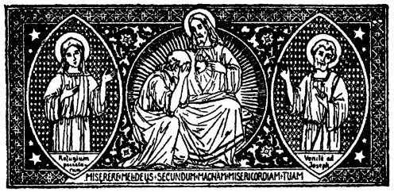
Sacrament of Reconciliation - “To receive Confirmation you should receive the sacrament of Reconciliation in order to be cleansed for the gift of the Holy Spirit” - Catechism 1310. Monthly reception of this sacrament is best. Throughout the 2 years of Confirmation Preparation, Reconciliation will be offered to students during Advent, Lent, and during the Confirmation Retreats, as well as at the Confirmation practice. Students preparing for Confirmation should attend the Sacrament of Reconciliation willingly whenever it is available. We will also offer the sacrament before the Confirmation Mass.

Dress Code for the Confirmation Mass - All candidates and sponsors are expected to dress appropriately. For young men: a pair of dress pants (no jeans), dress shoes, a dress shirt, and a tie. Suit coats or sports coats would be ideal, but optional. For young ladies: a nice dress or dress pants/dress top. Dresses should be at least knee-length or longer, and not low-cut, must have sleeves or a sweater.

Remember: This is a very special, holy, and sacred time, so please dress accordingly.

Confirmation – April 18, 2027 2PM Sacred Heart Church, Murdock

Year 2 Confirmation Checklist DATE

- Candidate Pledge Kickoff or Sept.23
- Candidate Baptismal Form Kickoff or Sept.23
- Sponsor Commitment Form Sept. 30
- Prep Meeting following Mass Oct. 3rd/4th (sponsors must attend)
- Saint Project and Saint Report Oct. 28
- Confirmation Retreat Nov. 1
- Advent Adoration/Confession December (TBA)
- Family Mass Night Jan. 6
- ASH Wednesday Mass w/sponsor Feb. 10
- Letter to Bishop Feb. 17
- Lent Adoration/Confession Feb./March (TBA)
- Interviews/Packet due April 7
- Works of Mercy Project April 7
- Confirmation Practice April 14
- Confirmation 2pm Murdock April 18

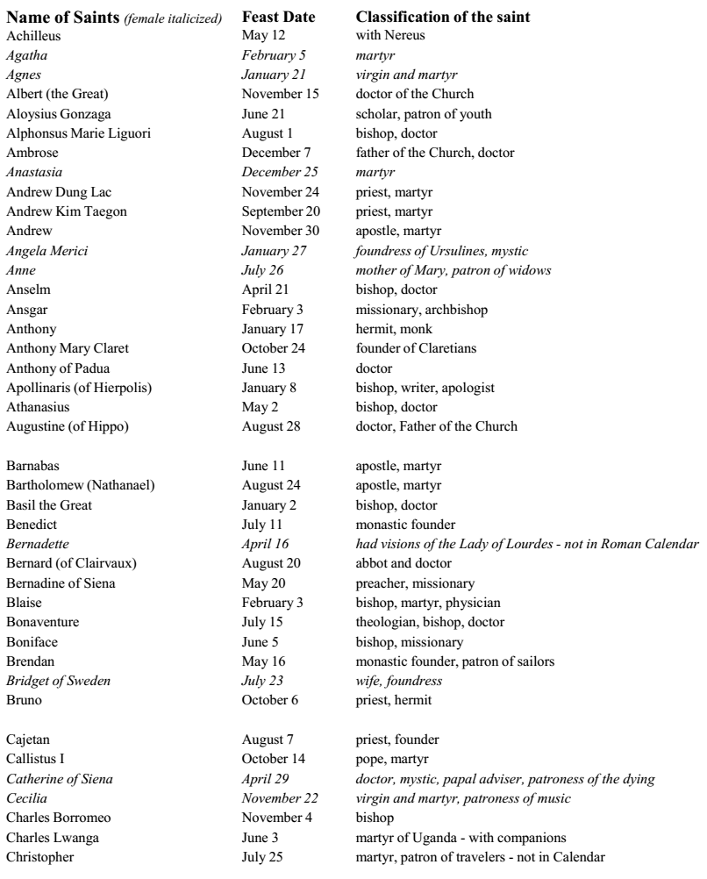
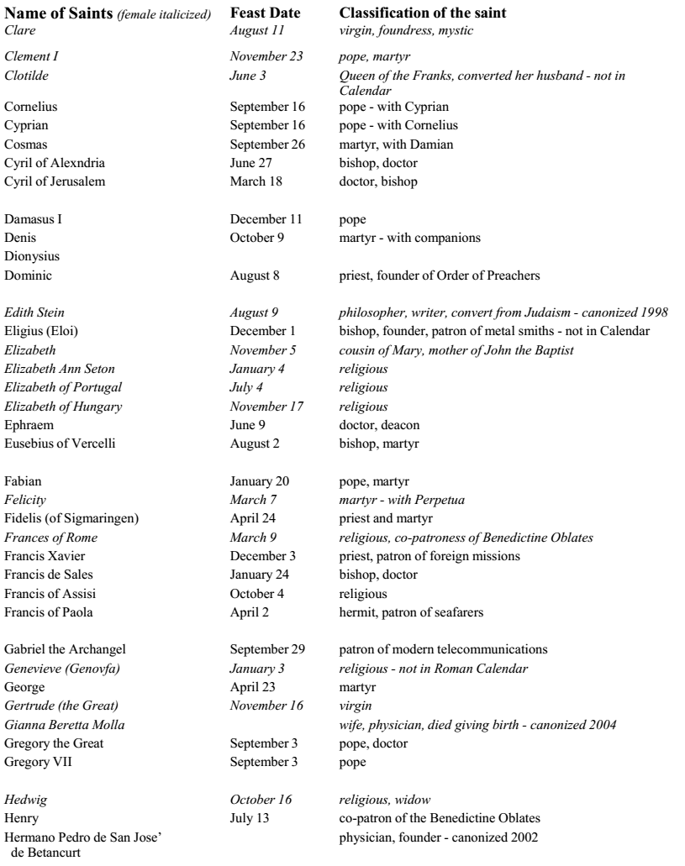
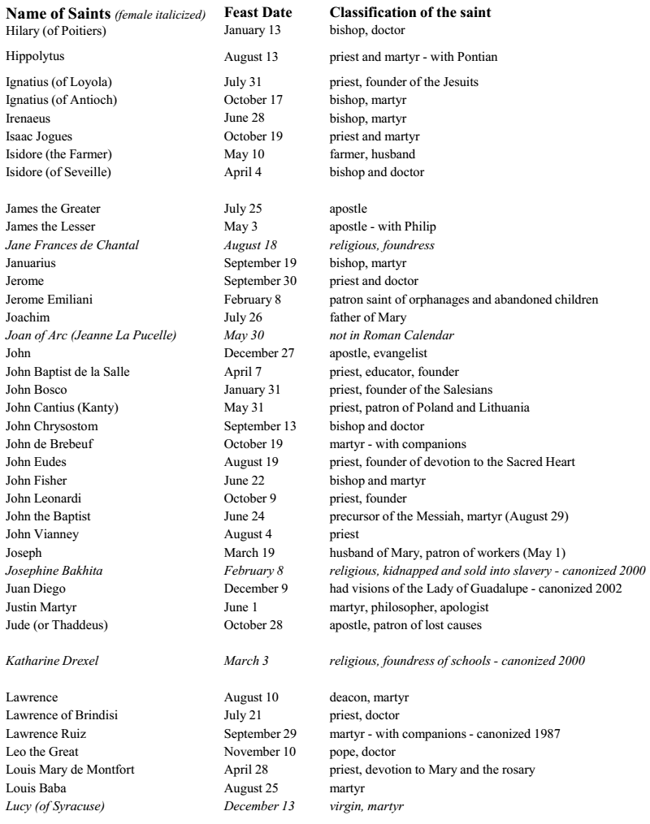
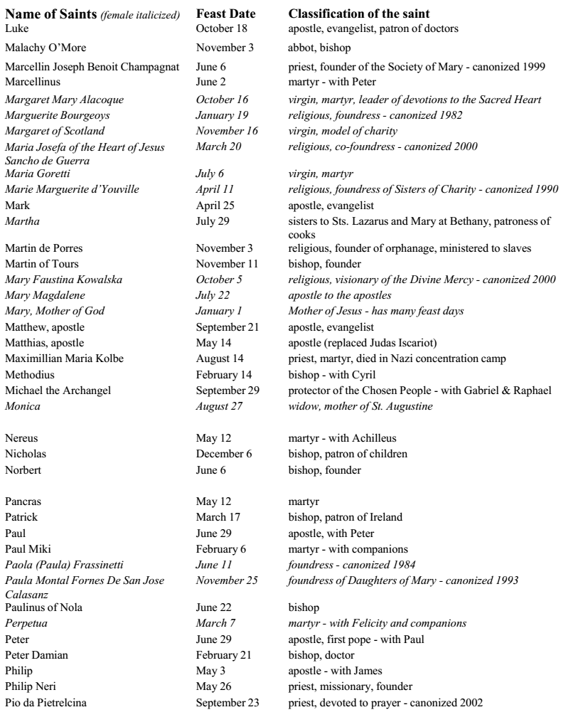
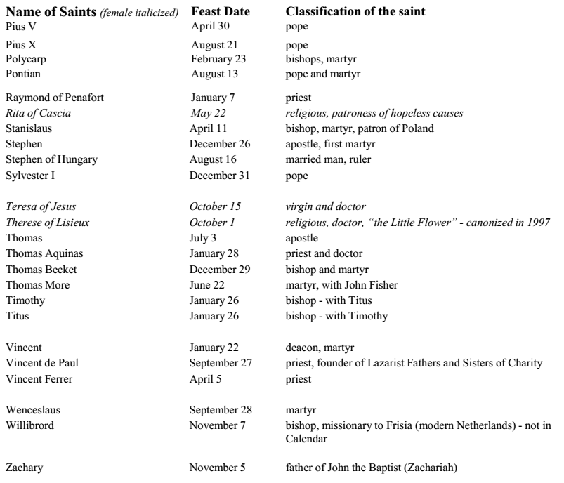

WHAT EVERY CONFIRMED CATHOLIC SHOULD KNOW

Who are the 3 persons of the Trinity?
God the Father, God the Son, and God the Holy Spirit

JOYFUL MYSTERIES OF THE ROSARY (Need to recite them in their correct order)
1. The Annunciation of the Angel Gabriel
2. The Visitation of Elizabeth
3. The Birth of Our Lord Jesus
4. The Presentation of Jesus in the Temple
5. Finding Jesus in the Temple

Sorrowful Mysteries of the Rosary (Need to recite them in their correct order)
1. The Agony in the Garden
2. The Scourging at the Pillar
3. The Crowning of Thorns
4. The Carrying of the Cross
5. The Crucifixion

Luminous Mysteries of the Rosary (Need to recite them in their correct order)
1. The Baptism in the Jordan
2. The Wedding at Cana
3. Proclamation of the Kingdom
4. The Transfiguration
5.The Institution of the Eucharist at the Last Supper

Glorious Mysteries of the Rosary (Need to recite them in their correct order)
1. The Resurrection
2. The Ascension
3. The Descent of the Holy Spirit upon the apostles
4. The Assumption of the Blessed Virgin Mary
5. The Crowning of Mary as Queen of Heaven and Earth

7 Capital Sins
Sloth Envy Gluttony Lust
Greed Anger Pride
6 Precepts of the Catholic Church
1. You shall attend Mass on Sundays and holy days of obligation.
2. You shall confess your sins to a priest at least once a year.
3. You shall humbly receive your Creator in Holy Communion at least during the Easter season.
4. You shall observe the prescribed days of fasting and abstinence.
5. The faithful also have the duty of providing for the material needs of the Church, each according to their abilities.
6. To obey the laws of the Church concerning Matrimony.

7 Sacraments
Baptism Confirmation Eucharist
Confession/Reconciliation Anointing of the Sick Matrimony
Holy Orders

What is the difference between a mortal sin and a venial sin?
For a sin to be mortal, it must be ALL 3 of the following: 1. be a serious sin, 2. you knew that it was a serious sin, and 3. you freely chose to do it.
A venial sin hurts your relationship with God, whereas a mortal sin is your choosing to turn away from God. cf. 1 John 5:17

The Beatitudes
Blessed are the poor in spirit, for theirs is the kingdom of heaven.
Blessed are the meek, for they shall possess the earth.
Blessed are they who mourn, for they shall be comforted.
Blessed are they who hunger and thirst for justice, for they shall be satisfied.
Blessed are the merciful, for they shall obtain mercy.
Blessed are the clean of heart, for they shall see God.
Blessed are the peacemakers, for they shall be called children of God.
Blessed are they who suffer persecution for justice' sake, for theirs is the kingdom of heaven.
Spiritual Works of Mercy
Counsel the doubtful.
Instruct the ignorant.
Admonish the sinner.
Comfort the sorrowful.
Forgive injuries.
Bear wrongs patiently.
Pray for the living and the dead.

Corporal Works of Mercy
Feed the hungry.
Give drink to the thirsty.
Shelter the homeless.
Clothe the naked.
Visit the sick.
Visit the imprisoned.
Bury the dead.
Give alms to the poor.
7 Gifts of the Holy Spirit
Wisdom Understanding Counsel
Knowledge Courage Piety/Reverence
Fear of the Lord/Awe and Wonder
ACT OF CONTRITION (this one or another memorized version)
O, my God, I am heartily sorry for having offended You, and I detest all my sins, because of your just punishments, but most of all because they offend You, my God, Who are all-good and deserving of all my love. I firmly resolve, with the help of Your grace, to sin no more and to avoid the near occasion of sin. Amen.

APOSTLES CREED
I believe in God, the Father Almighty, Creator of heaven and earth; and in Jesus Christ, His only Son, our Lord: Who was conceived by the Holy Spirit, born of the Virgin Mary; suffered under Pontius Pilate, was crucified, died and was buried. He descended into hell; the third day He rose again from the dead; He ascended into heaven, is seated at the right hand of God the Father Almighty; from thence He shall come to judge the living and the dead. I believe in the Holy Spirit, the Holy Catholic Church, the communion of Saints, the forgiveness of sins, the resurrection of the body, and life everlasting. Amen.

Two Greatest Commandments
1. Thou shalt love the Lord thy God with thy whole heart, and with thy whole soul, and with thy whole mind, and with thy whole strength;
2. Thou shalt love thy neighbor as thyself.

Who is Jesus Christ? (2nd person of the Trinity, fully God and fully man, born to Mary in Bethlehem, worked many miracles, taught us who God is and how we are to live, was crucified by Pontius Pilate 33 AD, rose from the dead, and is now seated at the right hand of God the Father)

Why is He important? (Because He is the savior—He is THEE only way to Heaven. He died for our sins and opened up the gates of Heaven for us. It’s now up to us as to whether we will accept this invitation to Heaven or not.)

What prayer did He teach us? (Our Father)

Who founded the Catholic Church? (Jesus Christ)

Where in the Bible did Jesus make Peter the 1st Pope? (Matthew 16:18-19, “You are Peter, and upon this rock I will build my church, and the gates of the netherworld shall not prevail against it. I will give you the keys to the kingdom of heaven. Whatever you bind on earth shall be bound in heaven; and whatever you loose on earth shall be loosed in heaven.”

How is the Catholic Church apostolic? (its teachings are completely consistent with that of the apostles, AND it has valid Orders going all the way back to the apostles themselves—Fr. Brian was ordained by a bishop, who was ordained by a bishop, who was ordained by a bishop, who was ordained by a bishop, who was ordained by a bishop, who was ordained by a bishop, who was ordained by a bishop, etc, etc, who was ordained by one of the apostles themselves, who were ordained by Jesus Christ, Himself !)

What is the goal of life? Where do you hope to go when you die? Tell me about the basic differences between Heaven, Hell, and Purgatory. (Heaven is the endless moment of love. Nothing more separates us from God, whom our soul loves and has sought our whole life long. Hell is the condition of everlasting separation from God, the absolute absence of love. Purgatory or the Final Purification – someone who dies in God’s grace (and therefore as peace with God and men), but who still needs purification before he can see God face to face.

What are examples of “serious sins”, that is, sins that could be mortal sins? (Murder, abortion, euthanasia (physician-assisted suicide), adultery, sex outside of marriage, contraception, sterilization, masturbation, pornography, missing Sunday Mass, getting drunk or high, etc.)

How can you be forgiven of a venial sin? (simply by asking for God’s forgiveness by praying the Our Father, or an Act of Contrition, or by calling it to mind at the beginning of each Mass)

What do you need to do to be forgiven of a mortal sin? (To be sorry for it and to confess it to a priest and receive absolution).

What happens if you die with a mortal sin on your soul that you have not Confessed or repented of?
(You choose to be eternally separated from God for all eternity; they would be choosing to go to Hell).

If a person has committed a mortal sin, but hasn’t gone to Confession yet, can they still receive Holy Communion? (No. They would be “eating and drinking condemnation upon themselves” cf. 1 Cor 11:27).

What should they do at Mass instead? (They could either stay in their pew and make a spiritual communion, or they could cross their arms over their chest and ask for a blessing instead of Holy Communion).

How do we especially receive God’s grace? (Prayer and the Sacraments)

What is a sacrament? (An outward sign instituted by Christ to give us grace)

Please talk about the meaning of Christianity to you with your sponsor and parents—Is it easy to be a Christian?
-What makes it difficult? (“Love your enemies,” etc.)
-How do our values differ from that of the world?

