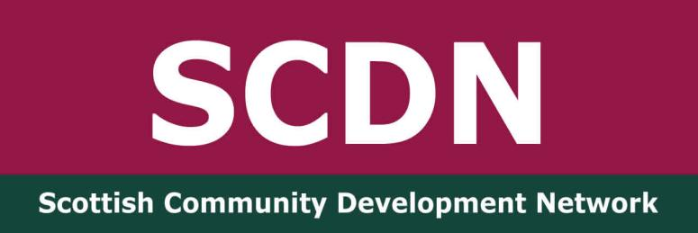

SCDN Greater Glasgow Network Meeting
Wednesday 5th November 2025
Crossroads Youth and Community Association

Present: Dave Donnelly, Digital Inclusion Lead – Mhor Collective, Fiona Ballantyne - Chair of SCDN, Fiona Herriot, Member Activator – Co-op, Izabella Sjue – SCDN Trustee, Susan Campbell – SCDN Consultant,

Apologies: Anne-Marie Gorman - SCDN Trustee, Colette McLure – SCDN Trustee, Frankie Frankgate, Community Worker – Crossroads Youth and Community Association Jodie Armour, Community Development Assistant – Cassiltoun Housing Association, ,

Welcome and SCDN Update
Susan welcomed everyone to the meeting and introductions were made. The conference and AGM took place on 23rd October and all at the meeting had attended. Dave fedback that it was enjoyable, and the discussions were useful and energising. Izabela joined the SCDN board at the AGM alongside Graeme McConnel-Campbell, one of our Ayrshire network members. She particularly enjoyed Ria Dunkley’s input. Fiona H enjoyed the workshops and the day in general. It had been useful to network and meet new people and bring the Co-op agenda to the table.

We discussed the fact that any work on climate justice should be linked to social justice. The notes from the conference will be compiled alongside the evaluations. We hope to pull together a SCDN statement on climate justice from the feedback.

We should hear if we have a further year’s funding by December. With support from the Accelerate programme, a further funding application with Creative Scotland has been submitted. Funding continues to be an issue for SCDN, as it is for so many smaller organisations.

Home Energy Scotland has been in touch with Susan to ask if they can attend network meetings to promote how they can help communities cut energy costs. It was agreed that it would be useful for them to attend the next meeting.

General Updates and Discussion
A discussion took place about the challenges of funding. Dave highlighted how challenging the application process had been for the Glasgow Community Fund and that lots of organisations didn’t get funding because of this. Fiona B stated that the funds were distributed to large organisations with many community-based organisations, rooted in delivering in the community, missing out. It would be useful to reflect on this at the next meeting.

Fiona H fedback that the Co-op has agreed its priorities for the new Local Community Fund over the next 12 months. While it’s not a lot of money, it’s an important fund for local groups.

Dave is working on a digital inclusion project in partnership with Glasgow Life over the next two years. The focus is on digital literacy and how to stay safe online. This aupport is open to community groups. He is also offers a drop in at the Love and Solidarity project based in Castlemilk Shopping Centre every Monday between 12pm and 2pm to answer any digital questions. This is a great free space, volunteer-led food activism group known as the ‘Soup"erheroes’. He is also offering digital support in an asylum hotel on Tuesday.

Crossroads has recently employed a Digital Inclusion Worker and Fiona B will link with Dave about this. Izabel highlighted how difficult it is to know if young people are safe online. Dave suggested Aye Mind Conversation Tool Kit as a good resource and a discussion took place about A I and how it is affecting all our lives.

Greater Glasgow Network
The number of people attending the network has been falling and we discussed how we can encourage more people to attend. Susan highlighted that a number of emails for the group bounce back and we worked through the list to see if anyone knew their circumstances. It was agreed that we will all think about contacts we have who may wish to join the network. Dave suggested the following organisations and will forward details to Susan - Govanhill Community Development Trust, Govanhill Baths and Ardenglen Housing Association. He also stated that the Southeast Integration Network could promote the network amongst their members.

Date of Next Meeting - Wednesday 4th February 2026 at 2pm at Co-op Funeral Care (Wylie and Lochhead), 27-31 Southwood Dr, King's Park, Glasgow G44 5SH. You can register here

