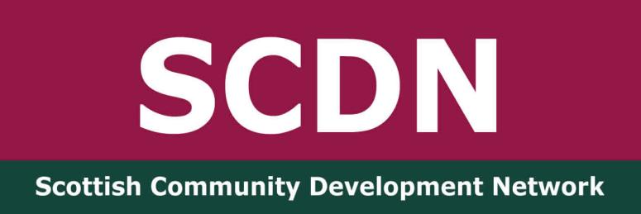

SCDN Greater Glasgow Network Meeting
Wednesday 23rd July 2025
Crossroads Youth and Community Association

Present: Fiona Ballantyne -SCDN board member, Frankie Frankgate, Community Worker – Crossroads Youth and Community Association/Chair of SCDN, Izabela Sjve, community member, Sean Ewart, Community Worker – NSPCC, Susan Campbell – SCDN Consultant,

Apologies: Anne-Marie Gorman, SCDN Board Member, Brian McQuillan, Locality Planning Officer – Glasgow City Council, Colette McLure, Community Connector – Thriving Places/SCDN board member, Fiona Herriot, Member Activator – Co-op, Jodie Armour, Community Development Assistant – Cassiltoun Housing Association,

Welcome and SCDN Update

Susan welcomed everyone to the meeting and introductions were made. She spoke about the purpose of the network offering community development practitioners a space to share resources, information, practice issues and offer support.

We have networks in Dunbartonshire, Fife, Ayrshire and Greater Glasgow, organise an annual national conference and our members receive a monthly bulletin with updates on community development events, policy and relevant information. Membership is free and you can take it out here. The more members we have the stronger our voice is in promoting community development.

We have a new Chairperson, Frankie Frankgate, who has taken over from Fiona Ballantyne. Fiona remains on the board as a trustee.

This year’s national conference will take place on Thursday 23rd October at the Pyramid at Anderston. The theme is Climate Justice. The venue is near Anderston Station and taking public transport is advisable as parking in the area is expensive. You can register here

The AGM will take place on the same day during the first half hour of the event. We have vacancies on the SCDN board and are particularly keen to recruit practitioners with funding and IT skills. Susan asked that people highlight this to colleagues and contacts and to contact her for more information.

The additional support from the Accelerate programme has just started so Susan hopes to be able to start working on the new membership system with this help.

Our new strategy covering 2025 – 2028 is now on the ‘About Us’ page of our website here

Fiona highlighted that as a member led organisation, we actively seek the views of our members though our networks and conferences to inform our work.

Isabela asked if we have seen progress through our work. Fiona stated that in the wider context things are challenging with community development not valued. We do, however, help our members with support and offering a safe space to come together. A discussion took place about the challenges of mobilising communities as they are struggling to get by. There are also ongoing issues with funding.

Greater Glasgow Network Updates
Sean is currently working with young people covering school holiday activities. Glasgow City Council cut the funds across the city which has had an impact, but he is supporting 80 children per week.

Frankie continues to work on the Youth Leaders project and community led climate justice work. He and Sean are working with a men’s group which is refocusing on how they can look after themselves and emotionally regulate. The Gorbals is 4 degrees warmer than the rest of Glasgow and the work he is doing with the community to analyse this has the potential to influence future planning and building.

Isabela asked what services there are for young people and Sean and Frankie highlighted the Gorbals Youth Café, the Givin’ it Laldy project and the Citizens Theatre. A discussion took place about the need for services to support young people who are addicted to gaming and support with their emotions. Frankie will speak to the Youth Worker at the Crossroads and Sean highlighted that there are good resources on the NSPCC website.

Frankie was thanked for hosting today’s meeting.

Date of Next Meeting – Wednesday 5th November at Co-op Community Room, 190 Crown Street, Gorbals, Glasgow, G5 9ZR. You can register here

