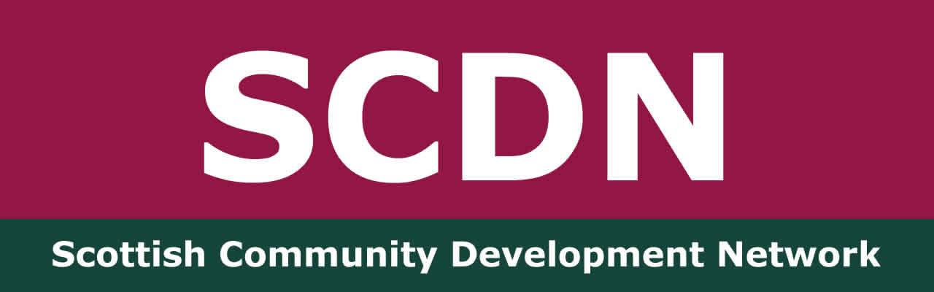

SCDN Greater Glasgow Network Meeting
Wednesday 22nd May 2024
Drumchapel Community Centre

Present: Anne-Marie Gorman, Community Development Officer – Glasgow City Council, Brian McQuillan, Locality Planning Officer – Glasgow City Council, Colette McLure, Community Connector – Thriving Places/SCDN board member, Dave Donnelley, Digital Inclusion Leader – Mhor Collective, Fiona Ballantyne - Chair of SCDN, Janet Weir, Community Development Officer – South Lanarkshire Council/SCDN board member, Jonny Howes, Community Services Officer – Glasgow Life, Julie MacLeod, Community Services Officer – Glasgow Life, Mark Langdon, Lecturer – University of the West of Scotland, Michelle Donaldson, Community Connector – Thriving Places, Susan Campbell – SCDN Consultant, Ted Scallion, Community Connector – Thriving Places.

Apologies: Lauren Engall, Children’s Services Practitioner – NSPCC.

Welcome and SCDN Update

Susan welcomed everyone to the meeting and introductions were made. She spoke about the purpose of the network offering community development practitioners a space to share resources, information, practice issues and offer support. We have networks in Dunbartonshire, Fife, Ayrshire and Glasgow, organise an annual national conference and our members receive a bulletin every fortnight with updates on community development events, policy and relevant information. Membership is free and you can take it out here. The more members we have the stronger our voice is in promoting community development.

SCDN’s national conference will take place this year on Friday 25th October at Townhead Village Hall and Susan asked the group to save the date. Our AGM is likely to be a separate online event on 7th October, but she will confirm details of this as soon as they are available.

Greater Glasgow Network

Susan fedback the Lauren had put her apologies in for today’s meeting, but had asked that she share information about free training the NSPCC is offering to help keep children safe. ‘Listen Up Speak Up’ training will be running until the end of the year. It is a Scotland wide one hour session offered in person or online. It supports practitioners to understand how to listen and speak up on behalf of children and who to contact if you are concerned about a child or need support yourself. Susan will circulate the poster Lauren sent and for more information and to book a session you can email Lauren - Lauren.Engall@nspcc.org.uk

At the last meeting we discussed making links with other organisations such as the Chair or Youth Scotland and Common Weal. Fiona has followed this up. We also felt it important to link with practitioners in housing associations, Glasgow Life and health to find out more about the work they do in CD that is aligned with the values of the network.

We discussed how we can create a new dialogue and create political buy in and also the potential for a sub-group to take up some of these ideas in-between meetings.

A discussion took place about moving these actions forward. Janet fedback that It can be challenging having time to do the statutory part of work as well and the CD part. Mark asked about the funding situation with SCDN. Our Corra funding takes us to the end of March 2025. Seeking future funding is a priority for SCDN too.

Mark suggested potential speakers for the SCDN conference stating that political literacy is at the heart of CD. He suggested Calum McGregor who is researching this. He also shared that links could be made to climate justice and the treatment of refugees.

Fiona fedback that she has been in touch with Craig Dalzell of Common Weal who has agreed to speak at the conference as we are looking at a theme around democracy. Janet has also asked Councillor Chalmers, COSLA Spokesperson for Community Wellbeing from South Lanarkshire to speak. Susan asked Mark to send her a brief description of his ideas that she can take to the next board meeting on 17th June.

Ted asked for ideas with linking climate justice, multi-cultural communities and displacement with what’s happening on the ground and linking it to global issues. Susan will link Ted with one of SCDN’s members who has been leading on climate justice work in North Ayrshire.

It’s about bringing people together to talk about collectivism not individualism with collective responsibilities and collective rights. Hearing real life stories has a big impact and opens up dialogue. There is no space for people to reflect on their experiences outwith blaming themselves. We know what to do – we need to collectively make the changes.

It was agreed that the sub-group would be made up of Janet, Anne-Maire, Mark and Dave and Janet will support the group to draw together a plan. Dave fedback that we need to be working on the root causes rather that a sticking plaster approach. The Mhor Collective are working on a Manifesto as to why they do what they do and why we get out of bed in the morning which they are calling ‘This is our thing’. Perhaps the network needs something similar.

Julie asked about SCDN’s links with the Scottish Government to highlight these issues. We are currently working on strengthening these as we recognise we have so much valuable feedback from our members and don’t want this to get lost. As ever, it comes down to where we are able to priorities our time against limited resources.

Brian highlighted that funding is always an issue with it being ringfenced, short term and there being a lack of sustainability. This led to a discussion on The Robertson Trust which has just awarded SCDN £2,000 towards the cost of this year’s conference. Mark suggested that Jim Robertson could be another potential speaker.

Janet and Mark attended the CLD Standards Council conference which highlighted the review of CLD. There is now a ‘have your say’ follow up. CD isn’t with the Education department so was not part of the review.

We agreed that the best way to take things forward is for the sub-group to highlight the issues raised at these network meetings and look at ways these can been taken to the Scottish Government.

Mark spoke about the Employees Reference Group, set up to ensure graduates are meeting the standards required of CD workers. The UWS is interested in hearing from practitioners and to get feedback on what the training should look like. If you are interested in joining the group, contact Mark and the next meeting is in October.

Date of Next Meeting - Wednesday 21st August from 2-4pm, Mark will ask Kingsway Wellbeing Centre if they can host.

