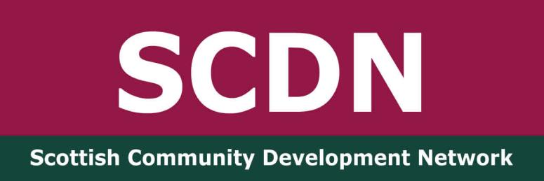

SCDN Greater Glasgow Network Meeting
Wednesday 22nd January 2025
Crossroads Youth and Community Association

Present: Ahlam Souidi, Senior Community Development Worker - Freedom from Torture, Colette McLure, Community Connector – Thriving Places/SCDN board member, Fiona Ballantyne - Chair of SCDN, Fiona Herriot, Member Activator – Co-op, Issie Wilson, Activate Tutor – University of Glasgow, Jodie Armour, Community Development Assistant – Cassiltoun Housing Association, Frankie Frankgate, Community Worker – Crossroads Youth and Community Association, Sean Ewart, Community Worker – NSPCC, Shonagh Hendry, Community Development Officer, Age Scotland, Susan Campbell – SCDN Consultant, Ted Scallion, Community Connector – Thriving Places.

Apologies: Anne-Marie Gorman, SCDN Board Member, Brian McQuillan, Locality Planning Officer – Glasgow City Council, Chani Bond, Community Development Officer – Givin’ it Laldie, Dave Donnelly, Digital Inclusion Leader – Mhor Collective, Janet Weir, Community Worker/SCDN Board Member.

Welcome and SCDN Update

Susan welcomed everyone to the meeting and introductions were made. She spoke about the purpose of the network offering community development practitioners a space to share resources, information, practice issues and offer support.

We have networks in Dunbartonshire, Fife, Ayrshire and Greater Glasgow, organise an annual national conference and our members receive a monthly bulletin with updates on community development events, policy and relevant information. Membership is free and you can take it out here. The more members we have the stronger our voice is in promoting community development.

We are hopeful that we have another year’s funding starting from April this year and should know for sure by February. We have a board development day on 1st February to review our strategy and plan for the next year.
We have been working with the Accelerate Programme which has been really useful in helping us review our systems and find cheaper options moving forward. It’s likely we will be doing a full membership audit asking everyone to rejoin SCDN so we have a more accurate idea of our membership numbers.

Fiona updated the group on joint partner meetings that have taken place between SCDN, CDAS, IACD and the Scottish Government to discuss how we can work in partnership. A discussion took place about this and Ted stated that it would be useful to explore the potential bridge between IACD working on international issues and the local issues communities and network members are involved in. The next meeting is on 4th February.

Greater Glasgow Network Updates

Fiona updated the group on her work as Member Activator engaging with Co-op members. The top five areas that have been identified in terms of member activity are Newton Mearns, the Gorbals, Castlemilk, Dennistoun and Ibrox.

Her work follows a calendar for the year and they are currently working on Warm Welcomes and Time to Talk through conversation cafes. This year celebrates 180 years of Co-op. The Community Donations funds offer small grants between £150 - £200 to grassroots organisations and the Local Community Fund opens in May. For more information you can contact Fiona - Fiona.Herriot@coop.co.uk

Sean is working on a Men’s Wellbeing group as a joint venture with Frankie in the Gorbals. He highlighted that Glasgow Club offers free six week passes to encourage people to exercise and this is particularly useful for young people during the holidays. He is looking for contacts and Ted will connect him with the Drumchapel Men Matter group.

Jodie fedback that a number of groups she works with are now self-supporting due to a cut in funds. They no longer receive the Glasgow Community Fund and she is looking for funding ideas. A discussion took place about the flaws in funding and how it is being centralised across Scotland. Larger organisations are accessing funding while grassroots organisations are missing out. Policy supports local democracy and community empowerment, but resources don’t match.

Ahalm’s team has been reduced from four to just herself. Freedom from Torture supports survivors of trauma and relies of donors to remain independent. There were five offices across the UK, but the Newcastle and Birmingham offices are closing, leaving London HQ, Manchester and Glasgow.
Ahalm covers the whole of Scotland supporting asylum claims as well as offering psychological support and taking people through the whole process. A discussion took place about westernisation and the need to respond to a multi-cultural society. You can make a referral on their website here

Frankie fedback that a Welfare Rights Officer will be coming into Crossroads on the last Friday of every month. He is working with Creative Climate Futures as there is an umbrella effect over the Gorbals due to climate change and not enough green spaces which keeps the temperature 4 degrees higher than other parts of Glasgow. They are funded to work on this for a further year with support also coming from SCDC.

Ted is working on the best way of occupying community spaces. They are tackling waste and will have a pantry and school uniform recycling project as reusing and recycling is the way forward. The theme for international Women’s Day this year is Accelerate Action. There will be a march in Drumchapel the day before on 7th March and lots of different activities in the community centre.

Shonagh has a Glasgow wide remit supporting sixty different groups. Some people in the groups are now wanting to step down and she is working to bring new people on board. Membership of Age Concern is open to anyone over 50. It lasts for three years and runs out in March and she will be carrying out a members consultation at this time too. There is a membership fund open to members and a vast number of resources on their website here

Colette has a new remit with a child poverty focused. She covers Parkhead, Dalmarnock and Barrowfield and her work is place based focused and a Local Place Plan will be developed. Frankie suggested that a Community Action Plan may be more effective and he and Jodie can share their Place Standard tools with Colette. She is also working on climate action and with a bike project that repairs bikes to give to the community.

Issie requested that the following information be shared in the notes.

People's Palace 'pop-up' exhibitions across the city between June to November.

If there is a pop-up event being organised by Glasgow Life in your neighbourhood/centre that you notify/involve us- the Friends of People's Palace Winter Gardens and Glasgow Green. They are still campaigning to make sure that the restoration goes ahead and that the Winter Gardens re-opens as a 'Winter Garden'. More information can be found here

Date of Next Meeting - Wednesday 23rd April at Crossroad Youth and Community Association, The Barn Youth Centre, 37 Abbotsford Place, Gorbals, Glasgow, G5 9QS from 2-4pm. You can register here

