November 9, 2025
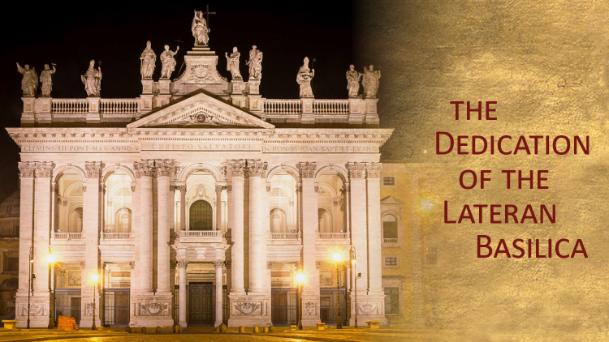
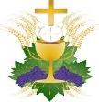
Mass Intentions
SATURDAY [08]
4:00pm +Robert Avery by wife, Irene & Family
SUNDAY [09]
8:30am +Doyle & Marie Smith by Doyle & Connie Smith
10:30am +Giacomina Meduri by Joanne & Paul Rossi
MONDAY [10]
8:00am +Dennis Nemchick by Mark Nemchick
TUESDAY [11]
8:00am +Victoria Pritchard by Maureen & Patrick Bozzuto
WEDNESDAY [12]
8:00am +Jozef & Jadwiga Polowczyk by Barbara Okula
THURSDAY [13]
8:00am +Catherine Krautkremer by Krautkremer Family
FRIDAY [14]
9:15am living and deceased members of the parish
+ + +
SATURDAY [15]
4:00pm +Teribio Cuono by Denny & Briedy
SUNDAY [16]
8:30am +Louis Snoha by Family
10:30am +Tom Zeiner by Donna Betz
(“+” before name indicates person deceased)

Ministers of the Altar – November 15/16
Altar Servers
4:00pm Michael Webber
8:30am Landyn Myers, Frankie Rowley
10:30am Natalie Chuisano, Elliana Roberts
Eucharistic Ministers
4:00pm Ann Weaver, Heather Webber
8:30am Debbie Muller, Jo Bullock
10:30am Jeff Detzi, Jeanne Smith
Lectors
4:00pm Domenic Scarlese
8:30am Frances Rowley
10:30am Lelia Topalanchik

CONFESSION TIMES Saturday 2:45pm – 3:30pm. Confessions are available after the Saturday Vigil Mass upon request, or any time by appointment.

Victim Assistance - Office of Safe Environment
Pamela J. Russo, M.S.W, M.S. Secretary, Youth Protection and Catholic Human Services P.O. Box F, Allentown, PA 18105-1538 610-871-5200 ext. 2204 prusso@allentowndiocese.org
The next Altar Minister schedule is to be made for Please let Philomena Reduzzi know if there are any changes or unavailability by November 17th. Contact Philomena at reduzzi@rcn.com or 610-863-9908.

(for next weeks bulletin)
The Christmas schedule will be included in the next schedule. If you are chosen for either the Christmas or New Years Mass and are unable to fulfill it please kindly find a replacement. Thank you.

Advertiser of the Week
Fiore Funeral Home
John A. Fiore, Funeral Director
www.fiorefuneralhome.com * 610-588-2233
230 Market St. * Bangor, PA

Please patronize our bulletin advertisers!

$$$ FUND RAISING $$$

Please consider purchasing Weis cards. You do not lose a penny of purchasing power and the church receives 5% profit.

Weis Cards are available by calling the Parish Office M-F from 10 A.M. to 2:30 P.M.

Congratulations to Kevin Cantor, winner of the 200 Club on November 2, 2025.

Weekly Collection
Our 4-week average collection for 11/02/2025 was $6107.00 with 189 envelope and online donations. Thank you for your support of our Parish!

Our budgeted weekly collection for this fiscal year (2025-2026) is $6731 per week. Last week’s averaged collection represents a shortfall of just $624.00. If the 189 donations were increased by $3.30 each, there would be no budgeted shortfall.
Will you please prayerfully consider an increase in your weekly donation? Thank you!

Christmas Cookie Extravaganza Fundraiser
Third Sunday of Advent -Dec 14, 2024

We will meet again for our Cookie Fundraiser mid-November before Thanksgiving.
Please watch the bulletin for date and time!

Volunteer Bakers are still welcome! If you are willing to bake, please send an email to Msgr. Koons @ TKoons@allentowndiocese.org. OR: Call Donna at the Parish Office, 610-863-4777.

Please consider baking a minimum of two varieties of cookies, four to six dozen of each. The more the better!
So far, we have 30+ bakers, 45+ varieties and 325+ dozen of cookies. Thank you for such a great participation!

Join Us for Bible Study with Monsignor Koons: “The Advent of the Messiah”

Next meeting: Thursday, November 13 @ 7pm

Those who have handed in a picture of loved ones for the All Souls display may pick up your original photo from the Parish Office between 9:30 – 3:00 M-F. If you are unable to come during those hours, please call Donna at the Parish Office for other arrangements.

The St. Elizabeth/St. Joseph's Ministry food truck will be in the church parking lot the Third Sunday of each month collecting non-perishable food items for the needy in our area. With the holidays quickly approaching items in need are canned fruit (no applesauce needed please), peanut butter, strawberry & grape jelly, tuna, soups cereal (no Cheerios needed), pasta, (no spaghetti needed), plastic bottles of apple & grape juice, coffee, ramen noodles, ravioli, beefaroni (pop off lids preferred).
If anyone would like to donate a Thanksgiving turkey, they may drop it off in the basement of the Old St. Joseph's Church, 231 N. Lehigh Ave. Wind Gap on Friday November 21st. between 1:30 & 3:30.
Thank you!

Diocesan Youth Rally -- NOW WELCOMING 7TH AND 8TH GRADERS Join us on November 22, from 10 a.m. to 5 p.m., at Bethlehem Catholic High School for a day of inspiring presentations, heartfelt prayer, uplifting music, and more, featuring Paul J. Kim, Catholic speaker and comedian. Together with your peers, you will celebrate the one true Light—Jesus Christ—and let His love “Reignite” you. The closing Mass at 4 p.m. will be celebrated by Bishop Alfred A. Schlert. Families are invited to join. $10 registration includes lunch. Questions? Contact Zelenda Hodgskin at zhodgskin@allentowndiocese.org. Register here.

Don’t forget to save your Weis shopping receipts and drop them in the “Weis Receipts” basket located in the Gathering Space. Thank you!

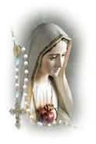

The Rosary is prayed publicly before all weekday morning Masses and Thursday’s, at 3 p.m. Do you have a ‘Special Intention’ whom you would like to be prayed for? Fill out a prayer request form located on the side tables in the vestibule, then place it in the basket next to the statue of the Blessed Mother.

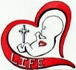
“We cannot diminish the value of one category of human life the unborn without diminishing the value of all human life.”
-President, Ronald Reagan

The St. Elizabeth of Hungary Memorial Society is an opportunity to have your departed loved ones prayed for once a month in a Mass. The next Mass for members of the Memorial Society will be offered Saturday November 22, 2025, at 4:00 P.M. Once enrolled, those in the Memorial Society will be prayed for each month and need not be reenrolled again.
Please pray for the sick… Janet Abitabilo, Liza Bonisese, Anna Fiorot, Kathleen Gerenser, Tina Lohman, Millie Popovice, Joan Quinnan-Flory, Ryan Savage

Forming a Parish Vocations Committee
The topic of our Diocesan Priest Convocation this past week was Priestly Vocations in the Diocese of Allentown. Our Diocese is embarking on a concerted effort to promote Vocations to the Priesthood in our Diocese from amongst the families of our parishes. EVERY Parish will be forming a Vocations Committee, and the first focus will be on encouraging vocations to the Priesthood. To that end, the Diocese of Allentown is sponsoring a workshop on SATURDAY, NOVEMBER 22, 2025 from 8am to 3:30pm at Saint Mary Church in Kutztown, PA. The workshop is entitled: “HOPE FOR THE HARVEST: OUR PLAN to BUILD A CULTURE OF VOCATIONS.”
The workshop is designed to help EVERY PARISH in the Diocese to start a Vocation Ministry Team. As Catholics, we need to pray for vocations to the priesthood and religious life, but we also need to promote vocations through identification of potential candidates, invitations to “discernment,” and support of candidates and seminarians.
Please prayerfully consider your participation in this transformative work of our Parish and our Church. Your participation can help to cultivate a harvest of vocations, enriching our parish and the Catholic Church in the Diocese of Allentown.
Consider attending this important workshop on Saturday, November 22, 2025. Please call the Parish Office or email Msgr. Koons at
TKoons@allentowndiocese.org if you are interested, and we will ensure your registration for this workshop.
During the week of January 12, 2026, we will be having daily Exposition and Benedicaiton of the Blessed Sacrament to Petition the Lord to send us more priestly vocations. Details will follow after Christmas.
Also, a first meeting of our Parish Vocations Team will be held on Thursday, December 11, 2025 at 6:30pm in the Social Hall. Please prayerfully consider attending. WE NEED MORE PRIESTS! The Lord calls, but YOU can help make a young man HEAR that CALL! Thank you!

