Christ the King
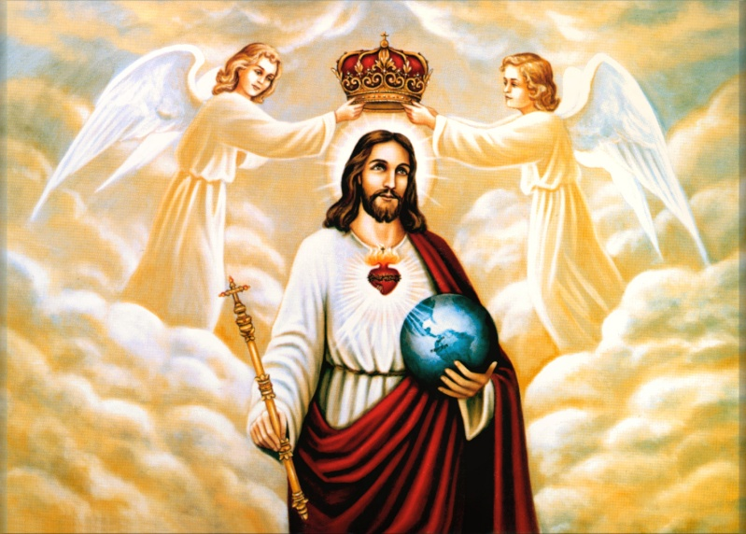
November 23, 2025
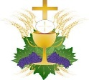
Mass Intentions
SATURDAY [22]
4:00pm for those enrolled in Memorial Society
SUNDAY [23]
8:30am +Jim Gum by Family
10:30am +Janet Yurescko by Krautkremer Family
MONDAY [24]
8:00am +Dennis Nemchick by Mark Nemchick
TUESDAY [25]
8:00am living and deceased members of the parish
WEDNESDAY [26]
8:00am +Bill & Ann Moore by Joseph Lathrop
THURSDAY [27] (Happy Thanksgiving)
9:00am Special Intention by Krautkremer Family
FRIDAY [28]
NO MASS
+ + +
SATURDAY [29]
4:00pm +David A. Perin by Roger & Anna Bet
SUNDAY [30]
8:30am +Allen Stewart by Glenn & Susan Fishbough
10:30am +Vic Cesare by Family
(“+” before name indicates person deceased)

Ministers of the Altar – November 29/30
Altar Servers
4:00pm Jaxon Ellis, Jordyn Ellis
8:30am Jane Duckworth, Henry Duckworth
10:30am Julian Lohman, Landon Myers
Eucharistic Ministers
4:00pm Charles DeBellis, Philomena Reduzzi
8:30am Joseph DePue, Philomena DePue
10:30am Sr. Maria Juveneeh, Sr. Maria Luz
Lectors
4:00pm Joseph Lathrop
8:30am Joseph DeFrank
10:30am Robert Pecca

CONFESSION TIMES Saturday 2:45pm – 3:30pm. Confessions are available after the Saturday Vigil Mass upon request, or any time by appointment.

Victim Assistance - Office of Safe Environment
Pamela J. Russo, M.S.W, M.S. Secretary, Youth Protection and Catholic Human Services P.O. Box F, Allentown, PA 18105-1538 610-871-5200 ext. 2204 prusso@allentowndiocese.org


Advertiser of the Week
A SCOTT ENTERPRISES INC.
Contractors * Developers * Heavy Equipment Rental Saylorsburg, PA 18353
Phone: 610-863-6031 * Fax: 610-863-1503

Please patronize our bulletin advertisers!

$$$ FUND RAISING $$$

Please consider purchasing Weis cards. You do not lose a penny of purchasing power and the church receives 5% profit.

Weis Cards are available by calling the Parish Office M-F from 10 A.M. to 2:30 P.M.

Congratulations to Renee’ Kauffman, winner of the 200 Club on November 16, 2025.

Weekly Collection
Our 4-week average collection for 11/16/2025 was $6137.00 with 172 envelopes and online donations. Thank you for your support of our Parish!

Our budgeted weekly collection for this fiscal year (2025-2026) is $6731.00 per week. Flip the last 3 digits of the average above, and we’d be right on budget! If the 172 contributions were increased by $3.45 each, we would be there! Thank you for all your prayerful support of the Parish. And:
Thank you for your generosity!!

Don’t forget to save your Weis shopping receipts and drop them in the “Weis Receipts” basket located in the Gathering Space. Thank you!

Those who have handed in a picture of loved ones for the All Souls display may pick up your original photo from the Parish Office between 9:30 – 3:00 M-F. If you are unable to come during those hours, please call Donna at the Parish Office for other arrangements.

Join Us for Bible Study with Monsignor Koons:
“The Advent of the Messiah”
Next meeting: Thursday, December 4 @ 7pm

Christmas Cookie Extravaganza Fundraiser
Third Sunday of Advent -Dec 14, 2024
We will meet again for our Cookie Fundraiser Monday, November 24th at 6PM
Please watch the bulletin for date and time!

Volunteer Bakers are still welcome! If you are willing to bake, please send an email to Msgr. Koons @ TKoons@allentowndiocese.org. OR: Call Donna at the Parish Office, 610-863-4777.

COOKIES WILL NEED TO BE DELIVERED
FRI, DECEMBER 12 & SAT DECEMBER 13.
Cookies can also be dropped off to our freezer
in the Social Hall Kitchen anytime
between now and the event. Let Donna know!

VOLUNTEERS NEEDED!
The Parish needs volunteers who can help to receive cookies, and to organize and set-up for our COOKIE EXTRAVAGANZA ON FRIDAY, DECEMBER 12, 12noon to 4pm, Saturday, 9am-12noon AND volunteers to assist from noon to 4pm on SUNDAY, DECEMBER 14. Volunteer sign-up sheets will be available in the Vestibule of the Church. Thank you!

It’s that time of year again for the St. Elizabeth of Hungary tradition of Operation Christmas Tree 2025 to begin, where we can remember our loved ones, living or deceased, by purchasing an ornament in their name where it will be hung on our beautiful altar trees. Watch your mail! If participating, please return your form as soon as possible. Requests received after Due date will not be acknowledged in the booklet. Thank you for your support!

The St. Elizabeth/St. Joseph's Ministry food truck will be in the church parking lot the Third Sunday of each month collecting non-perishable food items for the needy in our area. With the holidays quickly approaching items in need are canned fruit (no applesauce needed please), peanut butter, strawberry & grape jelly, tuna, soups cereal (no Cheerios needed), pasta, (no spaghetti needed), plastic bottles of apple & grape juice, coffee, ramen noodles, ravioli, beefaroni (pop off lids preferred).

SANCTUARY TABERNACLE CANDLE
This week, the Sanctuary Candle is burning in memory of:
Robert Avery, Michael Falcone, Josephine Falcone,
G.P. Carino, & J.L. Falcone.
Eternal Rest Grant unto them, O Lord.
And let Perpetual Light Shine Upon them! Amen.

CHRISTMAS KOLACH SALE (Nutroll)
Hand Rolled Slovak Koach Sale (Nutroll) walnut, apricot, lekvar (prune), poppyseed and raspberry rolls from Country Cottage Bake Shop, Tamaqua, PA, in time for Christmas. Cost is $20 each. Order deadline is Sunday, November 23. Pick-up will be in Church Social Hall Sunday, December 14 12:00 noon to 5:00 p.m. Order forms are available in vestibule.
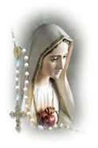

The Rosary is prayed publicly before all weekday morning Masses and Thursday’s, at 3 p.m. Do you have a ‘Special Intention’ whom you would like to be prayed for? Fill out a prayer request form located on the side tables in the vestibule, then place it in the basket next to the statue of the Blessed Mother.

“The unborn child has no voice!
That is why he and she depend on
ours.”
- Fight to end abortion!

The St. Elizabeth of Hungary Memorial Society is an opportunity to have your departed loved ones prayed for once a month in a Mass. The next Mass for members of the Memorial Society will be offered Saturday November 22, 2025, at 4:00 P.M. Once enrolled, those in the Memorial Society will be prayed for each month and need not be reenrolled again.

Please pray for the sick… Janet Abitabilo, Liza Bonisese, Anna Fiorot, Kathleen Gerenser, Tina Lohman, Millie Popovice, Joan Quinnan-Flory, Ryan Savage

Forming a Parish Vocations Committee
Our Diocese is embarking on a concerted effort to promote Vocations to the Priesthood in our Diocese from amongst the families of our parishes. EVERY Parish will be forming a Vocations Committee, and the first focus will be on encouraging vocations to the Priesthood.
During the week of January 12, 2026, we will be having daily Exposition and Benediction of the Blessed Sacrament to Petition the Lord to send us more priestly vocations. Details will follow after Christmas.
A first meeting of our Parish Vocations Team will be held on Thursday, December 11, 2025 at 6:30pm in the Social Hall. Please prayerfully consider attending. WE NEED MORE PRIESTS! The Lord calls, but YOU can help make a young man HEAR that CALL! Thank you!

Please join us at Notre Dame High School on Sunday, December 7th from 12:00 PM – 3:00 PM for our 5th Annual Crusader Christmas! Get your Christmas shopping completed early by attending our event! ND apparel, ornaments, crafts, prizes, and food items will be offered for cash/check and carry. Help us foster a sense of community while supporting our youth. All other proceeds will directly benefit NDHS’s clubs and sports teams. For more info contact Judith at 610-570-1807.
Come early on December 7th for The Inaugural Crusader Christmas 5K 2025. Whether you're a seasoned runner or just looking to stroll through a winter wonderland, this event is the perfect way to kick off the season on a fast, flat road course. Registration starts at 8:00 AM! See flyer on church bulletin board.
https://runsignup.com/Race/PA/Easton/CrusaderChristmas5K. Holiday costumes encouraged—think Santa hats, elf ears, and ugly sweaters! For more information contact Joe at jazzolina@ndcrusaders.com

