
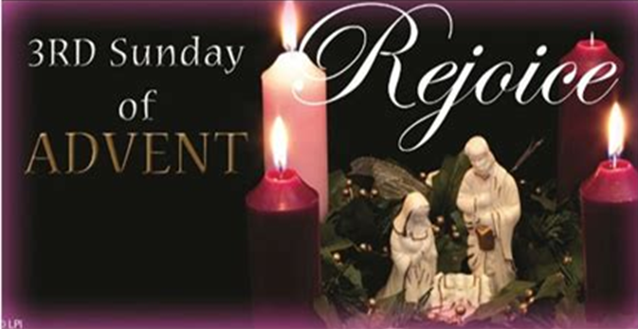
Gaudete Sunday
December 14, 2025

Mass Intentions
SATURDAY [13]
4:00pm living and deceased members of the parish
SUNDAY [14]
8:30am for those enrolled in Memorial Society
10:30am +Richard Wilson by Loretta Wilson
MONDAY [15]
8:00am +Carol Bals by Jordan Family
TUESDAY [16]
8:00am +Julius & Grace Bavaria by Children
WEDNESDAY [17]
8:00am +Matthew & Mary Nemchick by Mark Nemchick
THURSDAY [18]
8:00am +Edward Cesanek by wife, Carol & Family
FRIDAY [19]
9:15am +Matthew & Mary Nemchick by Mark Nemchick
+ + +
SATURDAY [20]
4:00pm living and deceased members of the parish
SUNDAY [21]
8:30am +Dennis Nemchick by brother, Mark
10:30am +Randy Ehle by Ann, Gretchen, Quinn, Kristen, Jeremi
(“+” before name indicates person deceased)

Ministers of the Altar – December 20/21
Altar Servers
4:00pm Michael Webber
8:30am Landon Myers, Elliana Roberts
10:30am Natalie Chiusano, Julian Lohman
Eucharistic Ministers
4:00pm Charles DeBellis, Heather Webber
8:30amLarry Hochreiter, Debbie Muller
10:30am Sr. Maria Kate, Sr. Maria Jane
Lectors
4:00pm Philomena Reduzzi
8:30am Cali Roberts-Egan
10:30am Robert Pecca

Note: Altar Ministers please pick up the new schedule from the Sacristy. Also note there will NOT be an 8:30 A.M. Mass Christmas morning as stated in the schedule…ONLY 10:00 A.M. Mass Christmas morning.

CONFESSION TIMES Saturday 2:45pm – 3:30pm. Confessions are available after the Saturday Vigil Mass upon request, or any time by appointment.

Victim Assistance - Office of Safe Environment
Pamela J. Russo, M.S.W, M.S. Secretary, Youth Protection and Catholic Human Services P.O. Box F, Allentown, PA 18105-1538 610-871-5200 ext. 2204 prusso@allentowndiocese.org

Advertiser of the Week

RUGGIERO’S MARKET
88 Dante St * Roseto, PA 18013
Ph: 610-588-2681 Fax 610-599-2881 www.ruggierosmarket.com
Homemade Sausage* Fresh Cut Meats* Italian Specialties
Mon-Fri 8 AM-7 PM * Saturday 8 AM-5 PM * Sunday Closed

Please patronize our bulletin advertisers!

$$$ FUND RAISING $$$

Please consider purchasing Weis cards. You do not lose a penny of purchasing power and the church receives 5% profit.

Weis Cards are available by calling the Parish Office M-F from 10 A.M. to 2:30 P.M.

Congratulations to Peter Gheller, winners of the 200 Club on December 7, 2025.

Play-the-Month tickets for January are available in Gathering Space. Only $5 per ticket and good for the entire month! Makes a good stocking stuffer! Rules are at the bottom of the ticket(s).

Weekly Collection
Our 4-week average collection for 11/30/2025 was $6574.00 with 223 envelopes and online donations. Thank you for your support of our Parish!

Our budgeted weekly collection for this fiscal year (2025-2026) is $6731.00 per week. An increase in giving is noticeable and greatly appreciated! If the 223 contributions were increased by just 70¢ each, we would be exactly on budget! Thank you for all your prayerful support of the Parish. Thank you for your generosity!!

St. Elizabeth BWAC Progress Report as of 12/4/25

Parish Goal: $19,073.00

Total Committed: $14,269.09

Total Collected: $14,139.09

Many thanks who have made a pledge to Because we are Catholic Annual Appeal. Your generosity supports children and families in our community and throughout the Diocese.

Join Us for Bible Study with Monsignor Koons:
“The Advent of the Messiah”
Next meeting TBA in early January 2026

CHRISTMAS KOLACH PICK UP
If you placed an order for Kolach, pick-up in the Church Social Hall on Sunday, December 14 from 12:00 noon to 3:00 p.m.

CHRISTMAS DECORATING VOLUNTEERS
Friday, December 19: 5pm - ?
Saturday, December 20: 9am - ?

-If you haven’t done so already, those who have handed in a picture of loved ones for the All Souls display may pick up your original photo from the Parish Office between 9:30 – 3:00 M-F. If you are unable to come during those hours, please call Donna at the Parish Office for other arrangements.

The St. Elizabeth/St. Joseph's Ministry food truck will be in the church parking lot the Third Sunday of each month collecting non-perishable food items for the needy in our area. With the holidays quickly approaching items in need are canned fruit (no applesauce needed please), peanut butter, strawberry & grape jelly, tuna, soups cereal (no Cheerios needed), pasta, (no spaghetti needed), plastic bottles of apple & grape juice, coffee, ramen noodles, ravioli, beefaroni (pop off lids preferred).
We have received a note of gratitude from the Food Bank. Please look at the church bulletin board.

Don’t forget to save your Weis shopping receipts and drop them in the “Weis Receipts” basket located in the Gathering Space. Thank you!

Forming a Parish Vocations Committee
Our Diocese is embarking on a concerted effort to promote Vocations to the Priesthood in our Diocese from amongst the families of our parishes.
During the week of January 12, 2026, we will be having daily Exposition and Benediction of the Blessed Sacrament to Petition the Lord to send us more priestly vocations. Details will follow after Christmas.
A first meeting of our Parish Vocations Team TBA January 2026. It will be held in the Social Hall. Please prayerfully consider attending. WE NEED MORE PRIESTS! The Lord calls, but YOU can help make a young man HEAR that CALL! Thank you!


SANCTUARY TABERNACLE CANDLE
This week, the Sanctuary Candle is burning in memory of:
Jozef Polowczyk, Jadwiga Polowczyk, Rev. Waclaw Polowczyk, Jacek Polowczyk & Richard Okula
Eternal Rest Grant unto them, O Lord.
And let Perpetual Light Shine Upon them! Amen.

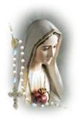
The Rosary is prayed publicly before all weekday morning Masses and Thursday’s, at 3 p.m. Do you have a ‘Special Intention’ whom you would like to be prayed for? Fill out a prayer request form located on the side tables in the vestibule, then place it in the basket next to the statue of the Blessed Mother.


“How can the dream survive if we murder the children? Every aborted baby is like a slave in the Mother’s womb.”
-Dr. Alveda King

The St. Elizabeth off Hungary Memorial Society is an opportunity to have your departed loved ones prayed for once a month in a Mass. The next Mass for members of the Memorial Society will be offered Saturday, January 10, 2026. Once enrolled, those in the Memorial Society will be prayed for each month and need not be reenrolled again.


Please pray for the sick… Janet Abitabilo, Liza Bonisese, Anna Fiorot, Kathleen Gerenser, Tina Lohman, Millie Popovice, Joan Quinnan-Flory, Ryan Savage

Soon: look for new advertisers on our Parish Bulletin
JFR Salvage
Scrap Metal 610.863.6071
6500 Sullivan Trail Wind Gap 18091

Scott Castone Property Maintenance

Diocesan Events
Reserve your spot today for the next Diocesan Pilgrimage to the National Shrine of Divine Mercy in Stockbridge, MA, and Our Lady of Martyrs Shrine in Fultonville, NY! Join Bishop Schlert and Father Hoffa from Wednesday, April 15 – Thursday, April 16, 2026, for a grace-filled two-day pilgrimage.
Double occupancy: $249 per person, which includes:
• Hotel and tax• Round-trip motor coach transportation• Hotel breakfast• Boxed lunch on both travel days• Mass at the National Shrine of Divine Mercy• Mass at Our Lady of Martyrs Space is limited—reserve early! Call 570-342-5790 to secure your spot. For reservation questions, visit asktravelworld.com or email info@asktravelworld.com.

