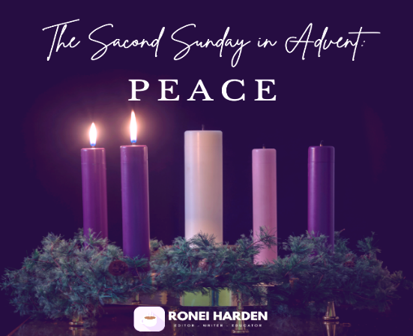
December 7, 2025
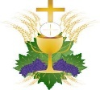
Mass Intentions
SATURDAY [06]
4:00pm +Eli & Rhetta Lathrop by Joseph Lathrop
SUNDAY [07]
8:30am +Catherine Krautkremer by Krautkremer Family
10:30am +Richard Kuster by Family
MONDAY [08] (The Immaculate Conception- Holy Day of Obligation)
8:00am +Dennis Nemchick by Mark Nemchick
9:15am living and deceased members of the parish
6:30pm +Becky Petroski by Oz & Cathy Seogna
TUESDAY [09]
8:00am +Angie Dalessio by Nick DeRea & Rita Hocking
WEDNESDAY [10]
8:00am +Joseph Crisante by Jo & Anthony Crisante
THURSDAY [11]
8:00am +Edwin & Anna Bradley by Joseph Lathrop
FRIDAY [12]
8:00am +Caitlin Shae Formichelli (baby)
+ + +
SATURDAY [13]
4:00pm living and deceased members of the parish
SUNDAY [14]
8:30am for those enrolled in Memorial Society
10:30am +Richard Wilson by Loretta Wilson
(“+” before name indicates person deceased)

Ministers of the Altar – December 13/14
Altar Servers
4:00pm Natosha Morrison
8:30am Emily McHale, Lucas McHale
10:30am Alexander Campbell, Nathan Fukashima
Eucharistic Ministers
4:00pm Briedella Fehr, Dennis Fehr
8:30am Carl Dincher, Dana Hahn
10:30am Jeff Detzi, Jim Rose
Lectors
4:00pm Diane Lobb
8:30am Joseph Lathrop
10:30am Kathy Scott

Note: Altar Ministers please pick up the new schedule from the Sacristy. Also note there will NOT be an 8:30 A.M. Mass Christmas morning as stated in the schedule…ONLY 10:00 A.M. Mass Christmas morning.

CONFESSION TIMES Saturday 2:45pm – 3:30pm. Confessions are available after the Saturday Vigil Mass upon request, or any time by appointment.

Victim Assistance - Office of Safe Environment
Pamela J. Russo, M.S.W, M.S. Secretary, Youth Protection and Catholic Human Services P.O. Box F, Allentown, PA 18105-1538 610-871-5200 ext. 2204 prusso@allentowndiocese.org


Advertiser of the Week
MT. BETHEL EYE CARE
Stephen DiMarco, O.D.
9 Mt. Bethel Plaza, Rt. 512 (Near Rt. 611)
Mt. Bethel, PA 18343
(570) 897-5911

Please patronize our bulletin advertisers!

$$$ FUND RAISING $$$

Please consider purchasing Weis cards. You do not lose a penny of purchasing power and the church receives 5% profit.

Weis Cards are available by calling the Parish Office M-F from 10 A.M. to 2:30 P.M.

Congratulations to Glenn & Sue Fishbough, winners of the 200 Club on November 30, 2025.

Play-the-Month tickets for January are available in Gathering Space. Only $5 per ticket and good for the entire month! Makes a good stocking stuffer! Rules are at the bottom of the ticket(s).

Weekly Collection
Our 4-week average collection for 11/30/2025 was $5823.00 with 176 envelopes and online donations. Thank you for your support of our Parish!

Our budgeted weekly collection for this fiscal year (2025-2026) is $6731.00 per week. An increase in giving is noticeable and greatly appreciated! If the 176 contributions were increased by just $5.16 each, we would be exactly on budget! Thank you for all your prayerful support of the Parish. Thank you for your generosity!!


Operation Christmas Tree is under way! This fundraiser has been long-standing here at St. Elizabeth’s, and a very successful one at that, whereby we can remember and honor our loved ones, living or deceased, by purchasing an ornament in their name, where it will be hung on our beautiful altar trees. If participating, please return your form as soon as possible. Requests received after Due date December 10th will not be acknowledged in the booklet. Thank you for your support!
Note: the Moravian Star above Nativity has been allotted.
Join Us for Bible Study with Monsignor Koons:
“The Advent of the Messiah”
Next meeting: Thursday, December 11 @ 7pm

Christmas Cookie Extravaganza Fundraiser
COOKIE BAKERS:
Please deliver cookies to the Church Social Hall on Friday, December 12 between 9am and 4 pm OR
Saturday, December 13 between 9am and 12 noon. Please use disposable containers… Christmas containers are provided for the sale.
VOLUNTEERS NEEDED!
We need volunteers who can help to receive cookies, and to organize and set-up for our COOKIE EXTRAVAGANZA ON FRIDAY, DECEMBER 12, 12noon to 4pm; Saturday, 9am-12noon AND volunteers to assist from 9am to 4pm on SUNDAY, DECEMBER 14. Volunteer sign-up sheets will be available in the Vestibule of the Church. Thank you!

CHRISTMAS DECORATING VOLUNTEERS
Friday, December 19: 5pm - ?
Saturday, December 20: 9am - ?

CHRISTMAS KOLACH PICK UP
If you placed an order for Kolach, pick-up will be in Church Social Hall Sunday, December 14 12:00 noon to 5:00 p.m.

Those who have handed in a picture of loved ones for the All Souls display may pick up your original photo from the Parish Office between 9:30 – 3:00 M-F. If you are unable to come during those hours, please call Donna at the Parish Office for other arrangements.

We will have our next Doughnut Exchange on Sunday December 14th after the 10:30 Mass.
Special thanks to Giant for giving us a $25 gift card. It is used towards the purchase of the doughnuts.

The St. Elizabeth/St. Joseph's Ministry food truck will be in the church parking lot the Third Sunday of each month collecting non-perishable food items for the needy in our area. With the holidays quickly approaching items in need are canned fruit (no applesauce needed please), peanut butter, strawberry & grape jelly, tuna, soups cereal (no Cheerios needed), pasta, (no spaghetti needed), plastic bottles of apple & grape juice, coffee, ramen noodles, ravioli, beefaroni (pop off lids preferred).
We have received a note of gratitude from the Food Bank. Please look at the church bulletin board.

Don’t forget to save your Weis shopping receipts and drop them in the “Weis Receipts” basket located in the Gathering Space. Thank you!

Forming a Parish Vocations Committee
Our Diocese is embarking on a concerted effort to promote Vocations to the Priesthood in our Diocese from amongst the families of our parishes.
During the week of January 12, 2026, we will be having daily Exposition and Benediction of the Blessed Sacrament to Petition the Lord to send us more priestly vocations. Details will follow after Christmas.
A first meeting of our Parish Vocations Team TBA January 2026. It will be held in the Social Hall. Please prayerfully consider attending. WE NEED MORE PRIESTS! The Lord calls, but YOU can help make a young man HEAR that CALL! Thank you!


SANCTUARY TABERNACLE CANDLE
This week, the Sanctuary Candle is burning in memory of:
Mary Jane Nasatka, Delray Nasatka and Marlon Nasatka
Eternal Rest Grant unto them, O Lord.
And let Perpetual Light Shine Upon them! Amen.

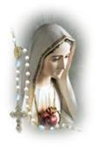
The Rosary is prayed publicly before all weekday morning Masses and Thursday’s, at 3 p.m. Do you have a ‘Special Intention’ whom you would like to be prayed for? Fill out a prayer request form located on the side tables in the vestibule, then place it in the basket next to the statue of the Blessed Mother.
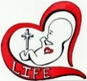
“The baby’s body is not the mother‘s body. End abortion.” - L. Rose

The St. Elizabeth of Hungary Memorial Society is an opportunity to have your departed loved ones prayed for once a month in a Mass. The next Mass for members of the Memorial Society will be offered Saturday November 22, 2025, at 4:00 P.M. Once enrolled, those in the Memorial Society will be prayed for each month and need not be reenrolled again.


Please pray for the sick… Janet Abitabilo, Liza Bonisese, Anna Fiorot, Kathleen Gerenser, Tina Lohman, Millie Popovice, Joan Quinnan-Flory, Ryan Savage

Reserve your spot today for the next Diocesan Pilgrimage to the National Shrine of Divine Mercy in Stockbridge, MA, and Our Lady of Martyrs Shrine in Fultonville, NY! Join Bishop Schlert and Father Hoffa from Wednesday, April 15 – Thursday, April 16, 2026, for a grace-filled two-day pilgrimage.
Double occupancy: $249 per person, which includes:
• Hotel and tax• Round-trip motor coach transportation• Hotel breakfast• Boxed lunch on both travel days• Mass at the National Shrine of Divine Mercy• Mass at Our Lady of Martyrs Space is limited—reserve early! Call 570-342-5790 to secure your spot. For reservation questions, visit asktravelworld.com or email info@asktravelworld.com.

