**25th Sunday in Ordinary Time**

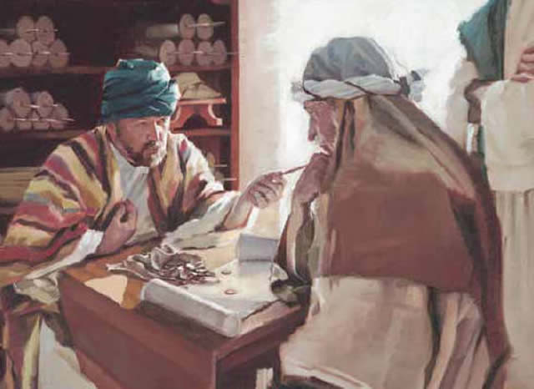

The Parable of the Dishonest Steward

Then to another he said, ‘And you, how much do you owe?’ He replied, ‘One hundred measures of wheat.’ He said to him, ‘Here is your promissory note; write on for eighty.’ And the master commended that dishonest steward for acting prudently. For the children of this world are more prudent in dealing with their own generation than the children of light.’ Luke 16:1-13

**September 21, 2025**

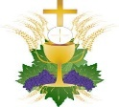 **Mass Intentions**

SATURDAY [20]

4:00pm +David Buskirk by Ginny

SUNDAY [21]

8:30am +Carole Albert Carrescia by Carrescia Family

10:30am living and deceased members of the parish

MONDAY [22]

8:00am +Matthew & Mary Nemchick by Mark Nemchick

TUESDAY [23]

8:00am Special Intention by Krautkermer Family

WEDNESDAY [24]

8:00am +M/M Angelo DeNicuola by Family

THURSDAY [25]

8:00am +Aurelio Falcone by MaryBeth & Mark Villiano

FRIDAY [26]

9:15am +Joseph Bartosh by Janet & Harry Nasatka

+ + +

SATURDAY [27]

4:00pm +Mark Buskirk by Mother

SUNDAY [28]

8:30am +Michael Curcio by Karin & Family

10:30am living and deceased members of the parish

(“+” before name indicates person deceased)

**Ministers of the Altar – September 27/28**

**Altar Servers**

**4:00pm** Michael Webber

**8:30am** Frankie Rowley, Goia Graziani

**10:30am** Emily McHale, Lucas McHale

***Eucharistic Ministers***

**4:00pm** Charles DeBellis, Ann Weaver

**8:30am** Larry Hochreiter, Jo Bullock

**10:30am** Sr. Maria Kate, Sr. Maria Jane

***Lectors***

**4:00pm** Joe Mootz

**8:30am** Frances Rowley

**10:30am** Kathy Scott

**Note to Ministers of the Altar: please pick up the new schedule from in the Sacristy.**

**CONFESSION TIMES** Saturday 2:45pm – 3:30pm. Confessions are available after the Saturday Vigil Mass upon request, or any time by appointment.

**Victim Assistance** - **Office of Safe Environment**  
Pamela J. Russo, M.S.W, M.S. Secretary, Youth Protection and Catholic Human Services P.O. Box F, Allentown, PA 18105-1538 610-871-5200 ext. 2204 [prusso@allentowndiocese.org](mailto:prusso@allentowndiocese.org)

**Advertiser of the Week**

***RENALDO’S INC.***

DAVID RENALDO

811 3rd Ave, Bangor, PA

610-588-1645 / [renaldosinc1645@gmail.com](mailto:renaldosinc1645@gmail.com).

Heating / Plumbing / Electrical / AC

*Please patronize our bulletin advertisers!*

**$$$ FUND RAISING $$$**

## *Please consider purchasing Weis cards. You do not lose a penny of purchasing power and the church receives 5% profit.*

## Weis Cards are available by calling the Parish Office M-F from 10 A.M. to 2:30 P.M.

Congratulations to **Heather Webber** winner of the **200 Club** on **Sept 14**

**Play-the-Month** winners:

Sept 6 #354 Bridget Strockoz

Sept 12 #373 Dennis Miller

Sept 16 #658 Renee Kauffman

The total of last week’s collection was $4880. Thank you.

If you wish to have any events published in our bulletin, the information is due by Wednesday at 12 p.m.

Please include the word “bulletin” in the ‘Subject’ line. Each event should have a title, date, time, location, group name, and all other information pertaining to the event.

**Don’t forget to save your Weis shopping receipts** and drop them in the “Weis Receipts” basket located in the Gathering Space. Thank you!

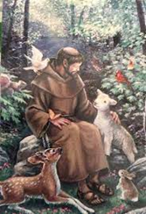We will have **Blessing of Animals** in honor of St. Francis of Assisi (Feast Day Oct. 4) in front of the church on **Sunday, October 5, 2025 at 12:00 noon**. Please make sure that animals are leashed or caged for their safety.



**St. Elizabeth’s Fall Flower Sale**, If you participated in the Flower Sale, **PICK UP TODAY** downstairs in the church Social Hall.

The ***St. Elizabeth of Hungary*** ***Memorial Society*** is an opportunity to have your departed loved ones prayed for once a month in a Mass. The next Mass for members of the Memorial Society will be offered ***Sunday October 12, 2025, at 10:30 A.M.*** Once enrolled, those in the Memorial Society will be prayed for each month and need not be reenrolled again.

***The Rosary is prayed publicly before all weekday morning Masses and Thursday’s,******at 3* p.m.**Do you have a ‘Special Intention’ whom you would like to be prayed for? Fill out a prayer request form located on the side tables in the vestibule, then place it in the basket next to the statue of the Blessed Mother.

**

*Please pray for the sick… Janet Abitabilo, Liza Bonisese, Anna Fiorot, Kathleen Gerenser, Tina Lohman, Millie Popovice, Ryan Savage*

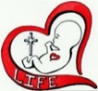

“If anyone is blind to the truth about abortion, it is because they don’t want to see.”

-Abolish human abortion

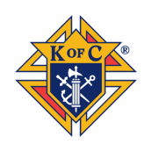The Knight of Columbus Council #3862 invites all parishioners and their families to an Open House at the Council Home, on Tuesday September 23, 2025 beginning at 7:30 PM, 1860 West Bangor Road, Bangor, PA 18013. There will be refreshment available with socialization and tour of the building amenities. Opening prayer and welcome will be held in the Capozzolo Event Hall. Come and see what Charity, Unity, Fraternity and Our Faith in Action have accomplished.

Dinner Dance   
The Knights of Columbus Council #3862 is extending the invitation to all Knights and Parishioners to this year’s Harvest Dinner Dance, to be held on Saturday, October 4, 2025. Our time for celebrating achievements with an evening of fun and fellowship will be held at the Council Home Event Hall beginning at 6:00 PM with Hors d’Oeuvres and dinner starting at 7:00 PM. We will also have the opportunity tp present the Knight of the Year Award. Catering will be provided by Carol's Catering and Music for the evening will be supplied by DJ Zazzy, of local fame. Tickets are available at $25.00 per person and $40.00 a couple. Reach out to: Jim Bauer at 570.994.2767 or jpbauer@ptd.net prior to September 26, 2025 to make your reservations. This is a BYOB event where sodas and mixers are included with the meal.

Liturgy of the Hours - Evening Prayer  
The next COR Catholic Men’s session is scheduled for September 25, 2025 at 7:30 PM at the Council Event Hall, 1860 West Bangor Road, Bangor, PA 18013. This session will be devoted to time spent in prayer with the Liturgy of the Hours – Evening Prayer. Being a reflection of the day’s events and fraternity in prayer. Gathering together to form an enduring habit in our conversation and grow in faith strengthening our relationship with our God. As well, time spent in fraternity and socialization. More information and session schedule can be found in the gathering space. If you are unable to attend this session, come as you are to the next!

Our Lady of Mount Carmel Parish is having bus transportation for the Diocesan Pilgrimage to the National Shrine of the Immaculate Conception in Washington D.C. on Tuesday, October 7, 2025. The cost of the trip is $90.00/pp. Includes transportation, boxed dinner, tolls, driver’s gratuity. To reserve your spot on this Pilgrimage please call the Parish Office at 610-588-2183 and leave a message for Roxanne DeCesare. Also, more information w/sign-up sheets in the Gathering Space.

**ALL SOULS PICTORIAL REMEMBRANCE**

**Sunday November 2, 2025 through Sunday November 23, 2025**

If you would like your departed loved ones to be prayed for in a special way during the month of November, you are invited to bring in a photograph of them to be displayed in the front of the Church during the month of “ALL SOULS.” ***Memorial candles also can be purchased to include up to five names on each candle for $15.00. Please see the bulletin insert this weekend, or pick up a form in the vestibule.*** There is no charge for having your loved one’s photo diplayed. Please place the **FRAMELESS** photo in an appropriate-sized envelope with your loved one’s name, year of birth, year of death, and YOUR NAME ON THE ENVELOPE so that the photos may be properly identified and returned at the end of the month.

**All Souls Envelopes**, with names inscribed, also will be placed on the Altar during the month of November, as Monsignor Koons will pray for the intention of their eternal rest at every weekday and weekend Mass during the entire month of November.

***Praying for the deceased is one of the seven SPIRITUAL WORKS OF MERCY*** and is ahallmark of Catholic Prayer that finds its biblical roots in:

1. 2 Maccabees 12:46 - Judas Maccabeus offers a prayer and a sacrifice for his soldiers who died with impurities or attachment to sin.
2. 2 Timothy 1:16-18 - Saint Paul offers a prayer for Onesiphorus and his household, asking for mercy on the Day of the Lord.
3. Matthew 12:32 - Jesus states, "whoever speaks against the Holy Spirit will not be forgiven, either in this age *or in the age to come*." This statement reveals that some sins can be forgiven or atoned for after death, providing a doctrinal basis for praying for souls who may need purification before entering heaven.

The Catholic faith has always taught that believers are in spiritual communion with the dead, and that prayers for them are not wasted, even if they are in heaven, as they can be applied to other souls in need.



Thank you note from the Cay Galgon Life House!

On behalf of everyone who benefited from your generosity and dedication, I want to extend our heartfelt thanks for the outstanding success of this year’s Baby Bottle Campaign.

Thanks to your commitment to life-affirming work, countless families will receive the care and resources they need during a critical time in their lives.

We are truly grateful for your compassion, your faith in action, and your unwavering support. May God continue to bless you, your ministry and all those your generosity has helped.

With sincere appreciation,

Paula Albanese – Executive Director