



Case Study for Response
Halle Center for Hope and Healing

October 2025

Table of Contents

Executive Summary ……………………………………………………………………………………. 3
Purpose Statement …………………………………………………………………………………….. 5
Featured Organization ………………………………………………………………………………… 6
The Opportunity …………………………………………………………………………………………. 7
Project Overview ………………………………………………………………………………..7
Project Team ……………………………………………………………………………………..9
Project Costs ……………………………………………………………………………………………. 10
Building Specifics ……………………………………………………………………………………….10
Process for Solving Problems ………………………………………………………………………11
Results of Process ……………..……………………………………………………………………….15
Lessons Learned……………………………………………………………………………….17
Graphs and Tables……………………………………………………………………………..19
Concluding Statements……………………………………………………………………………….21
Sources…………………………………………………………………………………………………….22
Acknowledgements………………………………………………………………….……………….22

Executive Summary
Response is a Basalt-based nonprofit with a mission to work with the community to end domestic and sexual abuse and to support survivors in achieving safety and empowerment. For decades its staff worked out of a cramped rented office in the Pitkin County Health and Human Services Building in Aspen. In addition, there was no secure or permanent shelter that survivors of abuse could rely on for mid-term stability anywhere in the upper Roaring Fork Valley, which is essential for those in immediate danger. Shelters provide a transition for survivors to rebuild their lives in a safe environment where they can thrive into the future and an important component in the healing process. The combined need for new office space and to create the first safe and welcoming shelter in the upper Roaring Fork Valley inspired the organization to construct a domestic and sexual abuse healing center in Basalt. And because the board and staff value environmental sustainability, a goal was set to build a zero emissions facility.

The project overcame many challenges along the way, particularly designing for sustainability in a flood plain, orienting the building for privacy and security while also capturing the most solar gain, advocating for a change in land use from the Town of Basalt to accommodate a unique use, forging relationships and buy-in from the HOA, while also raising $9.75 million for the land and project, and integrating energy efficient features that honored a building that serves dual functions.

Design features include solar voltaic panels on the roof, passive solar design, EV car charging stations, ADA accessibility, a multi-zone heat pumps for heating and cooling and electric induction cooking systems.

Grants from the Community Office for Resource Efficiency (CORE) were essential for Response to complete the final design for a net neutral building and to help fund an all-electric heat pump system. In addition, guidance from CORE staff was a significant contributor to the success of the project achieving its sustainability vision, including CORE’s recommendations for resources, advice on obtaining other grants and tax credits, and general consultations along the way.

The Response building known as the Halle Center for Hope and Healing, was a team effort from day one where all consultants and project sponsors were working toward the same sustainability goal and overcoming obstacles together because the vision was shared and problem-solving could be done cooperatively and proactively.

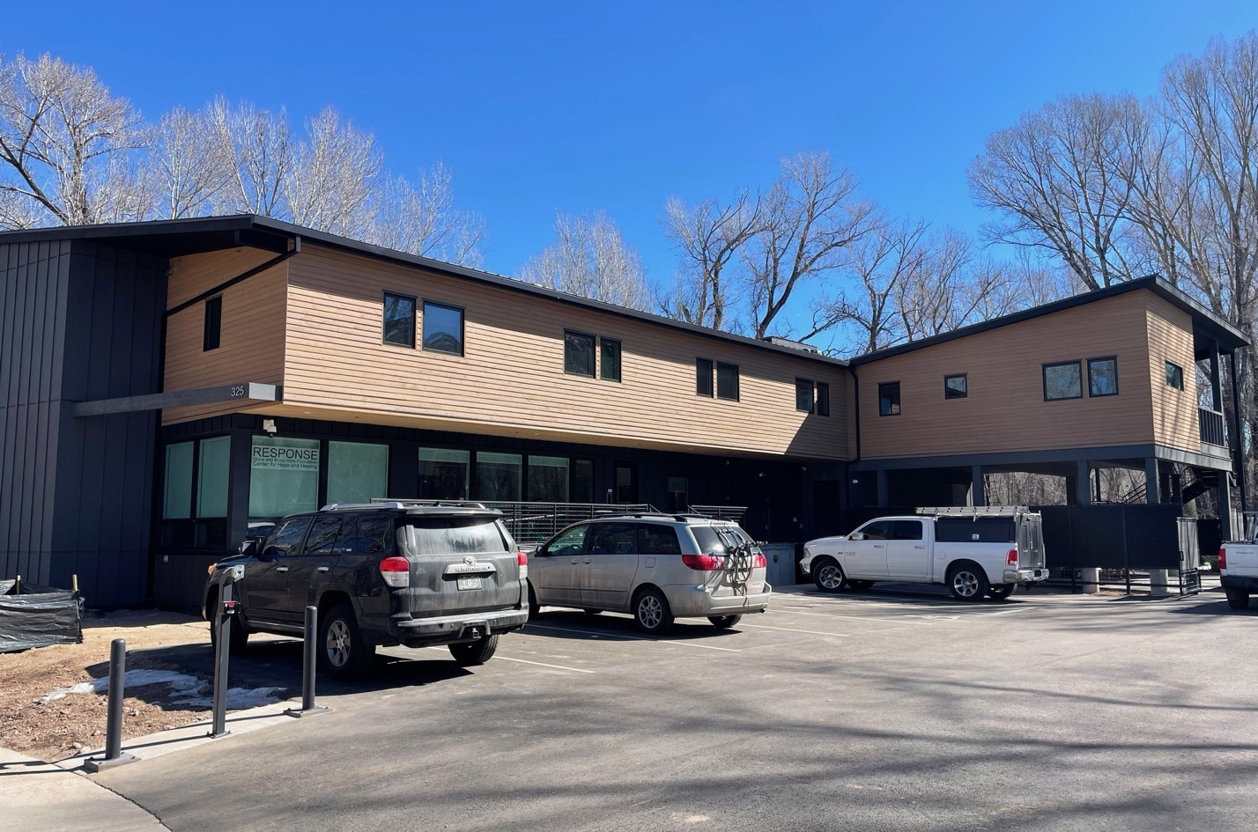
Halle Center for Hope and Healing in Basalt, Colorado

The Response building is a beautiful and highly functioning model for sustainability, privacy, and security that others can replicate, in part or in its entirety. It is zero emissions building with about 70% of its energy produced by solar onsite and the remainder purchased through Holy Cross’s renewable energy source program. It’s cool in the summer and warm in the winter and welcoming every day of the year.

The fruition of the Response building truly manifested a new path for a nonprofit with a dream.

Purpose Statement
This case study offers insight into a project that offers replicable strategies and solutions for building a new net zero building on a site with physical and land use constraints that can be overcome with innovative thinking and compelling persuasion about positive change for a town and neighborhood.

Often, nonprofits have limited budgets for big projects such as new buildings and have the pressures of fundraising and securing outside financial assistance through grants and tax incentives; however, having a strong vision and an ethic for a project can be a beacon during challenging times. Response was committed to building sustainably and generating energy onsite and found that the cost wasn’t prohibitive to do this, and in fact the team understood that it would save the organization money in the long run. This project can inspire others to think long-term and creatively while keeping the big picture in mind when financial decisions arise during a project.

Recognizing that teamwork and group problem-solving are opportunities to get ahead of challenges and implementing sound solutions for building goals is key. Working together and forming relationships with the team early can be a powerful success factor.

Meaningful lessons from this project illustrate that constraints can be overcome and a strong vision can lead a team toward a healthy and sustainable solution that benefits not just those with immediate ties to the project, but the community-at-large.

“We’re a community organization and for us this means keeping not just our people, but also our environment healthy, and we’re fully bought into that.”
- Shannon Meyer, Executive Director, Response

Those who may benefit from this case study include the following:
- Architects and designers
- Community planners
- Energy sector professionals
- Construction professionals
- Nonprofits looking to build a headquarters
- Nonprofits looking to build shelters of any kind
- Developers looking to build sustainable buildings
- Philanthropists and fundraisers
- State and local granting agencies

Featured Organization/Project Sponsor: Response

Response was formed in 1985 to provide support to survivors of domestic abuse in our community. Several years later, Response added sexual assault survivor services as well.

Response offers a 24-hour phone hotline, survivor advocacy, community outreach, and support groups, when possible, temporary emergency housing, transitional housing for survivors and their children, financial assistance to help survivors secure affordable housing, and other resources to those impacted by abuse.

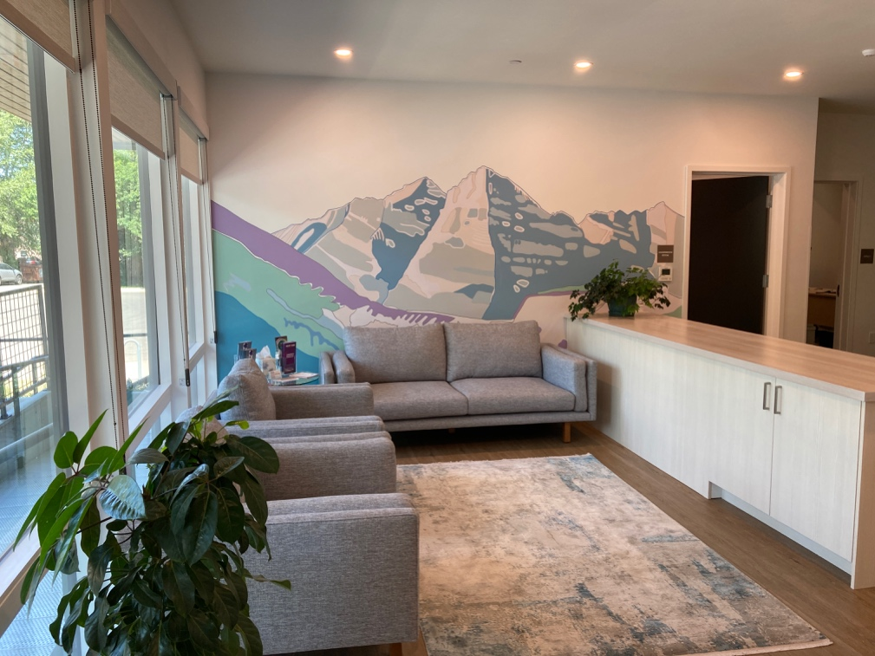
Response waiting room in front office

The Opportunity
Project Overview
From the outset, finding safe housing so that victims could leave their abuser, was crucial for meeting Response’s mission. Originally, board members and volunteers would house survivors in their own homes, sometimes for several months. When this was no longer was tenable, the only housing option that Response could provide was up to three nights of emergency shelter in local hotels that donated the nightly stays. However, this was merely a Band-Aid, after which survivors would often have to choose between moving in with family or friends, leaving the valley, or returning to their abuser.
For nearly 40 years that gap in services existed for vulnerable individuals and families in need of housing, an essential component for creating stability and a platform to heal and thrive.

Response began looking for land in 2022 with a vision to build a headquarters with combined shelter, office space, and meeting space to provide services and refuge for survivors. The Roaring Fork Valley is an expensive and daunting location to find vacant land for any purpose but the extra needs for privacy, security, outdoor space, and proximity to emergency services, transportation and schools added another layer of complexity in the search for an appropriate property.

The board and executive director, Shannon Meyer, were fully committed to building with zero emissions. Meyer said, “The board and I feel that any new construction in this Valley that we love needs to be sustainable and make minimal impact on our climate future. We’re a community organization and part of this community is keeping our people and our environment healthy, and we’re fully bought into that.”

When the organization found land that was in their price range in Basalt, it came with significant limitations and challenges for building. The property where the Halle Center for Hope and Healing now sits is on a 100-year flood plain offering no option for a basement to house mechanical and venting rooms. A solution to compensate for that would increase the cost of the project.

“We knew that the floodplain and triangular shape of the site would be difficult to navigate, but affordable property always comes with challenges,” said architect for the project Erica Golden, principal of Site Architects. To navigate the limited footprint for building, the shelter and offices would have to be built on floors higher than what the HOA allowed, which presented another challenge to overcome.

In addition, the land wasn’t zoned for a shelter with the Town of Basalt, so Response had to request a change in the land use code.

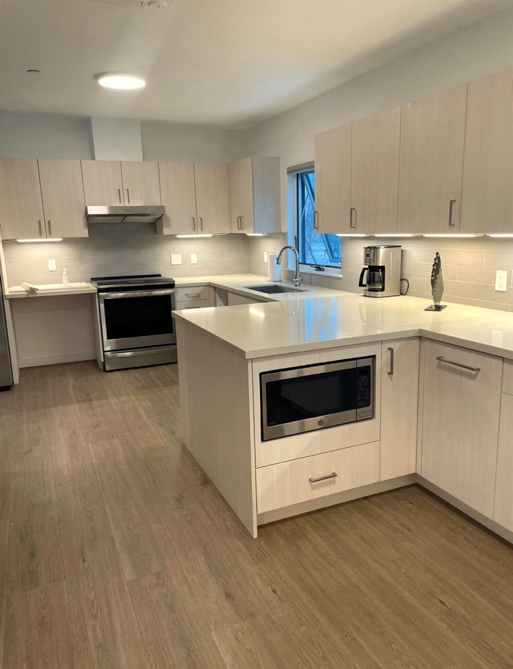
Communal Kitchen

It's important to keep in mind that survivors in transition should enjoy a warm, cozy space that is both functional and inviting. A space that supports healing and independence and is welcoming in its design, layout, and amenities is inseparable from the building’s purpose. The sustainable elements are part of this, but also making sure the project included features like properly sized kitchens and high ceilings were also an integral part of the puzzle to be solved.

Despite all these challenges, Response had a once in the organization’s lifetime opportunity to build its dream headquarters – designed for climate resilience as well as client safety and comfort. Although compromising on sustainability and livability features could cut down the expense, it was a non-negotiable for Response from the beginning and fueled the project team to overcome perceived roadblocks and deterrents.

“The consultants involved on this project really went the extra mile in looking at the design and function of the space to implement a sustainable design that met and exceeded operational expectations and provide an aesthetically pleasing building with sustainability at the forefront of design decisions.”
- Eric Wynne, Project Manager, G.F. Woods Construction

Project Team
The project partners were imperative in the overall success of the new building.

- Response executive director, Shannon Meyer
- Response shelter manager, Tiffaney Bledsaw
- Response Board
- site-architects, principal, Erica Golden
- GF Woods Construction, Eric Wynne, project manager
- Sun Sense, Chris Howard
- Big Horn Consulting Engineers
- Bendon-Adams Land Planning
- Holy Cross Energy
- R & H Mechanical
- Group 14 Energy Modeling
- Town of Basalt

Project Costs

Solar Panels: $194,000
Heat Pumps: $75,512
Total Project Cost including Land + Design + Planning + Construction: $9.75 million
CORE Contribution: $69,000 for energy modeling and heat pumps
Other Grants: $4 million from Colorado Division of Housing; $1.2 million from The Diane and Bruce Halle Foundation for the land; $135,000 for EV charging grant from Charge Ahead Colorado; $500,000 from Pitkin County; $250,000 from City of Aspen; $30,000 from Snowmass Village; $50,000 from Eagle County, $10,000 from the Town of Basalt.
Tax Credits: Response took advantage of tax credits for the solar panel installation. They anticipate a credit of approximately $60,000 once they apply at the end of the tax year.

Building Specifics

Location: 325 E. Cody Lane, Basalt, Colorado
Building Type: Combined office building and shelter with 5 client meeting rooms, a conference room, food and clothing pantry, 7 efficiency units, communal kitchen and living area, caretaker unit, and outdoor play yard. The building has 24 beds including 2 ADA compliant rooms. Overall capacity is 9 adults and 15 children at one time.
Building Square Footage: 7,900 square feet
Year Built: 2025
Utility Provider: Holy Cross
Heating and Cooling System: Mitsubishi wall mounted cooling
Domestic Hot Water System: Mitsubishi Multi-Zone Heat Pump
EV Chargers: 4 Level 2 chargers at 11.5 kWh
Electric Features: Electric baseboard heat (Intertek unit heaters), induction ovens, electric unit heaters, and Mitsubishi heat pump units
Solar Infrastructure: 51.41 kWh DC system
Electric Service Size: 800-amp service

Process for Solving Problem

- Establish Non-negotiables

Response was undertaking a project that would establish a legacy for the organization and its clients for decades to come. Building the first and only shelter in the upper Roaring Fork Valley for domestic violence survivors alongside offices and meeting rooms was a once in a lifetime project and it was imperative it was done to the highest level of comfort, safety, and sustainability.

“We ethically wouldn’t have built a building without considering a climate future in that process.”
- Shannon Meyer, Executive Director, Response

The team was aware that choosing an existing building to repurpose versus buying land could impact the level of sustainability the project could achieve as retrofitting can be as or more expensive than building from the ground up. Response had set the goal of creating a zero emissions facility and that was an important consideration. Finding a site that would facilitate this goal from the ground up required creative thinking, flexibility, and the willingness to work with constraints and see if the team could overcome them.

Because the most appropriate site was in a 100-year floodplain with HOA and Town of Basalt restrictions, the team had to be willing to persuade stakeholders to alter their rules and regulations to accommodate the larger vision of the building and the benefits it would bring to the community and Response clients.

Erica Golden, principal of site-architects recognized the challenges but persisted with creative thinking so adjustments could be made in design-thinking that would accommodate the limitations while achieving the fundamental goals.

Having a foundational ethic for the project allowed the team to stay focused and not waiver on other land, existing for-sale buildings, or design options that came along that might have “worked” but wouldn’t fulfill the overall vision for sustainability, safety, and comfort.

- Advocate for the Vision
The team knew they had to work with the Town of Basalt to change the land use code to allow a domestic abuse shelter as the primary use for the land. They went to the Town Council for the change in use while under contract knowing it would not close without this approval. The Town granted the land use change. Response had many advocates for the project in the Council meetings expressing community support, which was both strategic and helpful in fulfilling the vision for the project. Gathering supporters for any project requiring government approval is an important part of getting to the finish line.

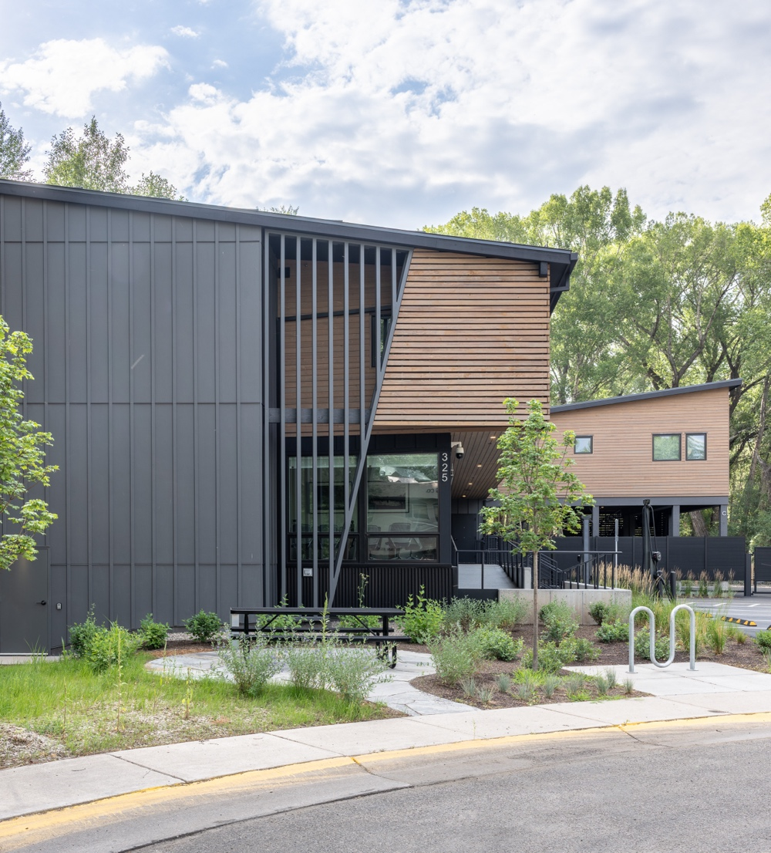
Street view of Halle Center for Hope and Healing

As part of this process, Response also had to work with the HOA as the land parcel was a part of a commercial industrial HOA with height restrictions that wouldn’t work for the project and the Town of Basalt required HOA approval in order to change the land use code. Because the land is not only in a floodplain but also had a ditch running through it and had large established trees, the building envelope was limited, and extra height and square footage was important to the full programming of the building as well as the space for solar panels. Response worked with the neighboring businesses to share its goals and why the site was so appropriate for the use and the HOA members agreed to the height change.

Working in partnership with neighbors and putting the time in to form relationships is integral to projects that create change in an area. Authentic communication and easing people’s worries were important pieces to this and any project. The HOA members all conduct business alongside this project so having their buy-in helps insure immediate and long-term success.

- Flexibility and Creative Thinking

Because Response wanted to achieve zero emissions, the team had to be creative about space and design. Room for solar panels, mechanical rooms, and venting was as important as constructing livable spaces with high ceilings, roomy living quarters, and peaceful shared kitchen and relaxation spaces. The floodplain necessitated building 50% of the building on piers, which means there is no basement room for mechanical and venting space. That’s where the extra height comes in to accommodate for systems functionality as well as roof space for solar panels. In addition, the building went beyond the Town of Basalt requirements for ADA accessibility in its entrances and its living quarters.

Meyer said, “Survivors can stay at the shelter for around two months so in terms of climate, temperate, ease of use, visual elements, privacy, and comfort, it had to be welcoming. Our challenge was to meld privacy with a welcoming environment.”

Golden said, “We always take a site-first design approach with all of our projects, digging in immediately on any unique site features such as the floodplain on this site. As the design and engineering progressed, the floodplain (pushing the building up) and the strict height limit (pushing the roof down) proved to compete against each other quite forcefully. We fought hard for an increase in height and the initial diagramming held, maintaining both security and effective sustainable design strategies.”

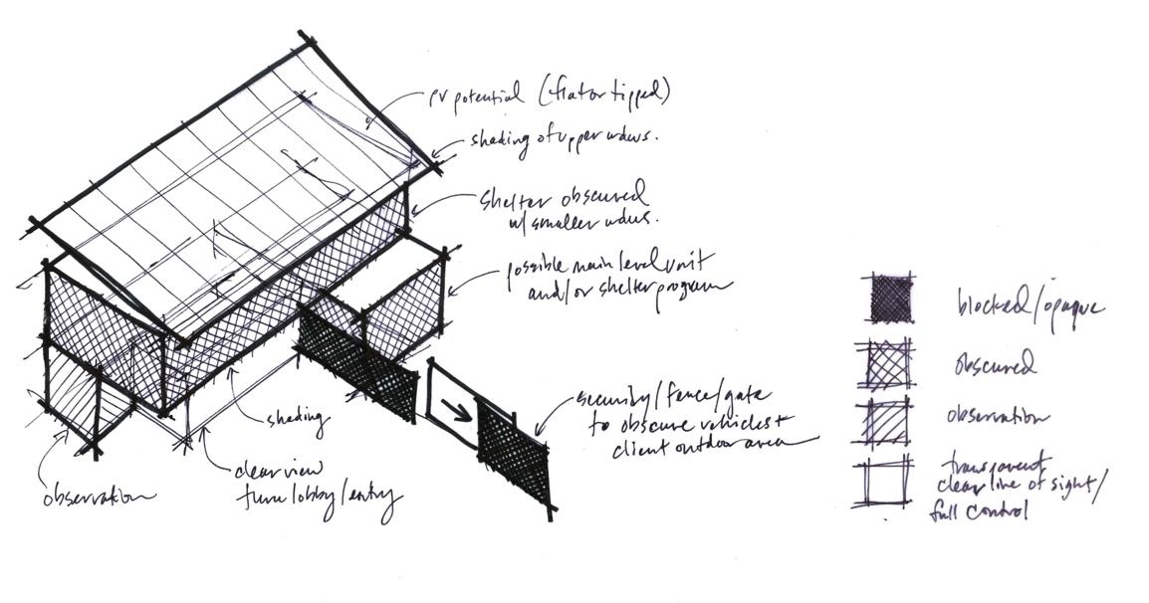
Initial draft of design by Erica Golden, Principal of site-architects

4. Use the Right Materials and Design to Achieve the Goals

The butterfly sloped roof design was the most important element in generating solar energy. Eric Wynne, Project Manager for G.F. Woods Construction said, “This was a design element that was vetted for aesthetics and was also utilized to attached solar. We looked to minimize any penetration in the roof for solar and worked with our local structural engineers and our roofing contractor and the solar company to vet solar mounting design and think through the best roofing materials to execute this mounting and have a balance between lifecycle of the roofing materials and the solar system.”

The low pitch metal design with a standing seam allowed for a clipped application for the solar mounting. While the low angle required additional waterproofing and sealing to account for freeze-thaw cycles, the design ultimately meant less penetration into the roof membrane for structural attachment of the solar panels and the choice for a metal roof meant increased longevity of the materials rather than a membrane roof product.

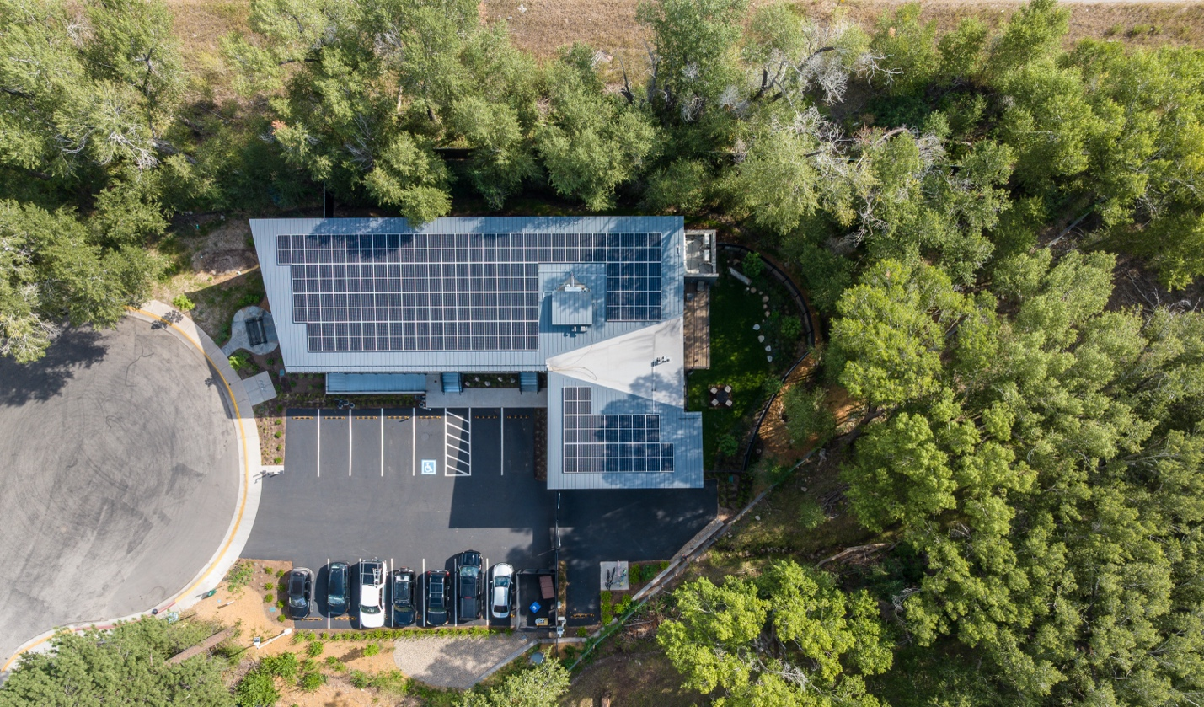
View of solar panels on the roof of Halle Center for Hope and Healing

Results of Process
Response has a state-of-the-art sustainable headquarters, the only one of its kind for a domestic violence shelter and office building in Colorado. The final building honors the original vision and is reducing the possibility of homelessness for survivors of domestic and sexual abuse. The uncompromising vision of building a headquarters near public transportation, schools, and law enforcement while still having privacy and safety is a crowning achievement. The site, though constrained, was so perfect is so many ways that overcoming challenges were worth what was accomplished.

“A property like this was incredible. We could do mixed use residential, and it is close to schools and buses and having this become available even in the floodplain, it just fit all the boxes. We had looked at an existing building and I am glad we didn’t go that route because with this site we were able to build what we wanted sustainability-wise and otherwise and got exactly what we wanted.”
- Shannon Meyer, Executive Director, Response

The building produces 70% of its electric needs with the remainder purchased as clean energy from Holy Cross. Due to the sizing of the building and roof, the project could not fit enough solar panels to power the entire building, but there is conduit under the parking area for a future ground mounted solar array. They achieve zero emissions by purchasing offsite renewable energy from Holy Cross Energy.

Meyer said, “I love that we are a demonstration project for other nonprofits to see you can build in a somewhat affordable manner and meet sustainability goals and not have to be a drain on the energy system.”

During the fundraising and building of the Halle Center for Hope and Healing the project received much public attention in government meetings and local newspapers and public radio. That exposure not only helped promote the sustainable building elements but also brought more attention to Response and its mission, which contributes to destigmatizing those suffering from domestic and sexual abuse.

In addition, CORE was integral to the success of the project beyond the funding. Tim Johns, Senior Energy Concierge for CORE said, “CORE provided technical advising throughout the project on the heat pumps, energy recovery ventilators (ERVs), and heat pump water heaters. We awarded a design assistance grant and then reviewed the design in detail, offering feedback—particularly around the domestic hot water system. We also highlighted opportunities to unlock additional funding, connected the team with Holy Cross Energy, and guided them on how to strengthen their CORE grant application.”

The project was a masterful success because of the teamwork employed from day one and that success will continue as Response continues to execute its mission daily from it’s beautiful and sustainable headquarters.

Lessons Learned

- Proactive teamwork
The pre-planning and support throughout the building process made the implementation of sustainable design easier to execute in the field. Wynne said, “This project was so successful because of such a cohesive team and well-thought-out design and willingness to work through contractor and subcontract questions and suggestions in a very timely manner. This was also the biggest take away for me as a lesson learned. Getting all stakeholder involved early on in design and review of constructability makes the entire process much more efficient and allows for all stakeholders to be vetted and the construction team to mesh with the design and the overall goal of sustainability to be thought through early to make sure those goals are met with the overall design intent.”

- Consult with experts early and often
CORE was an essential resource during the process. It is not simply a granting organization but a pool of experts who can help make a project more successful and achieve greater sustainability results. Meyer said, “Having the staff as a resource was just as important as the impact of the funding. They helped us with information about our grants and the Town of Basalt and pointed us toward other grants and tax credits. They pointed me in the right directions for all the things.”

- Build support
Throughout the process, it’s imperative to bring stakeholders along by building relationships with them that are more than simply transactional. Buy-in results from authentic communication, purposeful outreach, and consistent updates. Response worked with neighbors, funders, stakeholders, HOA members, and local government to help the approval process be successful and to gain vocal support for the project.

- Planning for the future, even in a new building is essential.
While Response had goals of producing 100% of its electricity, the space on the roof only allowed for 70%. However, part of the construction process was to establish the conduit for a ground solar array when the time is right and if room in the parking lot allows. Seeing future needs is important even in new buildings when it may appear that nothing will be left out. Future planning is a way to continue to enhance sustainability and account for improvements down the line.

- Pursue all funding opportunities
While Response was honored to receive significant funding from CORE for the sustainability piece, the executive director worked hard to scour for other funding sources, which paid off. A $4 million state grant along with local funding and fundraising helped the project live up to its vision. Networking and asking for help were also essential in finding funding sources, tax credits, and rebates.

- Stretch now for long-term gain
During the project there were times when budgetary limits might have compromised some of the sustainability elements. However, fulfilling the vision and realizing that long-term cost savings might equal the initial investment that may have felt overwhelming at the time. Calculating future savings or costs helped decision-making in the present. At first Response contemplated only installing the required amount of solar at the outset and adding the remainder in 2-3 years. However, they were able to raise the funds to install the full amount during construction, which paid off because federal funding and rebates went away due to changing federal policies during construction.

The path we were on made so much sense to us and we never came upon a stumbling block where if we took a less sustainable option it was appealing. We knew our environmental goals and we were committed and everyone on team was committed to getting us there.
- Shannon Meyer, Executive Director, Response
Graphs & Tables
These graphs provide a snapshot of kWh produced from Response’s solar panels in June and July 2025 as well as an illustration showing the carbon offset in the life of the project and year-to-date energy production.
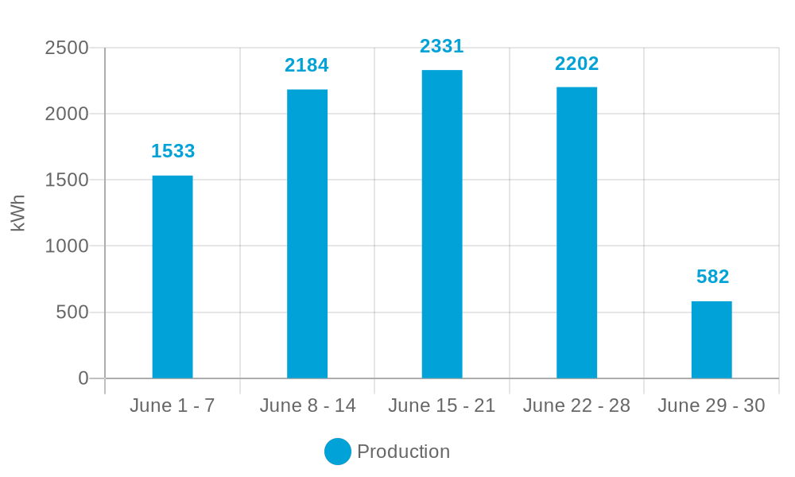

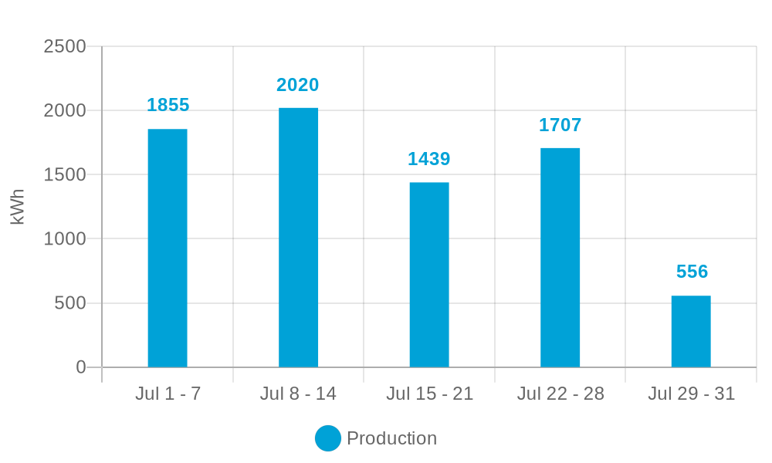

June 2025

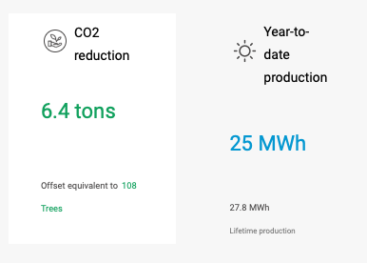

July 2025

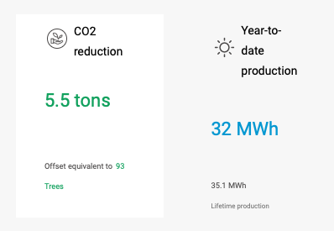

Concluding Statements
The Halle Center for Hope and Healing represents the realization of a decades-long dream and demonstrates how vision, perseverance, and collaboration can overcome even the most daunting obstacles. What began as an urgent need for a permanent office and shelter evolved into a landmark project that not only fills a critical gap in services for survivors of domestic and sexual abuse but also sets a new standard for sustainable and resilient community spaces.
Despite the challenges of building on a floodplain, navigating land use restrictions, raising sufficient funds, and integrating advanced energy-efficient systems, Response remained committed to a shared goal: creating a safe, healing, and environmentally responsible facility. The resulting building is warm, functional, and welcoming, with design features that support privacy, safety, comfort, and long-term cost savings, while also producing most of its own energy.
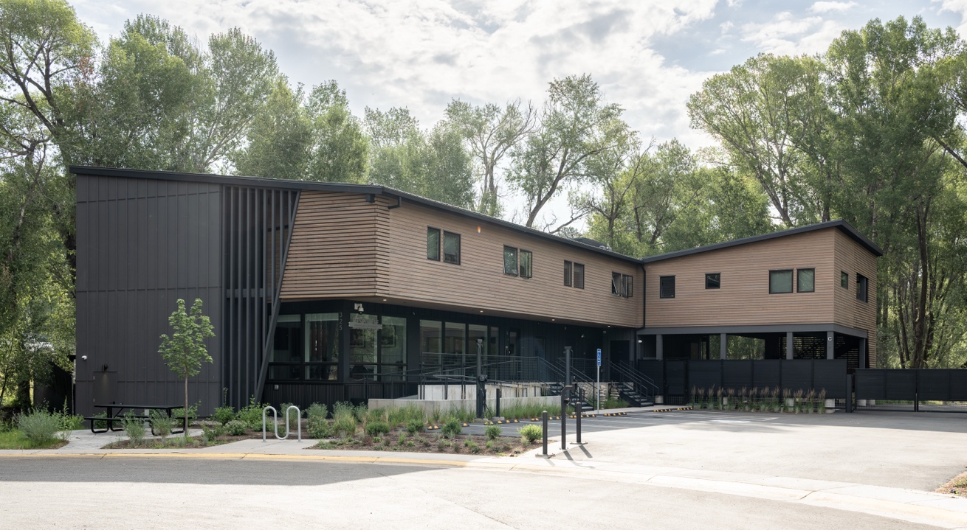
Halle Center for Hope and Healing
This project illustrates that nonprofits, even when working within limited budgets, can achieve transformational results by holding fast to a strong vision and engaging in creative problem-solving. By building trust among team members, cultivating community partnerships, and leveraging grant opportunities, Response ensured that its mission to serve survivors was inseparable from its ethic of environmental stewardship.
The Halle Center for Hope and Healing is far more than a shelter and office; it is a beacon of empowerment and sustainability that demonstrates the power of aligning human needs with ecological responsibility. As such, it provides a replicable model for other organizations, communities, and sectors—proof that investing in resilience, compassion, and sustainability is not only possible, but deeply impactful for generations to come.

Sources
- Response
- Post Independent article
- Aspen Daily News article and Aspen Daily News article
- Aspen Times article
- CORE
- Interviews with Shannon Meyer, Erica Golden, and Eric Wynne

Acknowledgments
This case study was made possible through generous collaboration with several individuals and organizations.
- Shannon Meyer, Executive Director, Response
- Erica Golden, Principal, site-architects
- Eric Wynne, Project Manager, G.F. Woods Construction
- Tim Johns, Senior Energy Concierge, CORE
- Mitzi Rapkin, Owner, Full Light Communications



