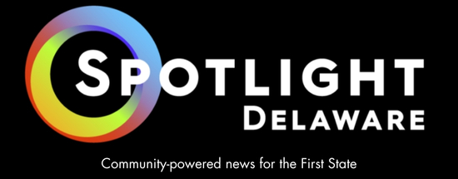

Spotlight Delaware
112 S. French St.
Wilmington DE 19801

TO: MDDC Annual Awards Judging Committee

Spotlight Delaware is proud to have undertaken significant work last year using Delaware’s Freedom of Information Act, which has helped to shed light on immigration enforcement, the investment of taxpayer money, neglect within mental health facilities and abuses of power in office.

In many cases, our FOIA requests were some of the most significant uses of the statute in their particular jurisdictions in many years – as evidenced by the education required by our reporters and editors for government employees to gain access to sought-after records. We also won two key appeals through the Delaware Attorney General’s Office, overturning denials from the cities of Wilmington and Dover to gain access to records in sensitive cases.

In our Wilmington case, we gain access to a presentation by city employees to leaders in the effort to build former President Joe Biden’s presidential library. We actually saw a part of the PowerPoint presentation in a public space, but the city denied supplying the entire presentation. We appealed and won the case, resulting in the publication of the city’s plans to attract the major project.

In Dover, the capital city has been embroiled in accusations of police misconduct and abuses of power. We requested email and text messages between the police chief and mayor regarding the issues, but were denied using an infamous litigation defense. The AG’s office once again ruled in our favor on appeal, and the city turned over hundreds of pages of messages in a recent disclosure. Reporting from those filing will follow shortly.

Such wins in records access cases are exceedingly rare in Delaware, with our cases representing about a third of all wins in the dozens of appeals filed.

Spotlight Delaware’s FOIA also work helped to inform health care reporter Nick Stonesifer’s investigation of a behavioral health center known as MeadowWood after spotting lawsuits raising concerns over deaths at the center. He dug into the cases and obtained scores of compliance documents through FOIA to help spell out the story of deadly oversight lapses. His reporting ended up in lawsuits and resulted in the state's first-ever fine against the facility.

Stonesifer also covered the acrimonious split between Kent County and its former administrator, gaining access to weeks of emails regarding an internal fight over his disclosure of potential ethical lapses by county leaders. Using FOIA, Spotlight was able to get a copy of their settlement agreement that disclosed Kent County taxpayer’s paid the former administrator $350,000 to avoid a lawsuit. We were the only outlet to cover the cost to taxpayers.

Spotlight Delaware’s FOIA helped immigration reporter José Ignacio Castañeda Perez investigate the behind-the-scenes workings of President Trump’s immigration agenda, tracking the conversations of U.S. Immigration and Customs Enforcement with local law enforcement. That reporting on solicitations for 287(g) agreements helped convince a state legislator to sponsor a ban of such agreements, which passed the General Assembly and was signed by Gov. Matt Meyer in July.

Finally, Spotlight Delaware does not publish opinion content, but we made a rare exception this past year in speaking out against a proposal to allow private legislative quorums for Wilmington City Council. Our Publisher & CEO Allison Taylor Levine wrote a well-read column that noted the pitfalls of such a proposal and warned against state legislators from assisting in the effort.

We also hosted a panel discussion in April 2025 that brought together legal experts to discuss the First Amendment, the Freedom of Information Act, the role of a free press and the threats to those freedoms underway by state and federal legislators. We expected a few dozen interested community members to join us, but instead filled a classroom and dozens more online for an attendance of more than 100 people.

Spotlight Delaware was founded in January 2024 to embolden investigative journalism in the First State, and we couldn’t be prouder of the efforts we’ve been able to complete in our first two years.

We appreciate your consideration for the James S. Keat Freedom of Information Award,

Jacob Owens
Editor-In-Chief, Spotlight Delaware
jowens@spotlightdelaware.org
302-379-1993 (Cell)

