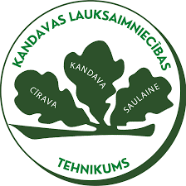

Workplace Responsibility in the 21st Century
(reading, text comprehension, writing, pair work)

Angļu valoda
1.kurss

Autore: Eva Kivleniece

2026
Metodiskais materiāls ir paredzēts audzēkņu angļu valodas prasmju pilnveidei, attīstot izpratni par mūsdienu darba vides prasībām, kā arī spēju formulēt un pamatot viedokli par tēmām, kas saistītas ar darbu un atbildību.
MĒRĶAUDITORIJA- 1. kurss
UZDEVUMU MĒRĶIS
Mērķis:
Attīstīt audzēkņu prasmi izprast mūsdienu darba vides prasības un spēt par tām runāt, izmantojot atbilstošu vārdu krājumu un vienkārši strukturētu viedokli.
UZDEVUMI
Uzdevumi veicina audzēkņu spēju formulēt viedokli, pamatot to ar piemēriem un piedalīties diskusijā par darba vidi.
SASNIEDZAMIE REZULTĀTI
Audzēkņi veido skaidru, loģiski strukturētu un noteiktam saziņas nolūkam atbilstošu mutvārdu runu.
Audzēkņi apgūst un lieto tematam atbilstošu vārdu krājumu un gramatiskās konstrukcijas.
Audzēkņi attīsta sadarbības, kritiskās domāšanas un radošās pieejas prasmes, analizējot mūsdienu darba vides situācijas.

VĒRTĒŠANAS KRITĒRIJI
Pēc uzdevumu izpildes audzēkņi reflektē par savu sniegumu, atbildot uz jautājumiem:
- Ko jaunu es uzzināju par atbildību darba vidē?
- Kuri vārdi vai izteicieni man bija jauni vai noderīgi?
- Kas man izdevās, runājot angļu valodā?
- Ko es nākamreiz varētu uzlabot?

IZMANTOTIE RESURSI
diffit.com

Name: ____________________ Date: ____________________
Reading & Summary
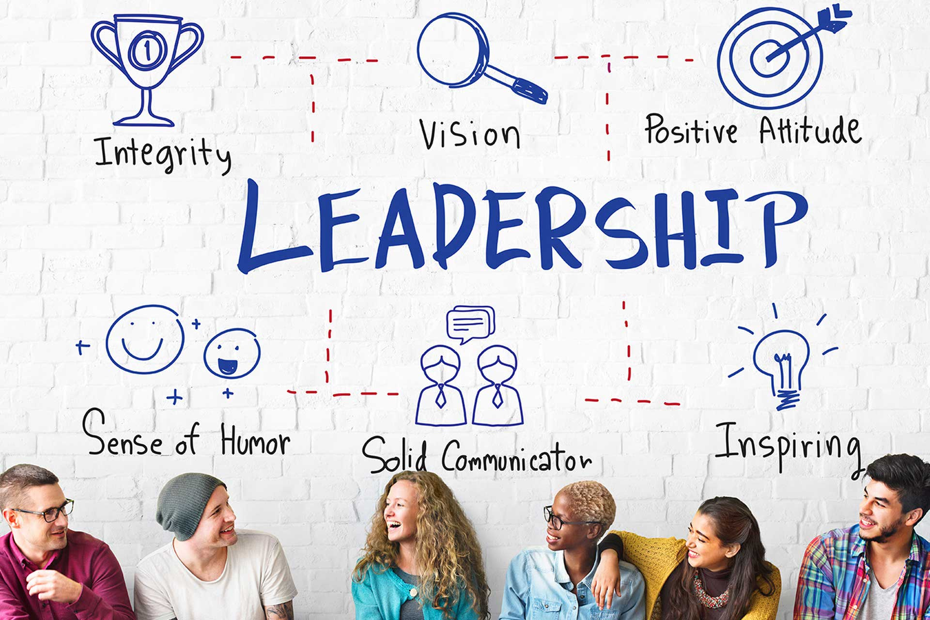
Workplace Responsibility in the 21st Century
The modern workplace is changing rapidly, driven by technology, new ideas about work-life balance, and a growing focus on diversity. To succeed in this environment, both employers and employees need to understand their evolving responsibilities. Human Resources (HR) departments, in particular, must be innovative, competitive, and fair to meet these new demands.
One of the biggest shifts is the increasing importance of ethics. With social media and instant communication, companies are more transparent than ever. People care about working for organizations that act responsibly, protect customer data, and follow the rules. In fact, a recent survey showed that most people think business ethics are more important now than in the past. This means companies need to build a culture of honesty, fairness, and respect.
Organizational culture is the foundation of ethical behavior. A company's values, policies, and leadership style influence how employees handle ethical dilemmas. When ethical principles are part of the culture, employees are more loyal, collaborative, and successful in the long run.
Technology is another major factor shaping the 21st-century workplace. Artificial intelligence (AI) and machine learning are changing how we work, making it possible to automate tasks and focus on more creative and strategic activities. While this can lead to increased productivity, it also means employees need to be adaptable and willing to learn new skills.
The rise of remote work and digital communication has also changed how we interact with colleagues and customers. Even if you never meet someone in person, it's still important to treat them with respect. Building strong relationships, even online, is crucial for success in today's connected world.

Personal responsibility is more important than ever. This means doing what's expected of you, being accountable for your actions, and caring about the results. It also means looking out for the people you affect, even if you're not in a leadership position. In a world where it's not always easy to see how productive someone is, employees have a responsibility to be transparent about their work, progress, and challenges.
Millennials, who grew up with technology and constant change, have played a big role in shaping the modern workplace. They're open to new ideas, willing to try new things, and not afraid to question the status quo. They also value work-life balance and want to work for companies that have a purpose.
Companies are realizing that a positive workplace culture is essential for attracting and keeping talented employees. This includes creating an environment where people feel connected to the company's mission, promoting collaboration and innovation, and ensuring employees are satisfied with their jobs.
In conclusion, workplace responsibility in the 21st century is a two-way street. Employers need to create ethical and supportive environments, while employees need to be responsible, adaptable, and committed to doing their best work. By embracing these principles, companies and individuals can thrive in the ever-changing world of work.
‏
Summary
- Workplaces are changing because of technology, work-life balance, and diversity.
- Companies and workers both need to be responsible and ready to change.
- A good workplace culture helps companies find and keep good workers.

ethics
noun
Moral principles that govern a person's behavior or the conducting of an activity.
The company developed a strict code of ethics to ensure all employees acted with integrity.
Artificial intelligence
noun
The theory and development of computer systems able to perform tasks that normally require human intelligence.
Artificial intelligence is being used to automate many tasks in the manufacturing industry.
culture
noun
The ideas, customs, and social behaviour of a particular people or society.
The company's culture promoted teamwork and open communication among employees.
accountable
adjective
Required or expected to justify actions or decisions; responsible.
Each team member was held accountable for their individual contributions to the project.
status quo
noun
The existing state of affairs, especially regarding social or political issues.
The new CEO was hired to challenge the status quo and implement innovative strategies.
collaboration
noun
The action of working with someone to produce or create something.
Effective collaboration between departments led to the successful launch of the new product.

innovation
noun
The introduction of something new; a new idea, method, or device.
The company invested heavily in research and development to foster innovation.
Name: ____________________ Date: ____________________
Multiple Choice Questions
Answer the following multiple choice questions about the reading.
1. According to the passage, what is a key characteristic of Human Resources (HR) departments in the 21st century?
A. Standardized, unyielding, and conventional
B. Hierarchical, exclusive, and secretive
C. Innovative, competitive, and fair
D. Traditional, structured, and rigid
2. According to the passage, what is the foundation of ethical behavior in a company?
A. Mandatory ethics training
B. Employee performance reviews
C. Organizational culture
D. Strict disciplinary actions
3. According to the passage, what is a crucial aspect of personal responsibility in the modern workplace?
A. Focusing solely on personal tasks without considering broader impacts
B. Avoiding collaboration to maximize individual output
C. Maintaining secrecy about work progress to stay competitive
D. Being transparent about work, progress, and challenges
Name: ____________________ Date: ____________________
Short Answer Questions
Answer the following short answer questions about the reading.
1. According to the passage, how has technology, specifically AI and machine learning, impacted the modern workplace, and what does this mean for employees?
‏
‏
‏
‏
‏
‏
2. In what ways have Millennials influenced the modern workplace, as described in the passage, and what do they prioritize in their professional lives?
‏
‏
‏
‏
‏
‏
3. According to the passage, what is the relationship between employers and employees in creating a responsible workplace in the 21st century, and how does this relationship contribute to success?
‏
‏
‏
‏
‏
‏
Name: ____________________ Date: ____________________
Think Pair Share
The passage discusses the importance of ethics and personal responsibility in the modern workplace. Can you describe a time when you faced an ethical dilemma or had to take personal responsibility for a challenging situation, and what did you learn from that experience?
I think...  Before talking to your partner, answer the question using what you learned from the reading and your own background knowledge. | ‏  ‏  ‏  ‏  ‏  ‏  ‏  ‏
My partner thinks...  Take notes on your partners response. How is it different from yours? How is it the same? | ‏  ‏  ‏  ‏  ‏  ‏  ‏  ‏
We will share...  Decide together what you will share aloud with others. | ‏  ‏  ‏  ‏  ‏  ‏  ‏  ‏
Instructions: Read and answer the question independently. Compare your answer with your partners. Work together to prepare what you will share.
Name: ____________________ Date: ____________________
Text to Text, Text to Self, Text to World
Instructions: After reading, make connections between the text and other stories, your personal experiences, and the world around you.
Reading Summary
- Workplaces are changing because of technology, work-life balance, and diversity.
- Companies and workers both need to be responsible and ready to change.
- A good workplace culture helps companies find and keep good workers.
‏
Text to Text  "It reminds me of the story..."   | ‏  ‏  ‏  ‏  ‏  ‏  ‏  ‏
Text to Self  "It reminds me of when I..."   | ‏  ‏  ‏  ‏  ‏  ‏  ‏  ‏
Text to World  "It reminds me of something in the world..."   | ‏  ‏  ‏  ‏  ‏  ‏  ‏  ‏

This Diffit resource was created by Eva Kivleniece

