The South Carolina Inn at Montreat is YOUR home in the mountains!

400 South Carolina Terrace Montreat, NC 28757 828.669.7460 https://scinnatmontreat.org

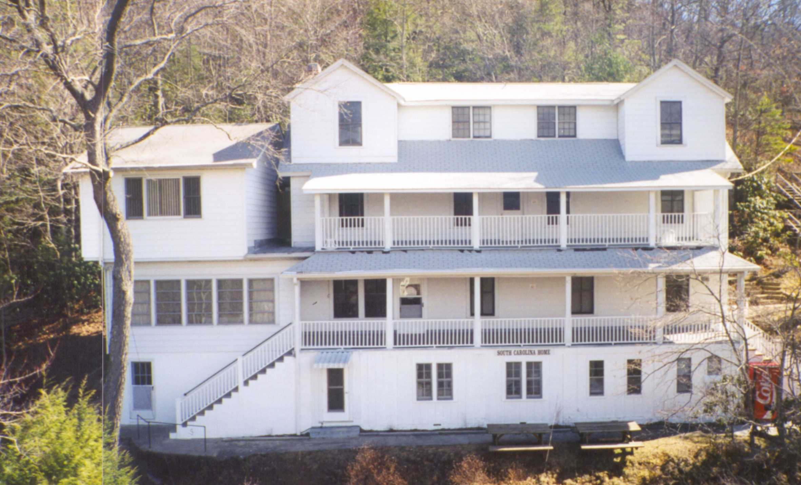
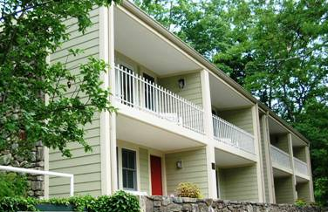
The William Brearley Home has 16 guest rooms and 8 shared/assigned hall bathrooms on the three floors of the home. The first floor has a spacious lobby with a gas log fireplace and a meeting room where reading, table games, spiritual studies, worship, and end of the day conversations take place. It also has a front porch overlooking the valley that provides opportunities for enjoying the view and developing friendships. In the Kirk Apartments there are eight modern units that have bath facilities and small kitchens.

The South Carolina Inn belongs to the five presbyteries of the Presbyterian Church (USA) in South Carolina:
Charleston-Atlantic, Foothills, New Harmony, Providence, and Trinity

Brief History* Back in the early days of Montreat, Dr. R.C. Anderson offered free lots to any Synod which would build a house where its ministers could stay rent-free while attending Montreat conferences. Mr. McIver Williamson, a planter of Darlington County, made it possible for our Synod to qualify by erecting a 16-room house in 1912. In honor of his boyhood pastor, Mr. Williamson called the home “The William Brearley - South Carolina Home for Ministers.” At first the home was not very popular, having no screens, no hot water, no linen, and no funds assigned to it to provide any of these conveniences. Later Rev. and Mrs. R. M. Kirkpatrick became host and hostess of the home. “Mrs. Kirk,” as she is lovingly known to the hundreds she has cheered and helped, is a woman to whom “all things are possible.” She enlisted the aid of the Women of our church, in those days known as Ladies Aid Societies and Young Ladies Missionary Societies. From the women came funds for hot water, screens, linens, furniture, and an annual amount for operating expenses. Best of all there was Mrs. Kirk herself, loving everyone, welcoming them, and making all around her happy and comfortable.
*from the 1955 SC Home report

When the apartments were built in the 1970s they were named in honor of Mrs. Amanda Kirkpatrick. At the time of the 100th anniversary celebration the Board changed the name from the South Carolina Home to the South Carolina Inn so that all will know it is a hotel not a retirement home! Just as an old brochure says – “We invite you to come join us for Rest, Relaxation, and Rejuvenation”

The SC Inn is one of the oldest, if not the oldest, facility in Montreat. Over the years many lives have been transformed and faith has been strengthened in those who have attended retreats, conferences, etc. while staying at the SC Inn. The Inn has served guests for over 100 years. We want to work together to sustain, improve and keep it functioning so that it can welcome and serve guests for years to come.
Over the years the South Carolina Inn has undergone many improvements. Now there are some additional improvements that need to be made to make the Inn fully functional year-round.

In 2025, the South Carolina Inn board of Directors made two important decisions:
1) to provide professional and sustainable management of the Inn through a new agreement with the William Black Lodge in Montreat.
2) to develop a campaign to raise funds for a winterization / weatherization project for the William Brearley House at the South Carolina Inn so that it can accomodate guests year round.
There are three phases to this project:
- Insulate pipes on the back wall of the house – sewer drain pipes are exposed to freezing weather and could freeze and crack thereby forcing the the Inn to close the rooms in the house. A plumbing consultant recommends insulating the pipes with 1.5 inch thick fiberglass pipe insulation and finish with .016 inch stucco aluminum jackets. [$3,500.00]
- Mini Split HVA Unit installation – currently small electric radiator heaters are placed in the bathrooms and bedrooms and propane heaters are used in the living room and kitchen during cold weather and ceiling fans and a few small window units are used to relieve the summer heat. HVAC consultants have approved a plan to install at least two, and preferably three, mini-split units in the house. These would be located on the office wall in the kitchen, above the windows opposite the living room lobby, and in the second floor hallway. These would provide base temperatures of 60 degrees in the winter and 80 degrees in the summer. This would keep the entire house well above freezing and no longer require all the small units when temperatures threaten frozen pipes. [$25,000.00]

- Electricity for the Mini Splits – the new units will require new wiring and electric support. [$4,500.00]
While the cost for these projects is significant, the improved protection of pipes and heating and cooling equipment will enable the William Brearley Home to be used year round thus providing an increase in income. While this is called a Winterization Project, the HVAC Mini-Split units will provide a less humid and cooler space in warm/hot weather.
A Whole House Generator will be added after the first three projects are completed and additional funding is available. [$20,000.00]
These projects will benefit the South Carolina Inn for many years. The cost is short term but the anticipated benfits are ongoing.
At its Febraury, 2025, meeting the SC Inn Board approved the project and
a campaign to raise funds with a goal of $50,000.

Please fill out the donor information and mail to:
South Carolina Inn Winterization Campaign
PO Box 670
Montreat, NC 28757

MAKE CHECK PAYABLE TO: THE SOUTH CAROLINA INN AT MONTREAT FOR: WINTERIZATION CAMPAIGN

Name: ___________________________________________________________________________________________________________

Address:__________________________________________________________________________________________________________

City, State, Zip: ____________________________________________________________________________________________________

Telephone:_______________________________ Email: ___________________________________________________________________

___ In Honor ___ In Memory of: _______________________________________________________________________________________

Please notify: ______________________________________________________________________________________________________

Thank you for your support! YOUR GIFT IS TAX DEDUCTIBLE

For on-line donations:
Funds will be given through an account with Providence Presbytery and will be forwarded to SC Inn at Montreat.
Direct Link to the giving form: https://onrealm.org/ProvidencePresb18431/give/SCInn

or scan QR Code
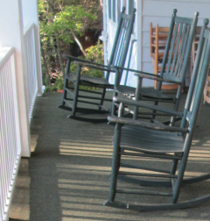
Make plans to visit your home in Montreat for a conference, with your church, with your family, with your friends, or by yourself for quiet time. There’s a chair on the porch waiting for you!
YOUR GIFT IS TAX DEDUCTIBLE
Thank you for your support!

