**The South Carolina Inn at Montreat is YOUR home in the mountains!**

**400 South Carolina Terrace Montreat, NC 28757 828.669.7460**

**https://scinnatmontreat.org**

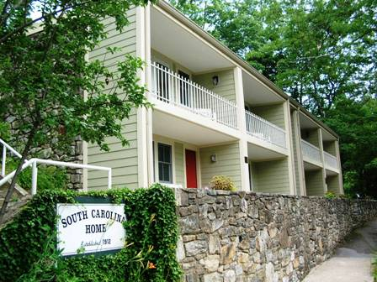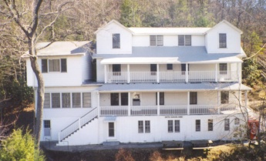The ***William Brearley Home*** has 16 guest rooms and 8 shared/assigned hall bathrooms on the three floors of the home. The first floor has a spacious lobby with a gas log fireplace and a meeting room where reading, table games, spiritual studies, worship, and end of the day conversations take place. It also has a front porch overlooking the valley that provides opportunities for enjoying the view and developing friendships. In ***the Kirk Apartments*** there are eight modern units that have bath facilities and small kitchens.

**The South Carolina Inn belongs to the five presbyteries of the Presbyterian Church (USA) in South Carolina:**

**Charleston-Atlantic, Foothills, New Harmony, Providence, and Trinity**

Since its founding over 100 years ago, the South Carolina Inn has undergone many improvements. Now there are some additional improvements that need to be made to make the Inn **fully functional year round**.

In early 2025, the South Carolina Inn board of Directors made two important decisions:

1) to provide professional and sustainable management of the Inn through an agreement with the William Black Lodge in Montreat.

2) to raise funds for a winterization / weatherization project for the William Brearley House at the South Carolina Inn so that it can accomodate guests year round.

While the cost for these projects is significant, the improved protection of pipes and heating and cooling equipment will enable the William Brearley Home to be used year round thus providing an increase in income. While this is called a **Winterization Project**, the HVAC Mini-Split units will provide a less humid and cooler space in warm/hot weather.

**The South Carolina Inn at Montreat is YOUR home in the mountains!**

**400 South Carolina Terrace Montreat, NC 28757 828.669.7460**

**https://scinnatmontreat.org**

The ***William Brearley Home*** has 16 guest rooms and 8 shared/assigned hall bathrooms on the three floors of the home. The first floor has a spacious lobby with a gas log fireplace and a meeting room where reading, table games, spiritual studies, worship, and end of the day conversations take place. It also has a front porch overlooking the valley that provides opportunities for enjoying the view and developing friendships. In ***the Kirk Apartments*** there are eight modern units that have bath facilities and small kitchens.

**The South Carolina Inn belongs to the five presbyteries of the Presbyterian Church (USA) in South Carolina:**

**Charleston-Atlantic, Foothills, New Harmony, Providence, and Trinity**

Since its founding over 100 years ago, the South Carolina Inn has undergone many improvements. Now there are some additional improvements that need to be made to make the Inn **fully functional year round**.

In early 2025, the South Carolina Inn board of Directors made two important decisions:

1) to provide professional and sustainable management of the Inn through an agreement with the William Black Lodge in Montreat.

2) to raise funds for a winterization / weatherization project for the William Brearley House at the South Carolina Inn so that it can accomodate guests year round.

While the cost for these projects is significant, the improved protection of pipes and heating and cooling equipment will enable the William Brearley Home to be used year round thus providing an increase in income. While this is called a **Winterization Project**, the HVAC Mini-Split units will provide a less humid and cooler space in warm/hot weather.

**We are seeking gifts**

**made through checks or on-line donations (sorry no pledges).**

**Please fill out the donor information and mail to:**

**South Carolina Inn Winterization Campaign**

**PO Box 670**

**Montreat, NC 28757**

MAKE CHECK PAYABLE TO: **THE SOUTH CAROLINA INN AT MONTREAT** FOR: **WINTERIZATION CAMPAIGN**

Name:_______________________________________________________________

Address:_____________________________________________________________

City, State, Zip:________________________________________________________

Telephone:________________________ Email: _____________________________

**For on-line donations:**

**Funds will be given through an account with Providence Presbytery and will be forwarded to SC Inn at Montreat.**

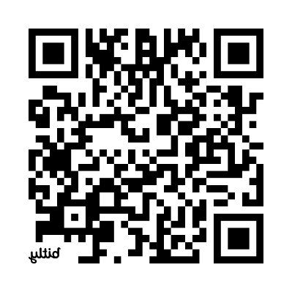**Direct Link to the giving form: https://onrealm.org/ProvidencePresb18431/give/SCInn**

**or scan QR Code**

***Thank you for your support!***

**YOUR GIFT IS TAX DEDUCTIBLE**

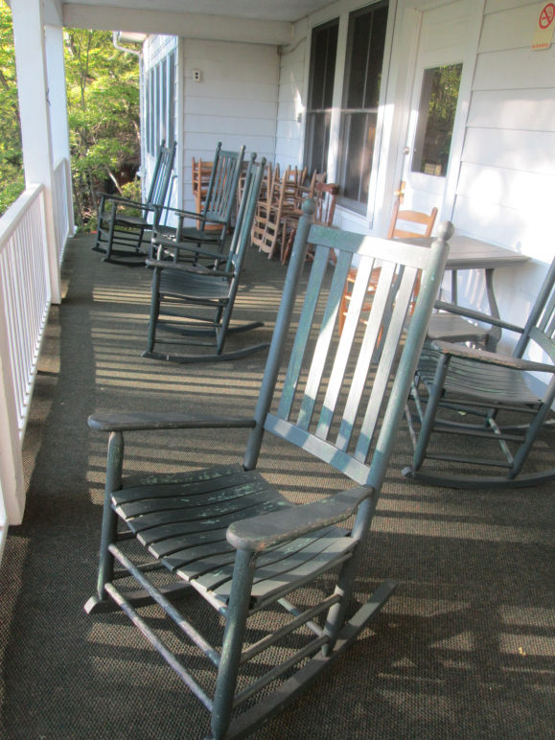

**Make plans to visit YOUR home in Montreat for a conference, with your church, with your family, with your friends, or by yourself for quiet time. There’s a chair on the porch waiting for YOU!**

**We are seeking gifts**

**made through checks or on-line donations (sorry no pledges).**

**Please fill out the donor information and mail to:**

**South Carolina Inn Winterization Campaign**

**PO Box 670**

**Montreat, NC 28757**

MAKE CHECK PAYABLE TO: **THE SOUTH CAROLINA INN AT MONTREAT** FOR: **WINTERIZATION CAMPAIGN**

Name:_______________________________________________________________

Address:_____________________________________________________________

City, State, Zip:________________________________________________________

Telephone:________________________ Email: _____________________________

**For on-line donations:**

**Funds will be given through an account with Providence Presbytery and will be forwarded to SC Inn at Montreat.**

**Direct Link to the giving form: https://onrealm.org/ProvidencePresb18431/give/SCInn**

**or scan QR Code**

***Thank you for your support!***

**YOUR GIFT IS TAX DEDUCTIBLE**



**Make plans to visit YOUR home in Montreat for a conference, with your church, with your family, with your friends, or by yourself for quiet time. There’s a chair on the porch waiting for YOU!**