CLUB BEGA LTD
ACN 001 011 383
NOTICE OF GENERAL MEETING
Notice is given to the members of Club Bega Ltd ACN 001 011 383 (Club) that a General Meeting will be held on Wednesday, 5 November 2025 at 6pm (Sydney time) at the Bega Country Club, 1477 Tarraganda Lane, Tarraganda NSW 2550.

BUSINESS
- Chairman to declare meeting open.
- Apologies.
- To consider and, if thought fit, to pass the Ordinary Resolution (as listed below).

ORDINARY RESOLUTION
That, in accordance with and for the purposes of section 41E(6) of the Registered Clubs Act 1976 (NSW), the members declare that the entire land comprising Lot 3 in DP 608678 (being the land shaded in yellow in the below plan), not to be core property of Club Bega Ltd.

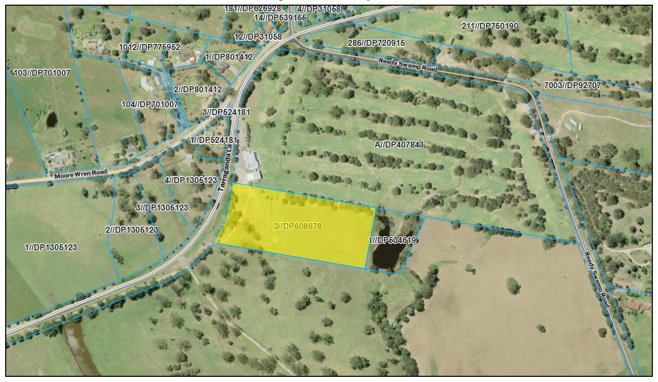

Explanatory Memorandum
Background
- The Board has convened this General Meeting to seek the members' approval to declare the Club's land shaded in the plan and as identified in the resolution above (Relevant Land) as non-core property for the purposes of the Registered Clubs Act 1976 (NSW) (Registered Clubs Act). The reasons for convening this General Meeting are set out in more detail below.
Core property and non-core property
- Under section 41E of the Registered Clubs Act, real property which is owned or occupied by a registered club may be either “core property” or “non-core property”, as summarised below.
- 'Core property' is defined in section 41E to mean any real property owned or occupied by the Club that comprises:

the premises of the Club (which is the property falling within the boundaries of the Club's liquor licence);

any facility provided by the Club for the use of its members and their guests (such as a car park or golf course); and

any other property declared by a resolution passed by a majority of members present at a general meeting of the ordinary members of the Club, to be core property of the Club,

but does not include any real property referred to in paragraphs (a)-(c) that is declared, by a resolution passed by a majority of the members present at a general meeting of the ordinary members of the Club, not to be core property of the Club.
- 'Non-core property' is defined in section 41E to mean any real property owned or occupied by the Club that is not core property.
- The difference between core property and non-core property is that, among other things, core property cannot be disposed of by the Club (except for limited purposes set out in the Registered Clubs Regulation 2025 (NSW) (Registered Clubs Regulation)) without the approval of the members in a general meeting.
- The exceptions in the Registered Clubs Regulation do not provide useful solutions for all the potential dealings with the Relevant Land, that are likely to be needed in the course of exploring the best uses for the Relevant Land and acting upon a suitable proposal. For example, a Club typically grants licences to developers to access the Club's premises, and it would not be practical to obtain approval from the Club's members or from the Secretary of the Department of Creative Industries, Tourism, Hospitality and Sport (which is the Department now administering registered clubs legislation) for each individual situation.
- On the other hand, non-core property can be disposed of by the Club pursuant to a resolution of the Board which does not require further approval from the members in a general meeting subject to any further requirements under the Club's constitution. Therefore, clubs in similar positions typically seek that certain land be declared non-core property to give the Board flexibility to deal with it.
Rationale
- The Board is proposing this Ordinary Resolution to assist in securing the future long-term success and viability of the Club. The Club wants to achieve the best possible use of all of its land. Accordingly, the Club needs to consider different uses of its landholdings, including the possibility to achieve alternate revenue streams and funding for the Club's licensed premises and facilities.
- The Board and Management have considered the real opportunities and challenges for the Club moving forward, in light of the Club's financial performance and available industry trends.
- Like many other clubs operating golf courses in NSW, the Club has also been dealing with continued challenges on its core operations including declining golf membership and participation (which only enjoyed a slight increase in more recent years due to people feeling more enthused to play golf outside due to COVID-19 and lockdowns), the ongoing impacts on revenue from recent challenges like the COVID-19 pandemic and cost of living issues, poor weather conditions, and operating cost increases, to name just a few. The Board's long-term objective has been to develop diversification strategies to generate alternate non-traditional income streams to endeavour, as much as possible, to future-proof the Club and improve profitability.
- The Board feels that the Relevant Land is not being put to its best and most financially optimal use, and that it needs to therefore deploy alternate strategies for the Relevant Land to assist the Club to invest in its licensed premises and other facilities.
- The Board and Management have done significant preliminary work in investigating the highest and best uses of its landholdings.
- As members are aware, the Club is intending to embark on a redevelopment of the Club's main premises which will involve modernisation of the clubhouse. If the Club is unable to deal flexibly with the Relevant Land including any potential disposal however, then the Board and Management do not consider that they can comfortably continue with that main club site redevelopment as it will not be financially feasible to do so.
- In addition, the Relevant Land is not being used optimally. At present, the driving range has limited usage and operates at a loss for the Club.
- In this regard, the Board considers that it should use the Relevant Land for alternate purposes, which may involve a future sale of the Relevant Land, granting a lease or licence to occupy over the Relevant Land, or redeveloping the Relevant Land.
- As noted above, other options under the applicable legislation for dealing with non-core property are not appropriate in this situation, as the Board considers it requires a greater degree of flexibility in dealing with the Relevant Land and exploring future potential uses to achieve a suitable outcome.
- The Board’s investigations have led it to the view that to have sufficient flexibility to investigate the highest and best uses of the Relevant Land and to liaise with third parties, that it will need to be classified as "non-core property". Otherwise, third parties do not have sufficient confidence in dealing with the Club because of the inherent uncertainty.
- In particular, the Club does not want to incur the significant expenses of further due diligence inquiries and/or negotiating a proposed deal in-principle, for example, a joint venture agreement, or a sale or lease arrangement (which may include expending significant costs in terms of consultants and work needed to reach that point) without the certainty provided by a members' approval.
Summary
- Therefore, the Board seeks the members' approval to declare the Relevant Land as non-core property to empower the Board to deal with the Relevant Land as it sees fit and in the best interests of members, and accordingly have flexibility for the Club to attain the best return from this Relevant Land.
General Notes
- The Explanatory Memorandum contains important information with which members should familiarise themselves to make an informed decision at this meeting. All documents (including those attachments referred to in this Explanatory Memorandum) should be read in their entirety.
- To be passed, the Ordinary Resolution must receive votes in its favour from a simple majority of those members present and voting who, being eligible to do so, vote on the Ordinary Resolution.
- All Ordinary Members and Honorary Life Members of the Club are eligible to attend and vote on this resolution.
- Employees of the Club are prohibited from voting and proxy voting is prohibited under the Registered Clubs Act.
- Members attending in person will need to register their attendance upon entry into the meeting.
- The Club's Constitution is available for members on request from the Club's website.

BY ORDER OF THE BOARD

Padraic Gorman
General Manager
13th October 2025

