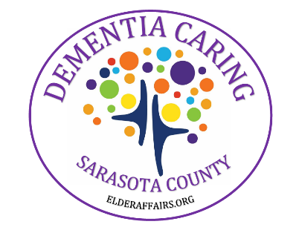
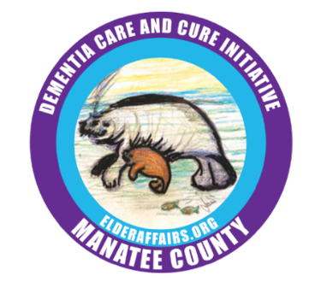
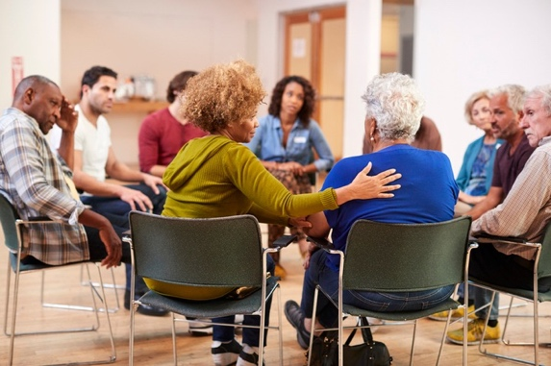

Manatee County Sarasota County
Free Monthly Senior Support Resources
Free Events and Resources in Manatee & Sarasota County

The Dementia Care & Cure Initiative (DCCI) and Aging Stakeholders have partnered to share FREE support groups, classes, and recurring events for senior families. These events are designed to uplift, educate and connect local seniors. Events subject to change. RSVPs encouraged.
Please call each location for more information and to confirm events.

SUPPORT GROUPS
Monday
- Every Monday 10am-11am: The Caregiver’s Pathway at Church of the Palms, 3224 Bee Ridge Road, Sarasota 941-924-1323
- 1st Monday 6pm-7pm: Virtual Support Group for Adult Children. Call for link: 941-277-5048
- 3rd Monday 10am-11am: Parkinson’s Support Group at Lakewood Ranch YMCA. 941-798-9622 x323

Tuesday
- Every Tuesday 11:00am-12:30pm: Loss & Grief Support Group at The Caregiving Place, 2350 Scenic Drive, Venice 941-556-3268
- Every Tuesday 1:30pm-3:00pm: Caregiver Support Group at The Caregiving Place, 2350 Scenic Drive, Venice 941-556-3268
- 1st Tuesday 9:45 am: Mild Cognitive Impairment Support Group at Venice Activity Room Community Center,
2350 Scenic Drive, Venice
- 1st Tuesday 10:30am-11:30am, Caregiver Tips & Tools ActivAge 3801 Bee Ridge Road, Sarasota
941-269-2273
- 1st Tuesday 11:30 am: Frances T. Bourne Jacaranda Library, 4143 Woodmere Park Blvd, Venice
- 1st Tuesday 3pm-4pm: Parkinson’s Care Partner Support Group at Town Square University Pkwy.
Free respite care. 941-277-5048
- 2nd Tuesday 9:30am-11am: Mild Cognitive Impairment Support Group for individual and caregiver at Town Square University Pkwy. 941-277-5048
- 2nd Tuesday 9:30am: Caregiver Collective, Conversations & Caring at Town Square, 3882 Central Sarasota Parkway, Sarasota. 941-336-5061
- 2nd Tuesday 1 pm: Caregiver Support - Angels Senior Living, 5750 S. Honore Ave., Sarasota 941-229-7709
- 2nd Tuesday 2pm-3pm at 81 Oaks Senior Living, 7850 Hawkins Road, Sarasota 941-278-9901
- 2nd and 4th Tuesday 2:30pm-4pm: Dementia/ALZ Care Partner Support Group at Town Square University Pkwy. Free respite care. 941-277-5048
- 2nd Tuesday 3pm-4pm: Dementia Caregivers Support Group at Arden Courts, Sarasota 941-925-3900
- 2nd Tuesday at 6pm at Bradenton Research Center, 3924 9th Ave. W., Bradenton. 941-708-0005
- 3rd Tuesday 12-1pm: Dementia/Alzheimer’s Support Group at Senior Friendship Centers,
2350 Scenic Drive Venice RSVP to 941-961-8751
- 3rd Tuesday 2:30pm-4pm: Younger Onset Care Partner Support Group at Town Square University Pkwy.
Free respite care 941-277-2048
- 4th Tuesday 11am-1pm: Parkinson’s Support Group at Freedom Village 6406 21st Ave W, Bradenton
Lunch provided 203-216-4434
- Last Tuesday at 11 am – Persons Living with Cognitive Challenges Group, Water’s Edge, 2015 32nd Ave. W.,
Bradenton 941-748-7797

Wednesday
- Every Wednesdays1pm-2:30pm: Virtual Caregiver Support Group. Call for link: 941-556-3268
- Every Wednesday LGBTQ Loss & Support Group: 11am-12:30pm, The Caregiving Place, SFC 1820 Brother Geenen Way. Sarasota 941-556-3268
- 1st and 3rd Wednesdays – Parkinson’s Couples Support Group: 9–10 am and 11–12 pm, Parkinson’s Place,
5969 Cattleman Blvd., Suite 100, Sarasota 941-893-4188
- 1st Wednesdays 9:45am-10:45am at Parkinson’s Support Group at Sarasota Memorial Hospital Care Center 941-926-5413
- 1st Wednesday 9:45-11:15am: Mild Cognitive Impairment Support Group at the Venice Activity Center, 2350 Scenic Dr., Venice. RSVP to 941-468-3250
- 1st and 3rd Wednesday 10am-11:30 am: Caregiver Support Group at Emmanuel Baptist Church, 8305 US-301, Parrish 941-723-4821
- 1st Wednesday 10am-11am: Virtual Spanish Support Group. 407-436-7755
- 1st Wednesday 2:00pm-1:00pm, with complimentary lunch, Veterans Support Group. Encompass Health Rehabilitation Hospital, 6400 Edgelake Drive, Sarasota 941-376-2747
- 2nd Wednesday1:30pm-3pm: MCI Education & Support Group at Sarasota Memorial Hospital Care Center 941-926-6413
- 3rd Wednesday 10am, San Pedro Catholic Church, 14380 Tamiami Trail, North Port
- 3rd Wednesday 10:30am-2:30pm: Free Respite at Shining Light Church 941-366-9903
- 3rd Wednesday 11am: Person Living with Dementia Support Group at Fountains of Hope,
Sarasota 941-316-6487
- 3rd Wednesday 3pm-4pm: Free Educational Class by Catherine McDermott, PMHNP at Town Square University Pkwy. 941-277-5048
- 4th Wednesday 10am: Caregiver Support Group at Key Clinical Research, 6060 26th St. W., Bradenton Free respite Call: 941-241-5539

Thursday
- Every Thursday10:00am-11:30am: Caregiver Support Group at The Caregiving Place, Senior Friendship Center, 1820 Brother Geenen Way, Sarasota 941-556-3268
- Every Thursday: Loss & Grief Support Group 1:30pm-3:00pm at The Caregiving Place, Senior Friendship Center, 1820 Brother Geenen Way, Sarasota 941-556-3268
- Every Thursday from 4pm-5pm: The Caregiver’s Pathway at Church of the Palms, 3224 Bee Ridge Rd., Sarasota 941-924-1323
- 1st Thursday 10am-11am at The Manor at Westminster, 1700 21st Ave. W., Bradenton 941-217-1291
- 1st Thursday 3pm-4pm at Elan Manatee, Bradenton 941-229-0052
- 1st Thursday 6pm-7pm at Amira Choice, Sarasota 941-259-8971
- 2nd and 4th Thursdays 10am-11:30am at Elan Manatee, 7375 Stone River Rd., Bradenton.941-773-2408
- 2nd Thursday 9:30am-11:00am, Mild Cognitive Impairment support group, ActiveAge, 3801 Bee Ridge Road, Sarasota 941-269-2273
- 2nd Thursday 10:00am: Caregiver Support Group at Town Square, 3882 Central Sarasota Parkway, Sarasota 941-336-5061

Friday
- 2nd Friday every month 8:00am-10:00am: Free breakfast, fellowship and education for Veterans and spouses/caregivers. ActiveAge: 3801 Bee Ridge Road, Sarasota 941-269-2273
- 4th Friday 1pm-2pm: Parkinson’s Support Group at Sarasota Memorial Hospital Care Center941-926-6413
- 2nd Friday 1pm-2pm: Parkinson’s Support Group at The Paradise Center (seasonal group)
Longboat Key. 941-383-6493

MEMORY SCREENINGS, MEMORY CAFES, DCCI, and VETERANS

Free Memory Screenings – Available by Appointment
- Bradenton Research Center 3924 9th Ave. W., Bradenton 941-708-0005
- Key Clinical Research 6060 26th St. W., Bradenton 941-241-5539
- Town Square University Parkway – Senior and Adult Day Center 8450 Lockwood Ridge Rd., Sarasota
941-277-5048
- Memory Disorder Clinic at Sarasota Memorial Hospital 515 S. Osprey Ave., Suite A-1, Sarasota 941-917-7197
- HealthLine at SMHCS 941-917-7777
- Intercoastal Memory Clinics
- Hyde Park Office: 2881 Hyde Park St. (1st floor), Sarasota 941-906-7155
- Lakewood Ranch II: 11715 Rangeland Parkway, Bradenton 941-538-0088

Free Memory Cafes
A memory cafe is a welcoming social gathering where people experiencing cognitive challenges and the people who care about them come together for socialization, friendship, fun, and refreshments.
- 2nd Tuesday of each month, from 10:00 am - 11:30 am at South Manatee Branch Library,
6081 26th Street West in Bradenton. RSVP (941) 755-3892
- 3rd Thursday of each month, from 10:00 am - 11:30 am at Braden River Branch Library,
4915 53rd Avenue East in Bradenton. RSVP (941) 727-6079
- 3rd Wednesday from 9am-10:30am: Memory Café. Free senior breakfast at Town Square University Pkwy.
941-277-5048

Manatee County DCCI (Dementia Care and Cure Initiative)
- Contact information: dccimanatee@gmail.com.
- To follow DCCI on Facebook, and track announcements and upcoming events:
Manatee County Dementia Care & Cure Initiative (DCCI)

Sarasota County DCCI (Dementia Care and Cure Initiative)
- Contact information: Danielle-Valery@smh.com

Free Services for Qualifying Veterans – Discovery Call Encouraged
- Manatee County Veterans Services: vets@mymanatee.org, 941-745-3795
- Sarasota County Veterans Services: veterans@scgov.net, 941-861-8387
- Sarasota VET Center: Readjustment Counseling Service, U.S. Department of Veterans Affairs
4801 Swift Rd., Suite A, Sarasota 941-927-8285 x23184
- Goodwill Manasota Veterans Services: Every Tuesday from 10am-12pm. Coffee social at Goodwill,
2715 51st Ave. E., Bradenton 941-355-2721 x460
- Town Square University Parkway (free day services and transportation.) 8450 Lockwood Ridge Rd., Sarasota 941-277-5048
- ActivAge is a VA approved provider offering adult day services, call 941-269-2273 for more information
- Senior Friendship Centers Sarasota/Venice is a VA approved provider offering adult day services, call 941-556-3268 or 941-955-2122
- Easterseals Southwest Florida: Free coffee social for Veterans; meets bi-monthly. Call for details.
1629 Ranch Rd., Nokomis 941-412-9333

