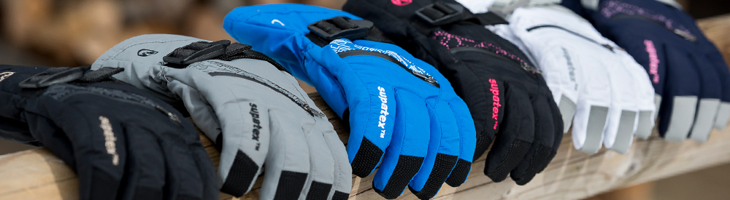
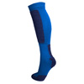
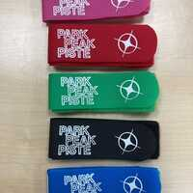

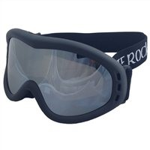
SPECIAL OFFER £50.00
3 pairs of Ski Socks. Double Lens Goggle. Wing Ski Gloves. Ski Hat. Lip Salve and Cream. Ski Tie
ADD £10.00 For Epic or Rocket Glove, ADD £4.00 for different Hat or Neck cowl.
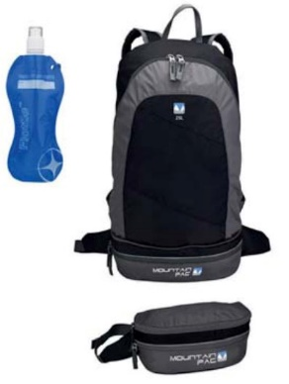
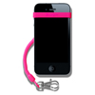
EXTRAS TO CONSIDER.
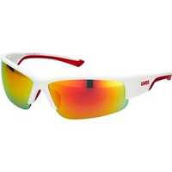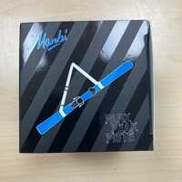

Phone Safe Bungee £8.00. Duo Backpack with Flottle £20.00. Sunglasses from £10.00 to £27.50. Easy Carry Ski Harness £8.00.


