Phoenix Weaponry Ambi Selector Instructions
Bill of Materials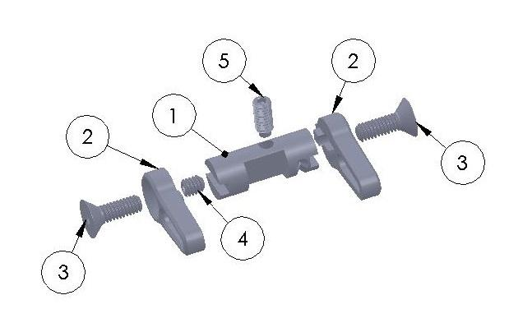
- Qty 1 Selector barrel made from precision ground W-1 tool steel.
- Qty 2 Levers made from 6061-T6 aircraft aluminum.
- Qty 2 8-32 x ½ Flat head cap screws
- Qty 1 8-32 x 3/16 brass set screw
- Qty 1 8-32 x hex extended (dog) set screw
Installation Instructions
- Remove the pistol grip. Collect the safety detent spring and plunger, which are retained by the pistol grip and will come out of the bottom of the receiver once the grip is removed.
- Remove the Hammer and existing selector if you are starting with a fully assembled lower.
- Preform the installation procedure on any aftermarket trigger parts you are using. After you have installed and tested your trigger components, you are ready to install the selector.
- Locate the detent track on the right-hand side of the selector. Note the detent hole in the right side of the receiver selector hole. Install the selector drum with the detent track on the right-hand side to correspond with the detent hole in the receiver.
- Reinstall the detent, spring and pistol grip on the lower.
- Using one of the 8-32 x 3/8” flat head screws install the Right side lever.
- Rotate the selector to the “safe” position.
- Put a drop of Loctite 242 on the 8-32 dog point adjustment set screw, and insert it into the hole on top of the selector drum. With the hammer in the cocked position, turn the screw down until it stops against the trigger rail. Then, back it off 1/8th of a turn for proper clearance.
- Install the brass 8-32 lock screw into the left side of the selector drum and tighten it against the adjustment screw.
- Using the 8-32 x 3/8” flat head screw install the Left lever.
- Test the function of the selector. Make sure that the hammer is in the cocked position and that the selector is in the “safe” position. Squeeze the trigger hard. There should be no apparent movement of the trigger against the selector. Move the lever to “fire” and test the function of the trigger. It should work properly. Move the lever back and forth between fire and safe to make sure you have a smooth, positive detent function on the selector.
Warning: It should not be possible to move the selector from fire to safe when the hammer is in the down or fired position. Attempting to force the selector from fire to safe with the hammer in the down/fired position may damage the trigger components or the receiver. Replacing any original fire control components with aftermarket components may render the safety selector nonfunctional by allowing the rifle to fire on safe. It is imperative to verify safety function.

