WILDLIFE STEWARDSHIP TIPS
Prepared by the Be Bear Aware Campaign
406-540-4140 Bearinfo@BeBearAware.org
For More Quick Links go to:
https://bebearaware.org/quick-links/

Wildlife stewardship is an important part of our responsibility to wild animals. We need to understand there is a delicate balance to keeping wildlife wild and healthy. In our enjoyment of getting to see a wild animal, sometimes we do not realize our interaction is causing them stress and disrupting this balance.

The following materials are intended to show us how to enjoy wildlife without stressing or distracting them from what they need to do to survive.

- GIVE US ROOM TO BE WILD AND FREE Many tourists who visit our National Parks, Forests, and Refuges are unaware how their subtle actions can interfere in the lives of wild animals. It is important to understand that wild animals that have been habituated and conditioned to interact with people still have a flight or fight response.
GIVE US ROOM VIDEO

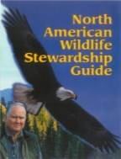
- NORTH AMERICAN WILDLIFE STEWARDSHIP GUIDE
Wildlife + Distance = Safety for both people and wildlife.
This guide provides information about how close is too close. There are special sections for wildlife along the road, protecting children, photographing etiquette, hiking and camping, hunting, bear spray, and tips to reduce the chances of dangerous encounters with wildlife both at home and in wild places.
- KEEPING WILDLIFE WILD VIDEO Wildlife stewardship is emphasized in the introductory message by the late General Schwarzkopf. The video is narrated by the Laird Robinson who was the Information and Education Chair of the Interagency Grizzly Bear Committee and an employee with the USDA Forest Service. It contains information about wildlife stewardship protocol and enjoying wild places safely and responsibly.
KEEP WILDLIFE WILD VIDEO
WILDLIFE STEWARDSHIP TIPS
CONTINUED

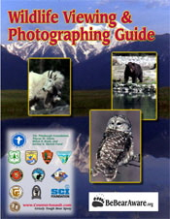
- WILDLIFE VIEWING & PHOTOGRAPHING GUIDE This guide helps identify how close is too close when enjoying our wildlife treasures. It also provides tips for safely getting great wildlife photographs without stressing wildlife. It features animal in the wild and along the road, and the importance of not feeding animals.
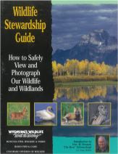
- WILDLIFE STEWARDSHIP GUIDE Wildlife that live in parks, forests, and refuges are wild even though they may look or act tame. Animals need space, just like you and me. Even a cute little chipmunk has a fight or flight instinct. This guide is intended to help people be responsible for their own safety and the safety of wildlife.
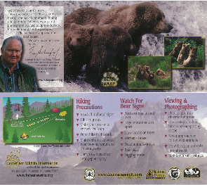
- WELCOME TO BEAR COUNTRY HANDOUT This is a 4” x 9” inch card that is two-sided. It offers quick tips for hiking, identifying bear sign, and viewing and photographing wildlife. The photographs depicted were all taken from observation areas with telephoto lenses.

- ADDITIONAL FUN VIDEOS AND INFORMATION can be obtained from our website and YouTube channel. Learn the differences between grizzly, black and polar bears. Learn bear avoidance techniques for hiking, biking, camping, hunting, and fishing in bear country. Watch video demonstrations of how to use bear spray in different charge scenarios.

YOU CAN MAKE A DIFFERENCE BY SHARING THIS INFORMATION
WITH FAMILY AND FRIENDS

BeBearAware.org  youtube.com/bebearaware
 facebook.com/bebearaware instagram.com/be_bearaware

