
VOLUME 26 ISSUE THREE NOVEMBER 2026

A MESSAGE FROM JUDI MIGDOL, PRESIDENT

It is hard to believe it is November already. Our snowbirds are back – or will be back very shortly – so our Temple Shalom family can be together again.


We are planning our annual Temple Shalom Chanukah Menorah lighting and latke party. Please bring your families – more info in the flyer. We hope to make it very special.

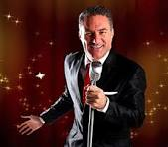

We are also working on our Jimmy Mazz dinner dance in March. More info will follow in next month’s Shalom. We thank all of you who have sponsored this event so far. It is so appreciated!!!

We also have ideas for some smaller functions. Please watch for flyers. Do you have any ideas for a function? Please let me know. We love all new ideas.

Thanksgiving is this month. We ALL have so much to be thankful for – especially our families - and even our Temple Shalom family. That is what we are – we truly are a family, Families disagree sometimes, but still always care about each other. Families are always a blessing!!

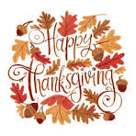
Rabbi Emeritus Agin and Arline join the board and I in wishing you a Happy Thanksgiving and may all your blessings keep growing.

YAHRZEITS

November 6, 2026
Selma Basoff  Bessie Epstein  Raphael Hasson | Betty Helft  Michael Hoffman  Joseph Horenstein | Dr. Bernard Horowitz  Joseph Horowitz  William Langel | Kenneth Migdol  Clara Karp Olsan  Mary Portock

November 13, 2026
Stanley Bagan  Doris Barnard  Florence Berkowitz  Bessie Bloom  Milton Bloom | Morris Chait  Lynne Cook  Alfred Frankenthal  Marc Friedman  Herman Goldberg | Sandra Karlin  Harry Krasney  Rynette Kraus  Sampson Leff  Helen Rebma | M. William Siegel  Anna Warshaw  Harry Weinstein  Leo Wotitzky

November 20, 2026
Eva Binstock  Lotte Freiman Domke  Lillain Gleaner  Gerson Goldberg  Samson Golden  David Goldsein | Paul Hallerman  Rita Horenstein  John Kennedy  Passie Kleiner  Simon Levin  Benjamin Lubiner | Louis Neiman  Morris Perel  Rachel Reisner  Samuel Rothenberg  William Stein  Samuel Schecker | Jerry Schneider  Harry Sherry  Annie Shulman  Rose Weinstein  Martha Welkis

November 27, 2026
Charles Bader  Murray Cohen  Beatrice Daroff  Gary Druker  Doris Epstein | Andrew Fadness  Carol Galburt  Rebecca Golden  Sam Levin  Louis Levinson | Nadine McMahon  Lester Migdol  Sylvia Migdol  Gordon Rodetsky  Claire Salouf | Samuel Salzinger  Sigmund Schoenfeld  Bessie Selenkow  Ida Silverman  Sarah Widzer

FAMILIES THAT ARE OBSERVING A YAHRZEIT DURING THE MONTH ARE REQUESTED TO ATTEND THE FRIDAY EVENING SERVICE DURING WHICH THE NAMES WILL BE READ PRIOR TO KADDISH.

A donation to the Temple in memory of your loved one is an honored tradition.



DONATIONS

The Mergentheimer Family
Donation

Iris Labush
In honor of Ruth Ross 90th birthday

Paul and Judy Leight
Donation

Temple Shalom Opera Group
In memory of Odette Port

Rabbi Solomon and Arline Agin
In memory of Janet Levine

Gayle Druker
In memory of Sylvia Barenbaum

Joe and Anita Sabatino
In memory of Dr. J. Kaplowe
In memory of Sarah Vishno

Joanne Singerman
In memory of Trevor Singerman

Rhoda Hammer
In memory of David Greenfield

Allen Levin
In memory of Adele Levin
In memory of Ruth Gregory

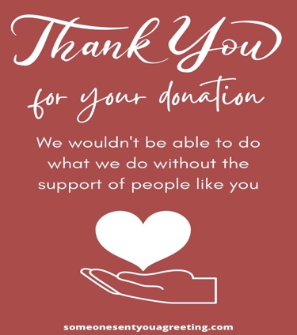
NOVEMBER BIRTHDAYS

Linda Bloom
November 4th

Joanne Singerman
November 6th

Amira Bernstein
November 12th

Geri Waksler
November 12th

Samuel Cohen
November 13th

Jack Bernstein
November 24th

Sharon Forsch
November 24th




You are encouraged to bring a non-perishable food item to Temple as a sign of a “Mitzvah of Concern”, that we have an obligation to help those who are in need in the community.

Do you have any GOOD IDEAS for the Temple – functions, fundraisers, and committees? If so, please let us know. Please contact any board member with your thoughts. This is your temple, and we want your input!!!!

Would you like to sponsor and shop for an Oneg Shabbat? It could be for a life cycle event – birth of a child, birthday, anniversary, or just to do it. Please call Naomi Alexander to schedule it. We really need different members to sponsor and shop for Onegs.

Would you like to advertise in the Shalom (and reach all our congregants) – or do you know someone who would like to advertise? If so, please call Judi Migdol at 516-635-9871 for information.

We have a wonderful library in Temple Shalom. Please let us know what kind of books you would like us to obtain for your reading pleasure.
Any camera buffs in our congregation? Please take some pictures at our functions and some of our Shabbat Services and forward to Jeff Marks.



Sisterhood's Fall Season has been off to a great start.

We enjoyed a fun lunch meeting at Cody's. We accomplished quite a lot of business, hearing our financial report from our excellent Treasurer Amira Bernstein, and planning our next activities. Thanks to the members who have sponsored Onegs we were able to give the Temple a generous donation for the High Holiday appeal. Many members of the congregation have sponsored Onegs in the last few months, we appreciate it very much.

Our Sisterhood Hanukkah Party will be held on Wednesday, December 9, at 11:30 am at the Temple. We will have a "Holiday" lunch and our popular Gift Exchange. Please bring a gift worth $15. I will be sending out reminders as it gets closer.

Our Game Day will be held on February 15, 2027 at the Temple. This is our largest fundraiser, and also lots of fun. I will be sending you information and tickets in the New Year. Thank you to everyone who supports us and enables us to support the Temple.
Naomi Alexander

Brotherhood

Brotherhood had our first meeting and breakfast of the year. We are making many plans for a variety of programs. We have also been busy hanging Mezuzahs at people’s homes. If you would like one, please let a member of Brotherhood know.

The next Brotherhood meeting will be on November 29th at 9:00am and breakfast will be served! Please let me know if you will be attending.

Please keep your eyes open for information of upcoming events.
Al Lubiner

Temple Shalom’s
Community Chanukah Menorah Lighting
Sunday, December 6th – 5:00pm


Music and sing-along with Dr. David Katz

Refreshments including
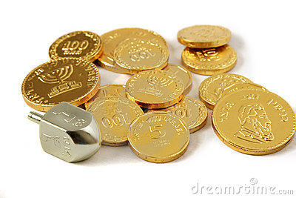Latkes and Donut Holes Served

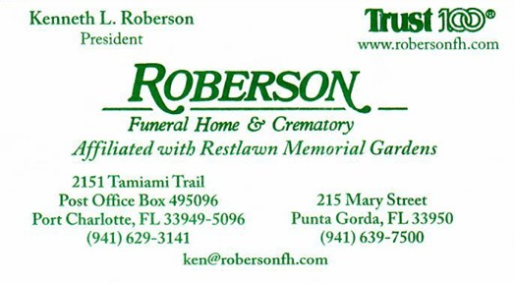

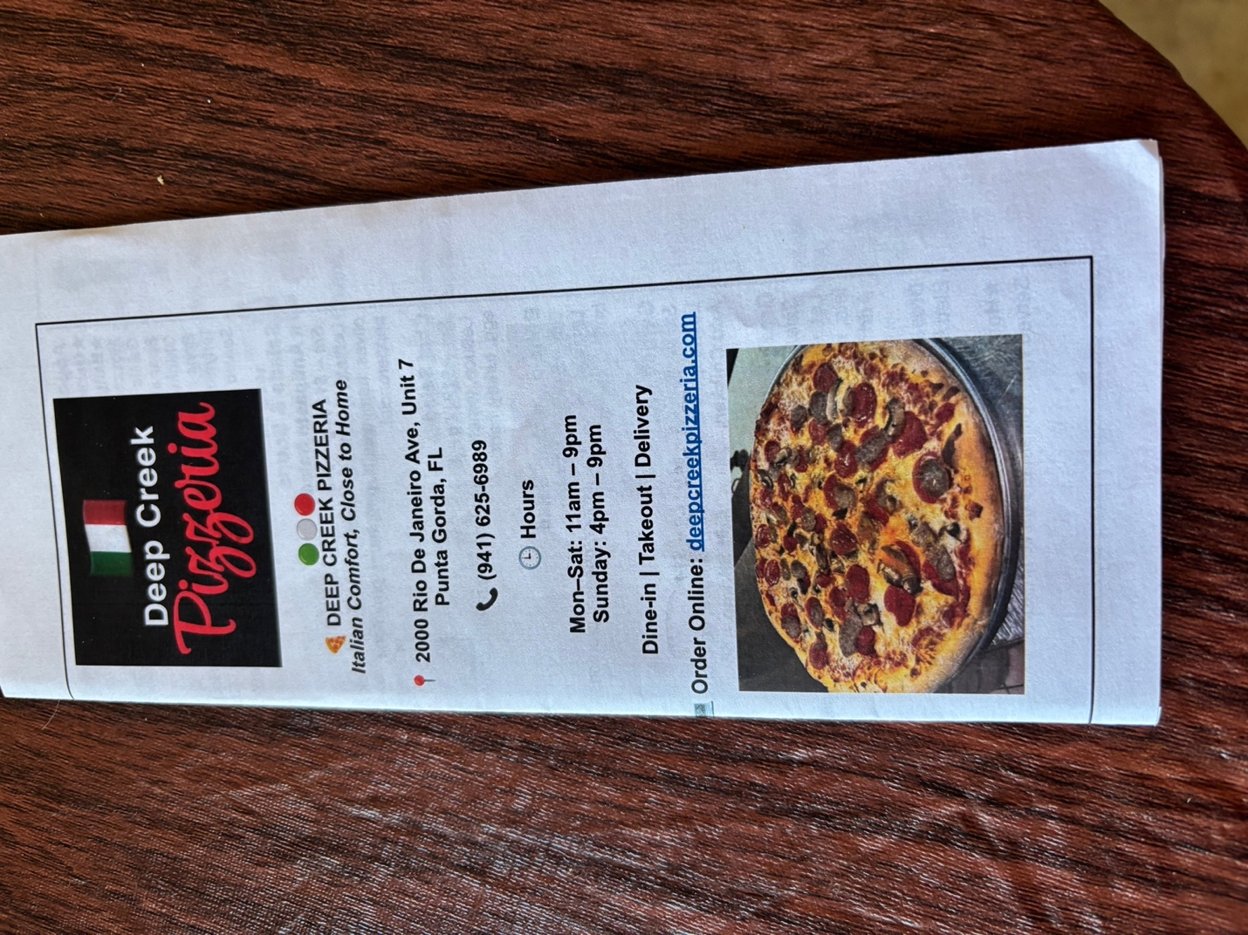

TEMPLE SHALOM

23190 Utica Avenue
Post Office Box 494675
Port Charlotte, Florida 33949-4675
941-625-2116
http://www.Templeshalomfl.com
Affiliated with Union of Reform Judaism

Solomon Agin, D.D. Rabbi Emeritus

Judith Migdol President
TBA President - Elect
Arnold Kantor First Vice President
Sheldon Harris Second Vice-President
Glenn Stern Treasurer
Sharon Cooper Corresponding Secretary
Shelly Pollack Recording Secretary
Naomi Alexander Trustee
Joyce Gelfand Trustee
Alvin Lubiner Trustee
Cindy Melser Trustee
Sandi Walker Trustee
Barbara Allvin Temple Staff – Administrative Assistant
Debbie Stisher Temple Staff – Building Custodian
Roy Thom Temple Staff – Friday Evening Attendant
Judith Migdol Editor - Shalom



IMPORTANT NOVEMBER DATES

Shabbat Services – 7:30pm
Friday, November 6th
Friday, November 13th
Friday, November 20th
Friday, November 27th

Temple Board of Directors Meeting
Thursday, November 19th – 1:00pm

Brotherhood Breakfast Meeting
Sunday, November 29th – 9:00am

