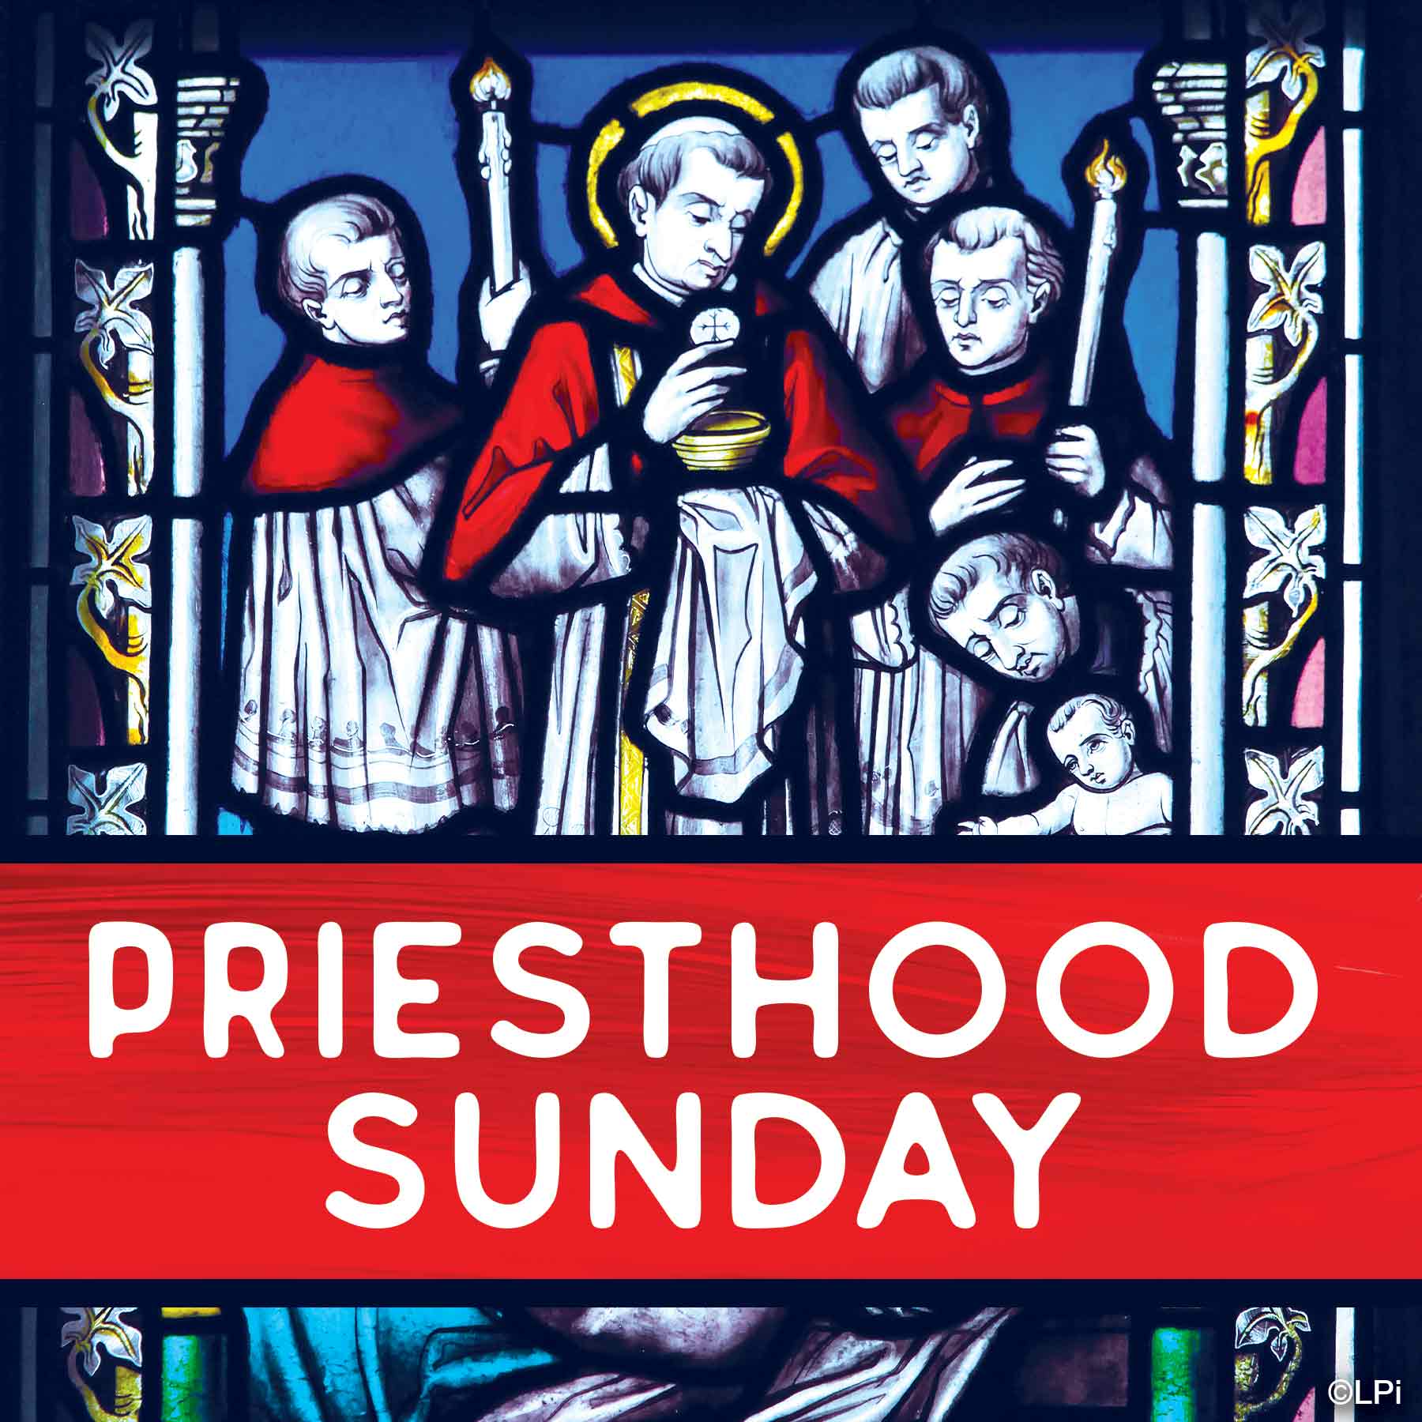**Priesthood Sunday • September 28**

Pope Francis declared 2025 the Jubilee Holy Year of Hope.

Show your appreciation for our priests here at Saint Anthony’s by sending a personal message of hope to them. Shhh, it’s a surprise!

Please fill out your message and return to the Respect Life Committee members after each Mass **on or before** the weekend of September 13/14.

We will be presenting your surprise messages and gifts to Friar John,   
Fr. Florian, and Fr. Christian at the 11:00am Mass on Sunday, September 28.

**Prayers for your Journey!**

Friar John,

I would like to take this opportunity to thank you. I am offering these prayers of Hope on your behalf:

_________________________________________________________________________________________________________________________________________

_________________________________________________________________________________________________________________________________________

_________________________________________________________________________________________________________________________________________

_________________________________________________________________________________________________________________________________________

_________________________________________________________________________________________________________________________________________

**Prayers for your Journey!**

Father Florian,

I would like to take this opportunity to thank you. I am offering these prayers of Hope on your behalf:

_________________________________________________________________________________________________________________________________________

_________________________________________________________________________________________________________________________________________

_________________________________________________________________________________________________________________________________________

_________________________________________________________________________________________________________________________________________

_________________________________________________________________________________________________________________________________________

**Prayers for your Journey!**

Father Christian,

I would like to take this opportunity to thank you. I am offering these prayers of Hope on your behalf:

_________________________________________________________________________________________________________________________________________

_________________________________________________________________________________________________________________________________________

_________________________________________________________________________________________________________________________________________

_________________________________________________________________________________________________________________________________________