**New Caledonia 2026**

**Start:** Nouméa

**Finish:** Nouméa

**Duration:** 22 days

The tour starts early on Sunday 4 October 2026, and finishes on Sunday 25 October 2026.

We will organise our pre-meeting in Nouméa on Saturday 3 October at 5 pm.

**Grande Randonnée GR1 - Bushwalking the South Province**

The next day, on Sunday 6, a van will pick us up at our hotel to drive us to the old village of Prony, which will be the starting point of our bushwalking on the GR1 and the Parc Provincial de la Rivière Bleue.  
It will take us 10 days to cross the Rivière Bleue Provincial Park. We will walk on tracks built by the Kanak People in immemorial times or by the "Muletiers" (mule drivers) who supplied the region's mines and sometimes on tracks broken by the runoff of rain and time. The tracks go up and down, sometimes steep and slippery. But the landscapes of the primary forest and the lookouts will reward you for your efforts. We will evolve in a universe of moss, giant trees (kaoris) and horizons of red earth and green vegetation. We will explore one of the richest ecosystems on the planet, which is said to be a relic of what Australia was 80 million years ago.

At night, we will sleep in cabins, shelters, or tents.

A food drop will allow us not to have to transport 10 days of food. It will be organised on the 4th day, so we will only have to carry 6 days of food on the second section of the route.

On the 11th day, you can enjoy a day off in Nouméa while I prepare our second walk in the Northern Province Nord (Northern Province) in Kanak lands.

**Grande Randonnée GR2 - Bushwalking the North Province**

We will reach the start of our second hike by taking the local bus. It takes around 5 hours to reach the Northern Province from Nouméa.

On the GR2, we will walk for 5 days but we will not have to carry our backpacks. They will be transported by car to each village. Freed from the weight of our bags, we will be able to appreciate the tropical landscapes of the Northern Province even more. Most of the tracks are old redeveloped Kanak tracks well maintained. Along our way, we will have the opportunity to swim in streams or waterfalls.

In the evening, we will sleep in the Kanak villages, where we will be served our dinner and breakfast. We will then discover the local gastronomy, particularly the famous "Bougna", a traditional Kanak dish cooked from yams, tarot, sweet potatoes and coconut milk. This is a dish that we will discover at Helene in Tchamba and also at Michel in Napoepa.

Immersion in Melanesian culture is one of the highlights of this trip to New Caledonia. “The Kanak is welcoming by nature” as Jacques Thy likes to tell me, whom we will meet at his home in Ouanache.

**Ile des Pins**

We will end our discovery of New Caledonia with a trip to the magnificent Isle of Pines, which is covered with colonial pines and lined with bays that are inviting for swimming in the crystal waters.

On the Ile des Pins, we will sleep in a cottage where you can choose the type of accommodation you want according to the comfort that suits you best.  
We will explore the island by traditional canoe and on foot, and we will end our trip with a boat excursion where we will have lobster, fish, or chicken lunch.

Then we will return to Nouméa by ferry on Sunday 27 October in the late afternoon. And if you want, we can organise a farewell dinner in a gourmet restaurant in Nouméa.

**Weather**

October is the most pleasant month of the year to discover the island of New Caledonia. We should enjoy a tropical climate similar to the one we experience near Brisbane. It should, therefore, be sunny, but it could also rain or be very hot.  
Average temperatures are between 15 and 26 degrees. In the Southern Province, when we sleep in high-altitude shelters, the nights can be quite cold. And like in Australia, it can also be very hot during the afternoon when the sky is blue.

We will definitely have rain during these 22 days together. You must take the fly if you want to sleep in your tent.  
For my part, I don't carry rain clothes but if you choose to take some, make sure to take some light ones.

**Inclusions**

**GR1 & GR2:**

Including

- All transports GR1 & GR2 (Including Transport of the Backpacks on GR2)

- Accommodation GR1 & GR2

- Dinners GR1 & GR2

- Breakfasts GR2

Excluding

- Return flights Australia/New Caledonia

- Hotel in Nouméa (minimum of 5 nights)

- Breakfasts & Lunches on GR1

- Lunches on GR2

**Ile des Pins:**

Including

- All Transports (by boat or by plane)

- 1-day Boat Excursion

- 1-day Canoe + Walk

Excluding

- Accommodation

- Breakfasts (3), lunches (2) and Dinners (3),

**Optional activities:**

Visit of the Loyalty Islands (Maré and Lifou)

I would love to organise a two-week tour of the islands of Maré and Lifou (End October to 10 November). It would take 3 participants.

**NEW CALEDONIA DESCRIPTION**

New Caledonia separated from Australia around 80 million years ago. Tectonic forces carried it like a cork towards the immensities of the Pacific Ocean. It is now located 1630 km from Brisbane and 2260 km from Sydney. It's both far and so cloth!

New Caledonia has been a French territory since 1853 but has been inhabited for around 3000 years by Austronesian populations. Therefore, European culture through French and Melanesian culture coexist on "Le Cailloux" (The Rock), which the natives affectionately call New Caledonia. In a fairly schematic way, French culture is found mainly in the Southern Province around Nouméa and Kanak culture in the Northern Province.

As Bushwalkers travellers, we will have the chance to discover these two provinces by following two Great Walk trails in both provinces, the so-called NC GR1 and NC GR2.

The South Province is, as its name indicates, the southern part of the Big Island of New Caledonia. It has managed to preserve a vital biodiversity, particularly in the Riviére Bleue Provincial Park. It’s a botanist’s paradise! A walking path of around 120 km crosses this park; it is the NC GR 1 (Nouvelle Caledonie Grande Randonnée 1 - New Caledonia Great Walk 1) crosses the south of the Province through the centre starting from the small village of Prony on the bay of Prony to the Dumbéa valley. It is a route that allows you to explore the two main types of vegetation: mining "macquis" and more or less dense rain forests. We will find giant kaoris, immortal Neocallitropsis and gum oaks,  forests of "pins colonaires" or carnivorous plants (Nepenthes) in these almost entirely endemic environments. On the GR2 in the Northern province, tree ferns (cyathea) and niaoulis (melaleucas) will be added. The GR North in Kanak lands will take us through a labyrinth of rainforests and rivers. But beyond the beauty of the landscapes, it is the welcome of the villagers that will mark our hike. We will discover Kanak culture through the kindness of our hosts and the quality of their cuisine.

### 

## PHOTO DESCRIPTION

### A two-hour drive will take us to

### Prony Village

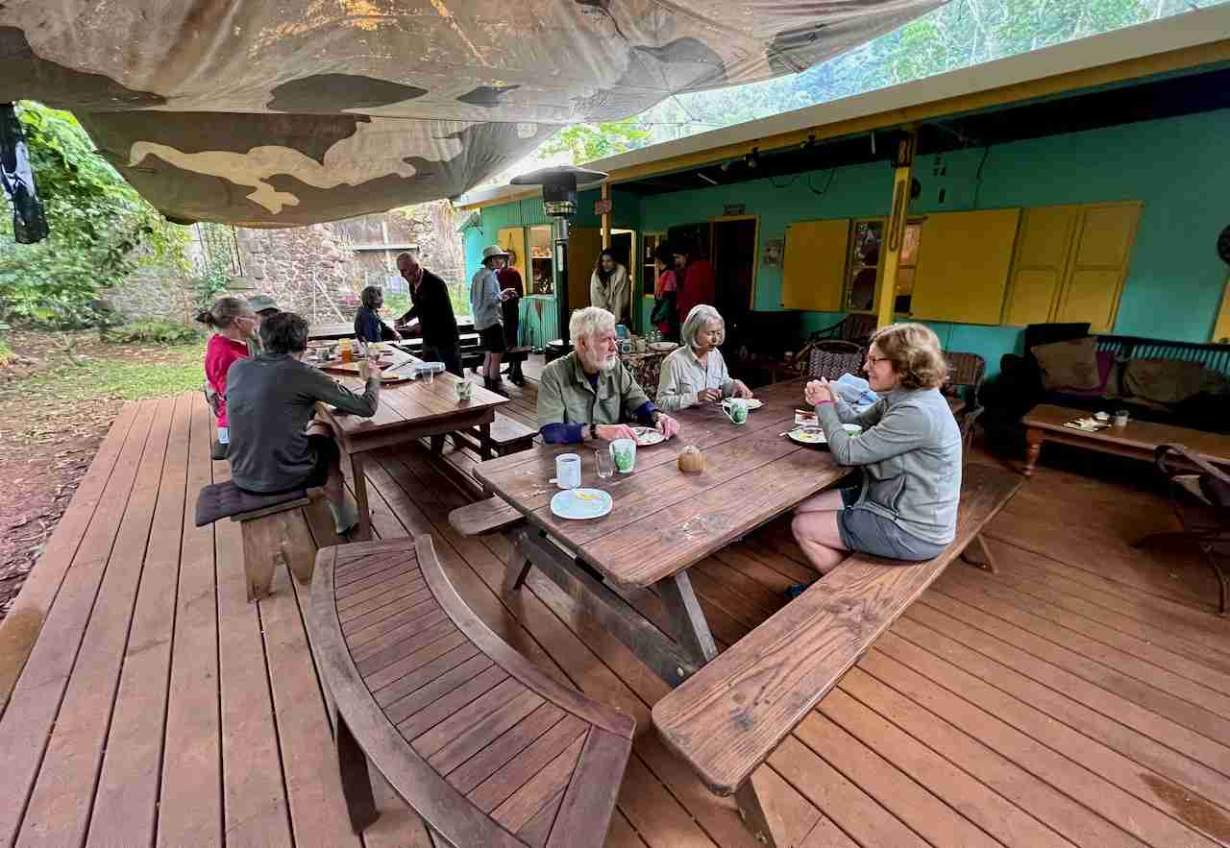

### 

### Where the old prison buildings disappear under the vegetation.

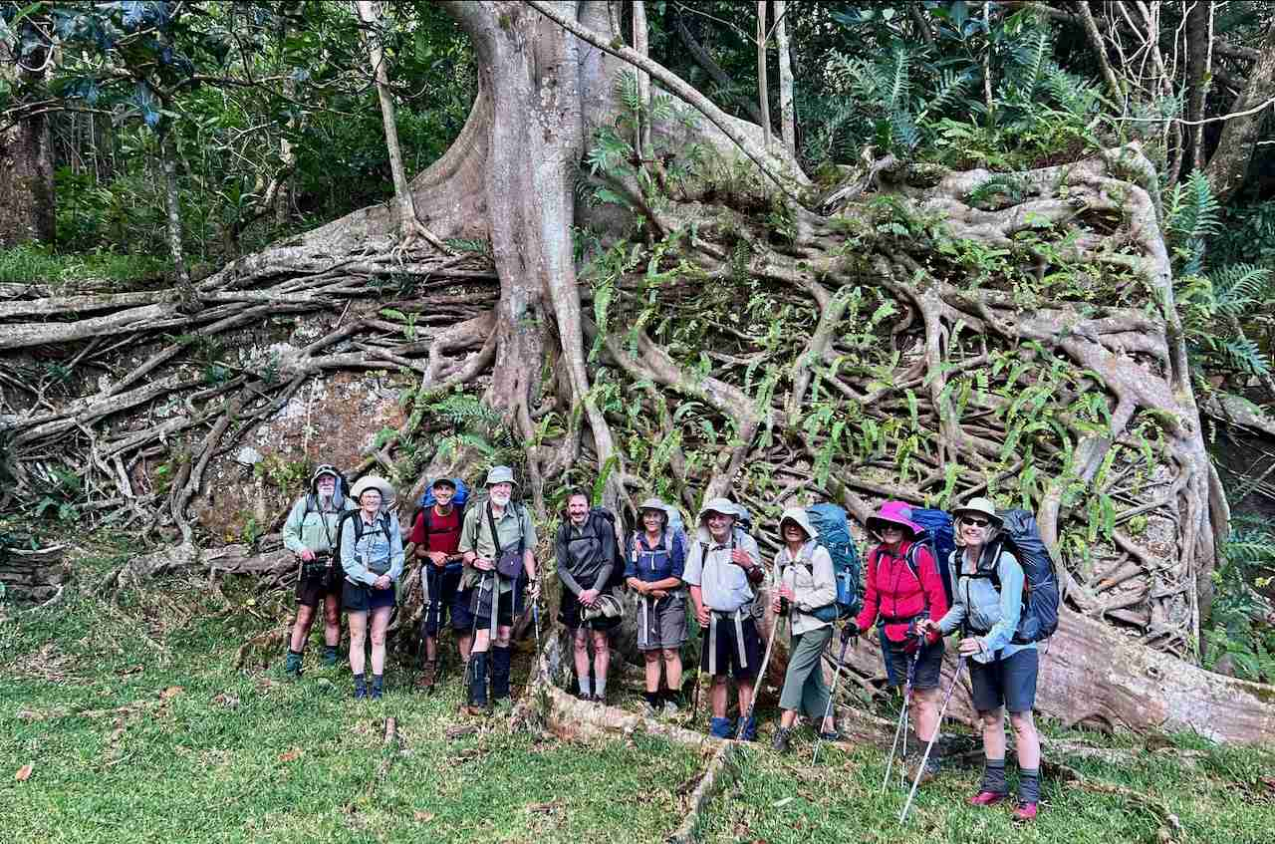

### 

### The flora of New Caledonia is fascinating, whether it is the strangler fig, the mountain kaoris or the carnivorous plants.

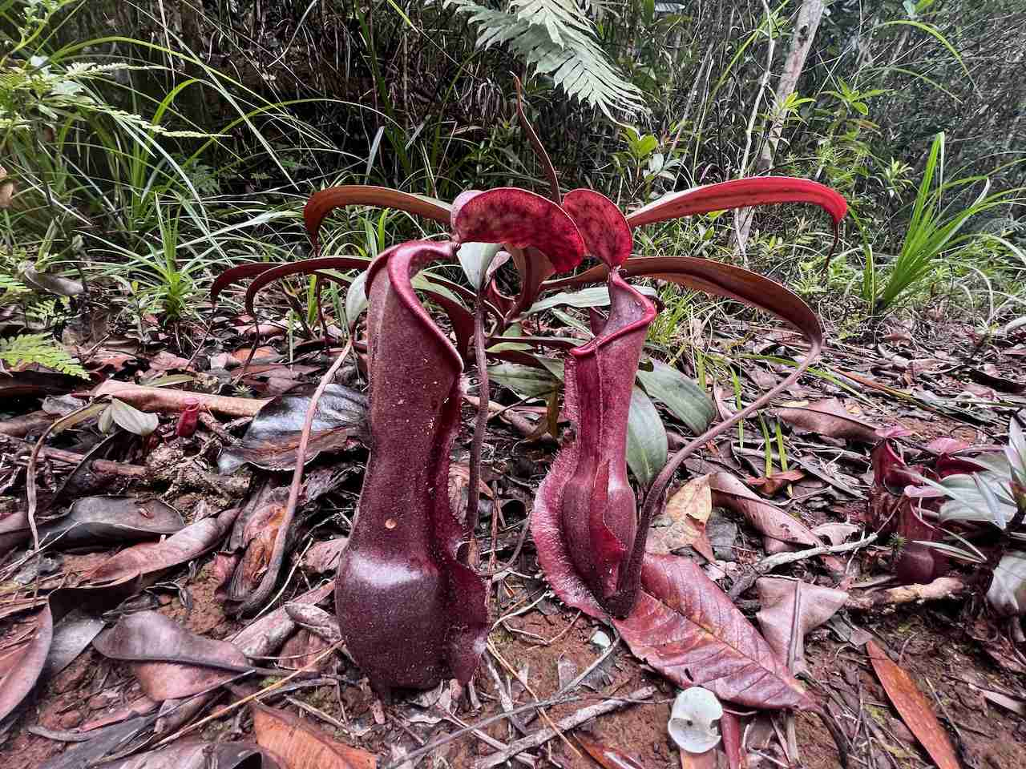Nepenthes Vieillardii

### During these first days, we will cross rivers where the water will invite us to swim.

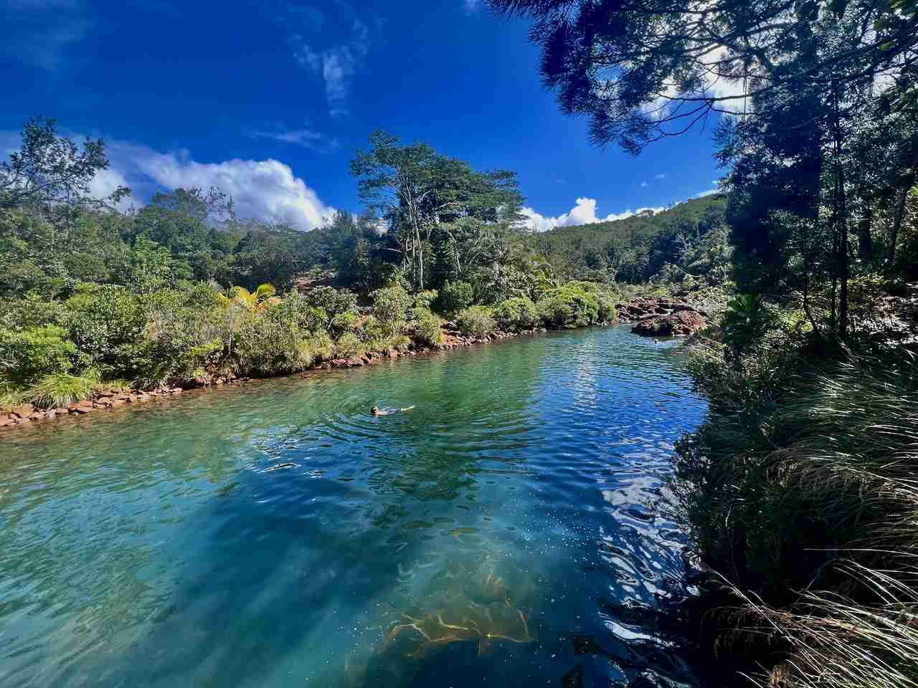La Petite Rivière Bleue (The Little Blue River)

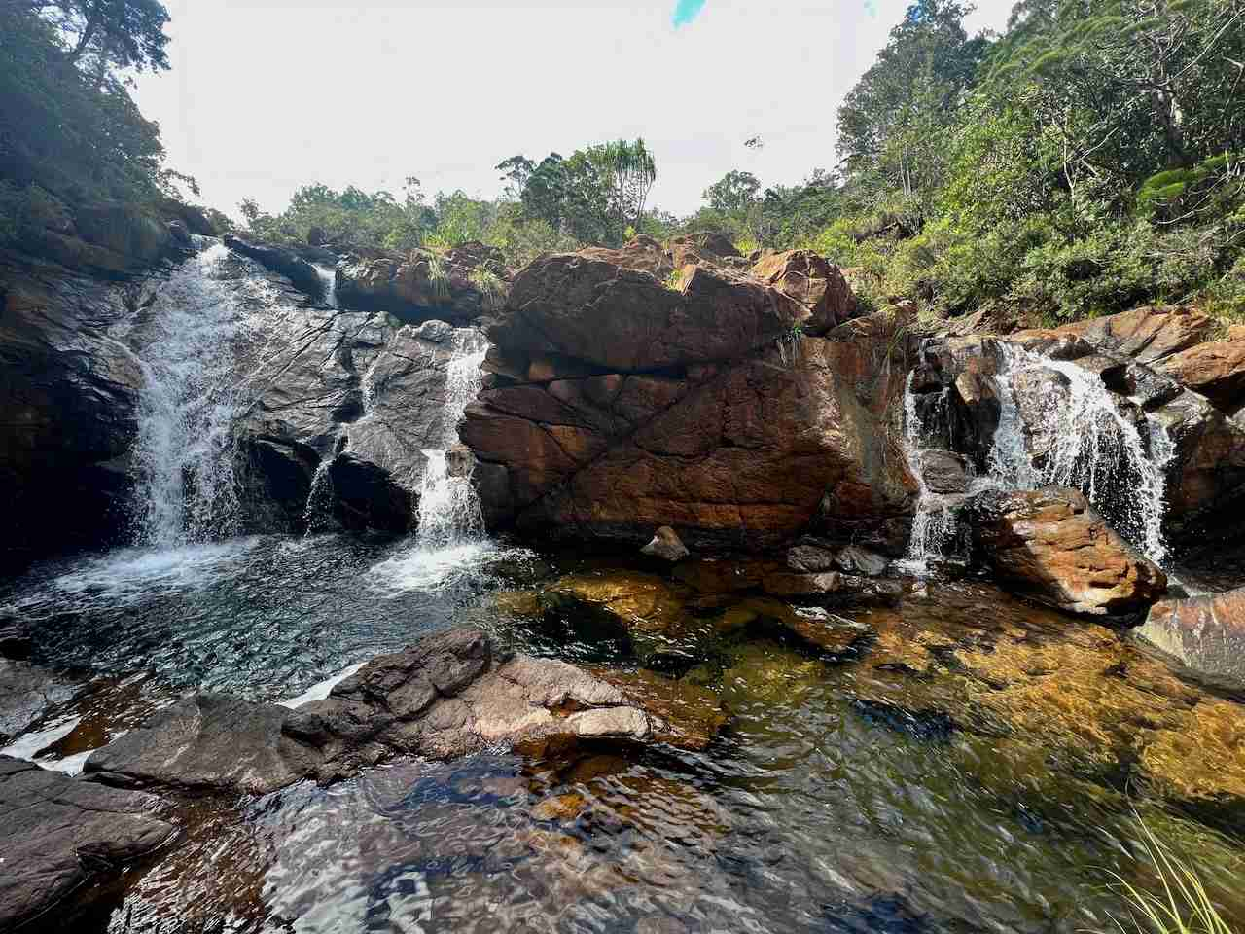Cascade du Carénage (Carénage Falls)

### 

### Our path will take us to the top of the hills.

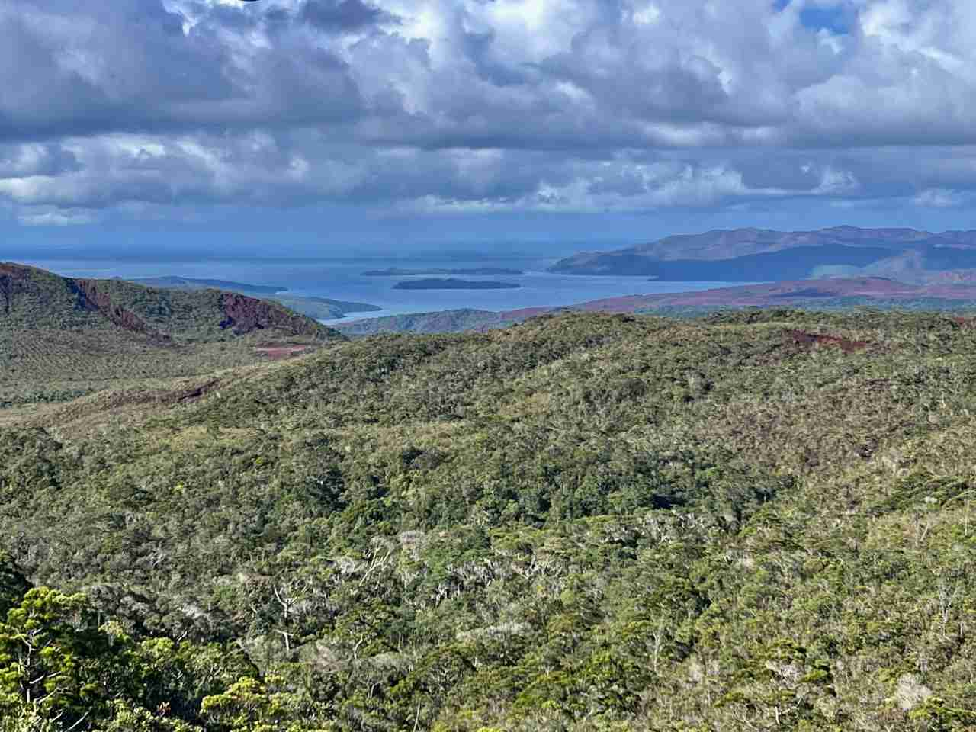Baie de Prony (Prony's Bay)

### 

### Where most of the plants are endemic (80 to 90%)

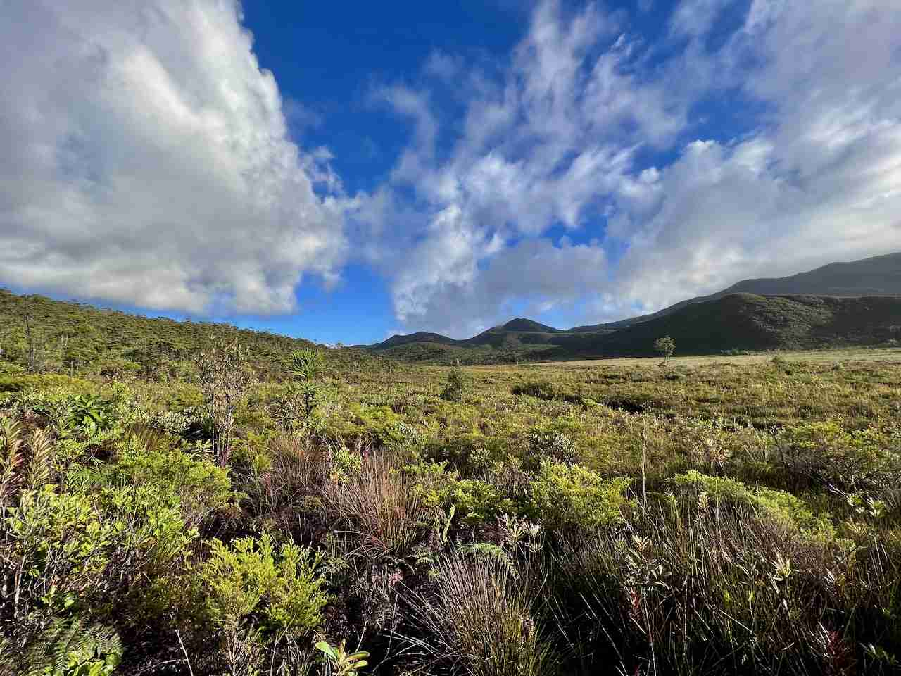Macquis Minier (Miners Scrub)

### We will sleep in equipped shelters or in tents at night, depending on our desires.

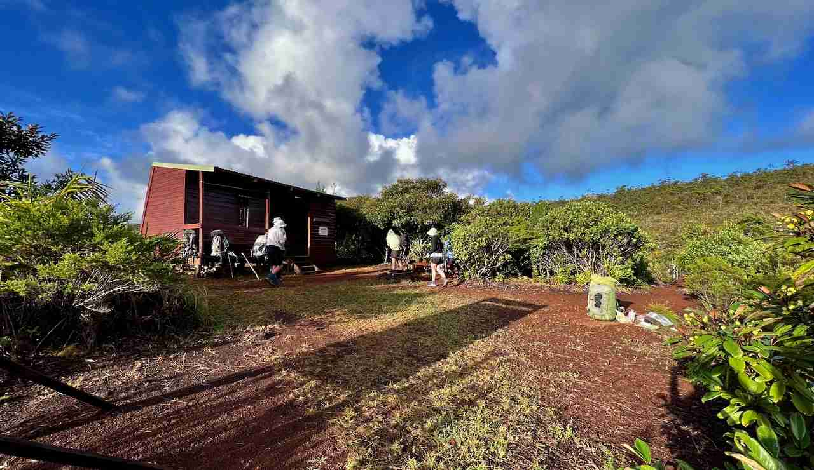Refuge de Neocallitropsis (Neocallitropsis Shelter)

### 

### From the fourth day, we will discover the Rivière Bleue park and its varied landscapes.

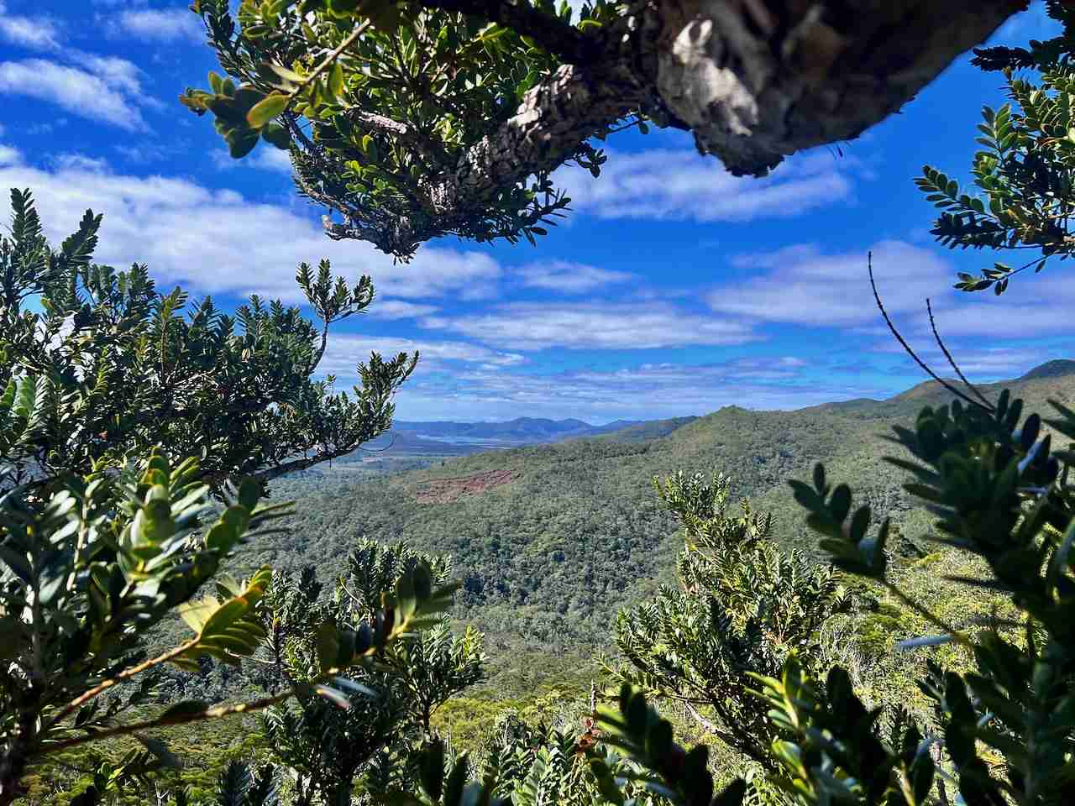Kaori des Montagnes - Agathis Ovata  ( Mountain Kaori - Agathis Ouata )

### 

### On the fourth day, we will discover the Rivière Bleue Park and its varied landscapes.

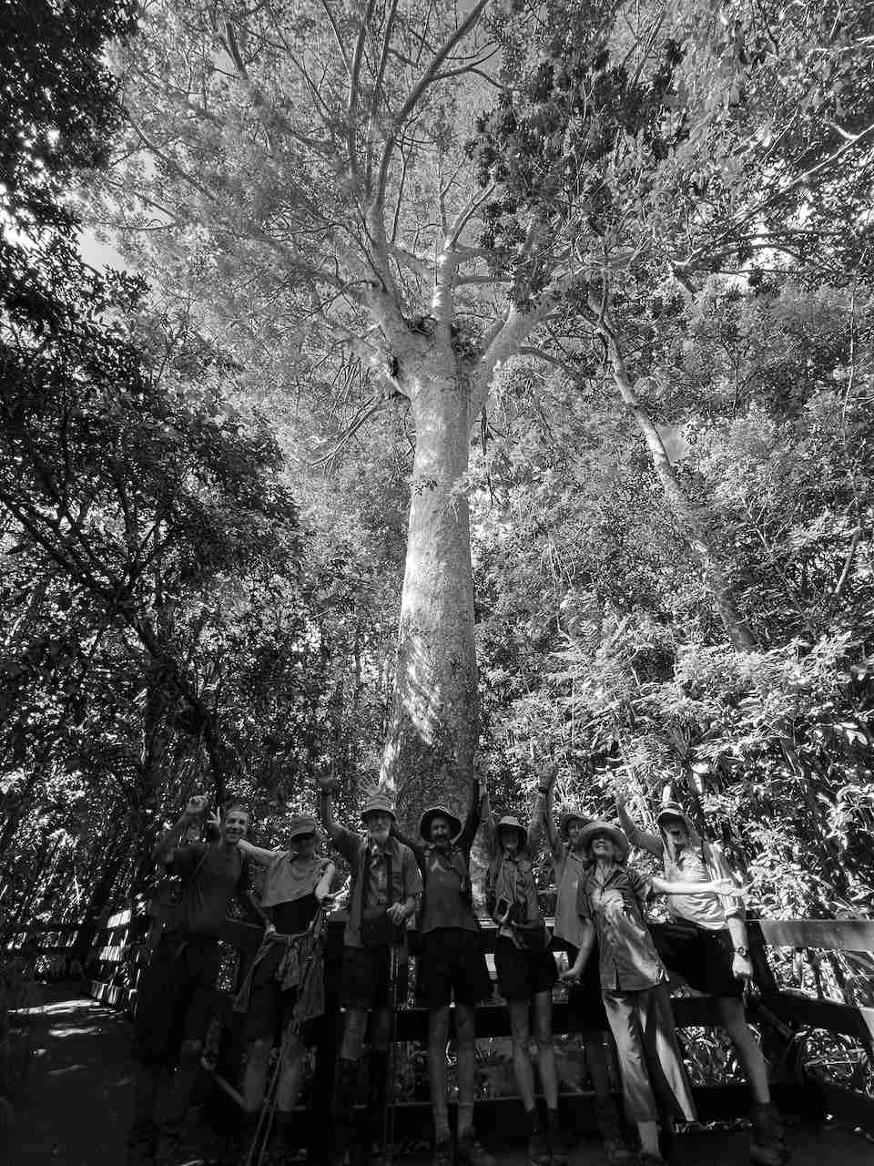Kaori Géant- Agathis Lanceolata  ( Giant Kaori - Agathis Lanceolata )

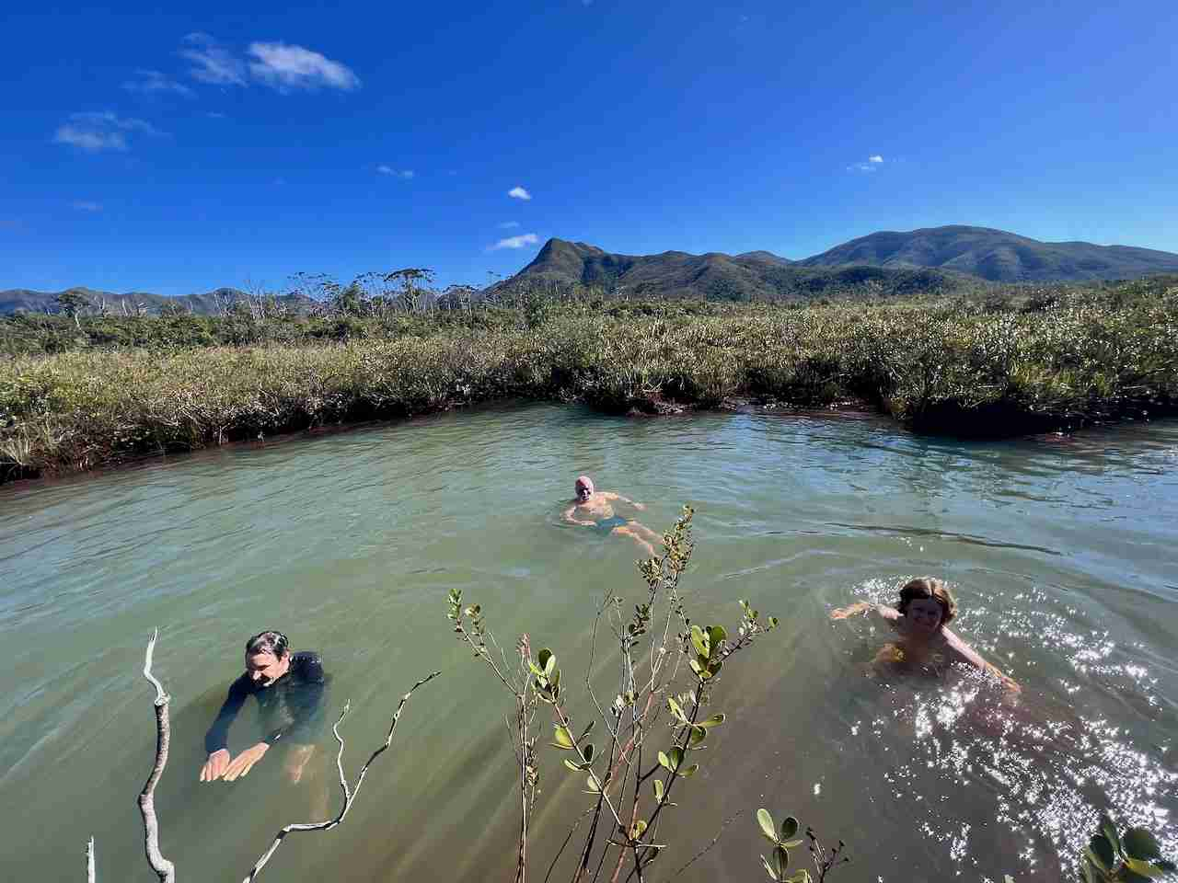Creek Pernod

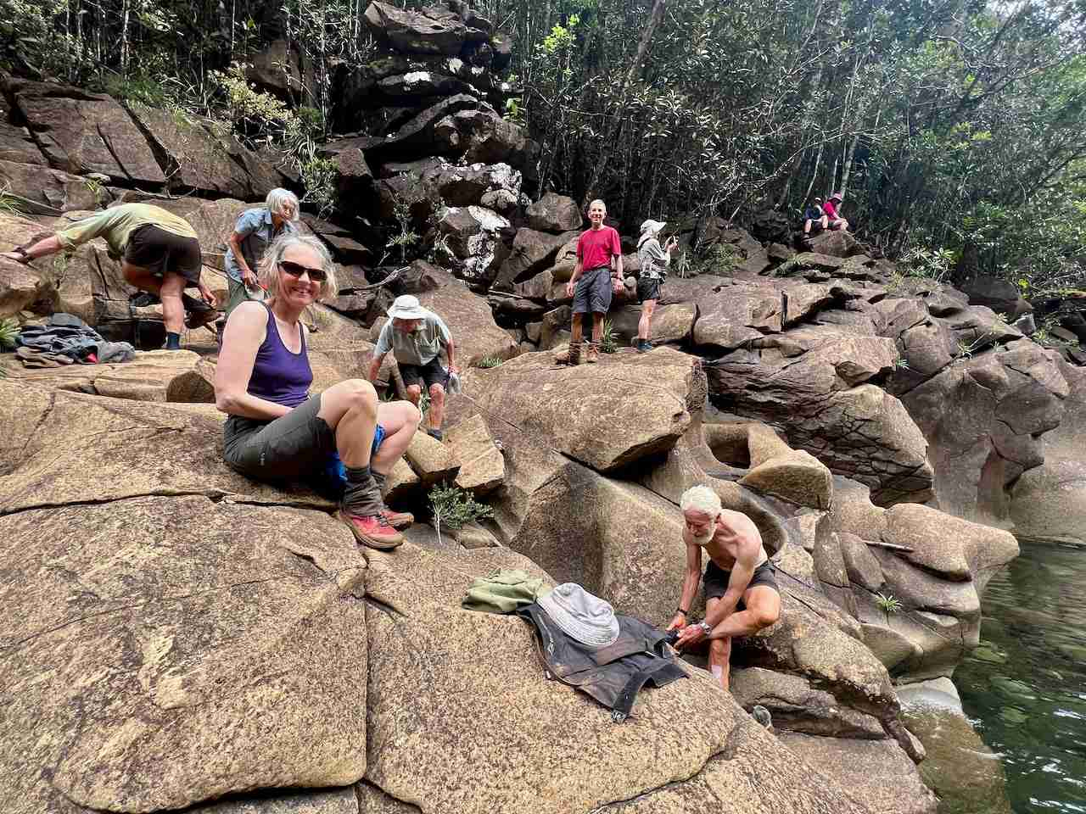La Rivière Bleue (The Blue River)

### On the fourth day, we will discover the Rivière Bleue Park and its varied landscapes.

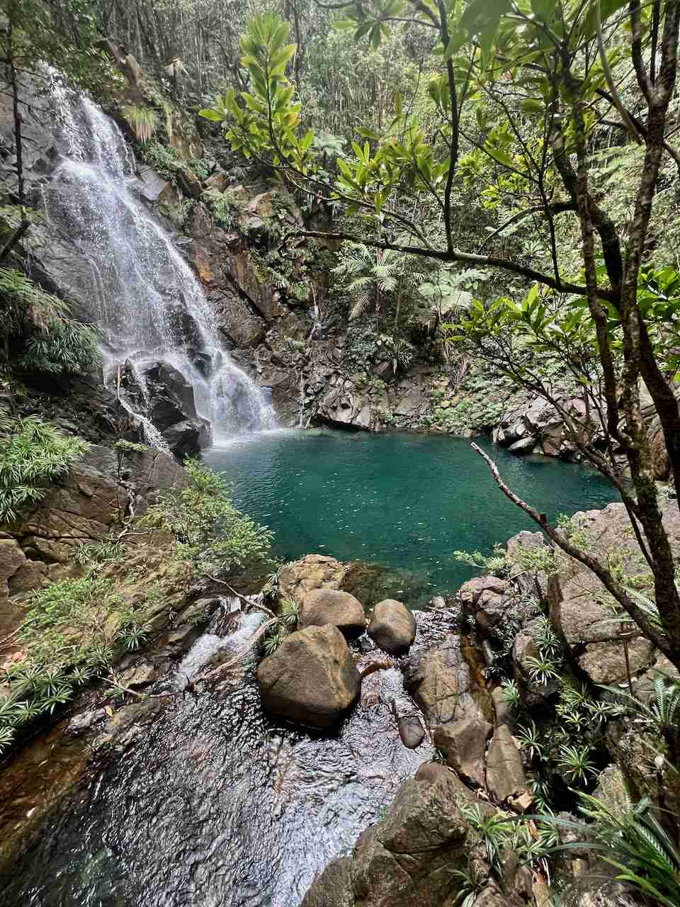La Grande Cascade (The Great Cascade)

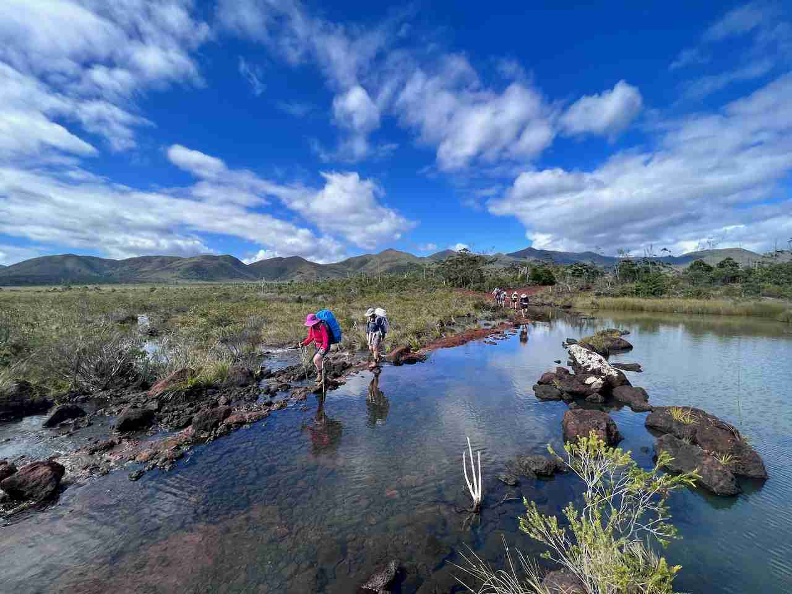Creek Crossing

### 

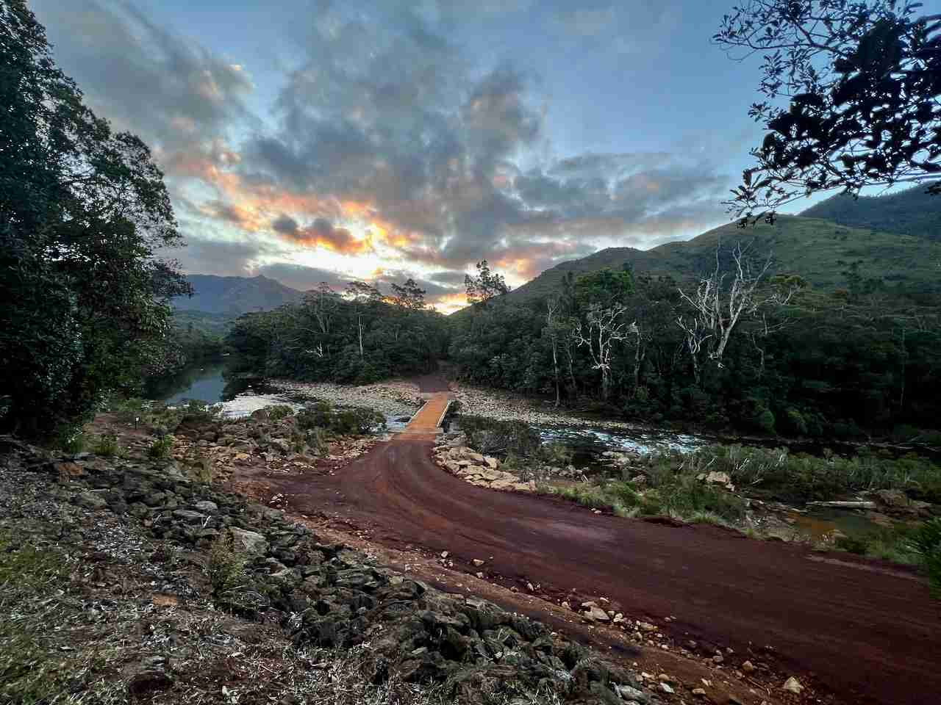Pont Saint Germain (Saint Germain Bridge)

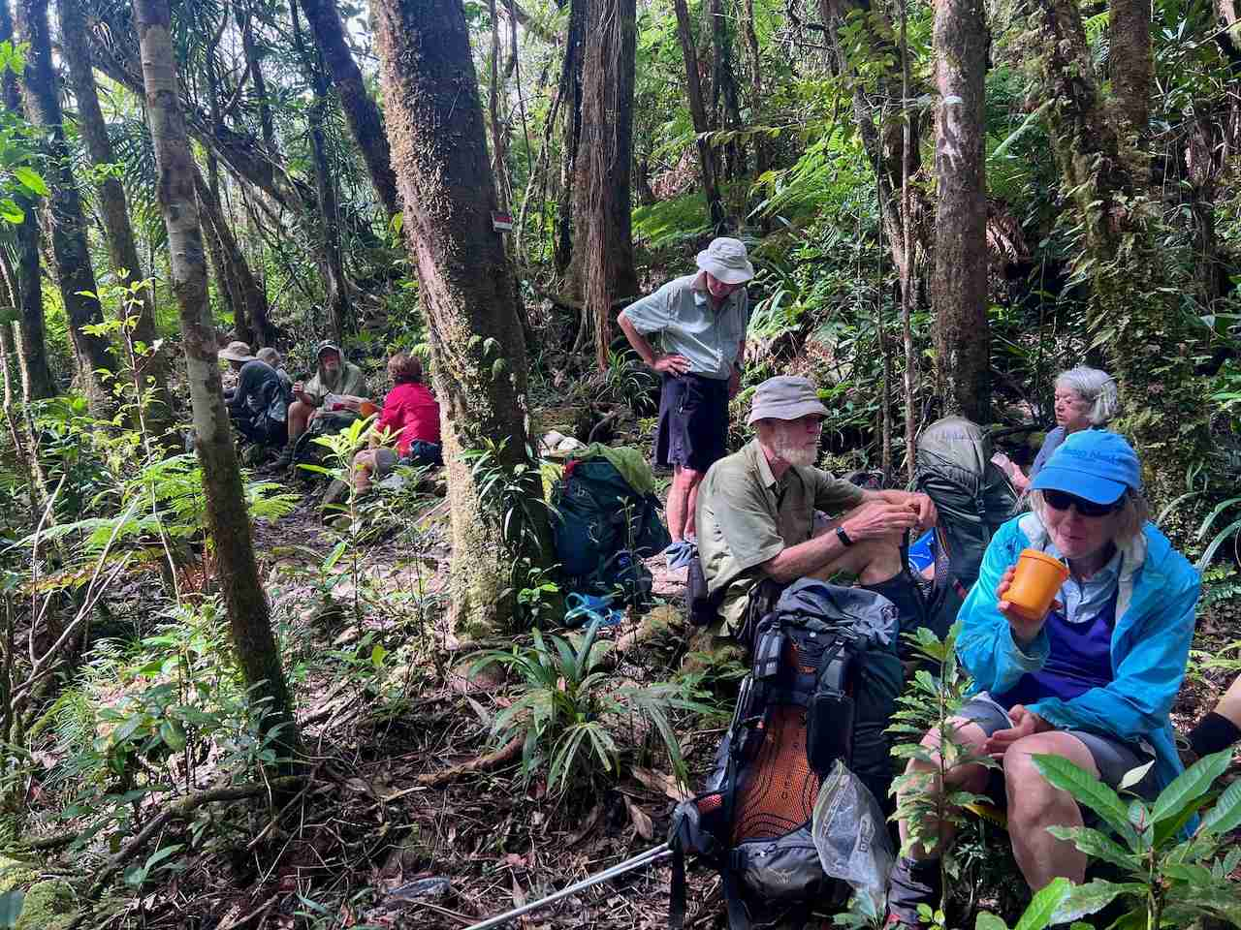Rest time

### On the fourth day, we will discover the Rivière Bleue Park and its varied landscapes.

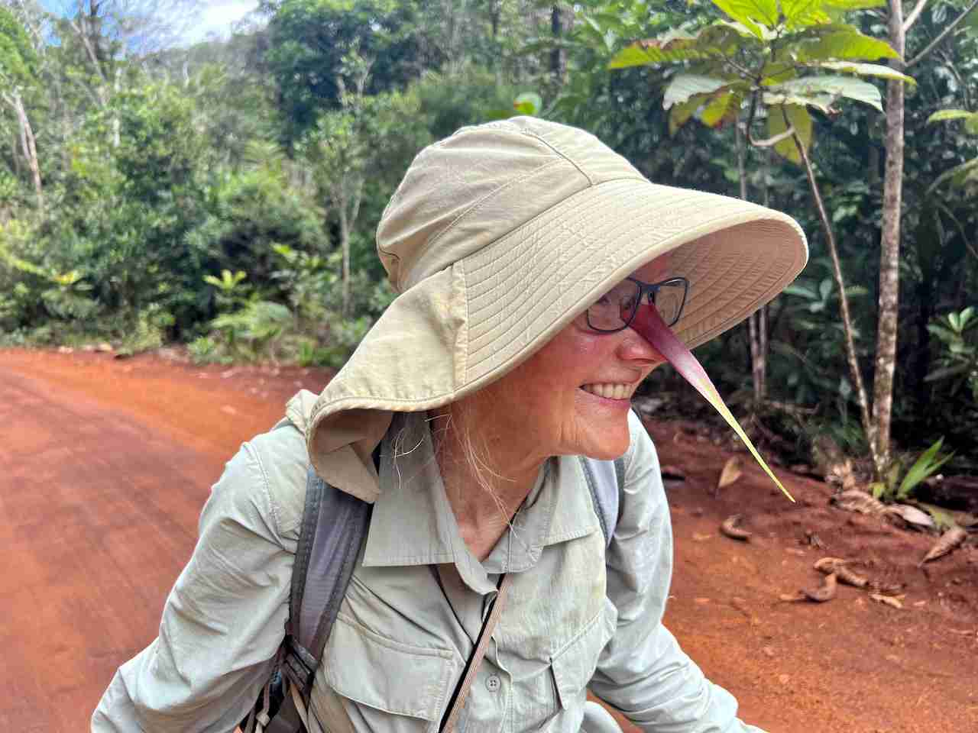Lynette bird!

### 

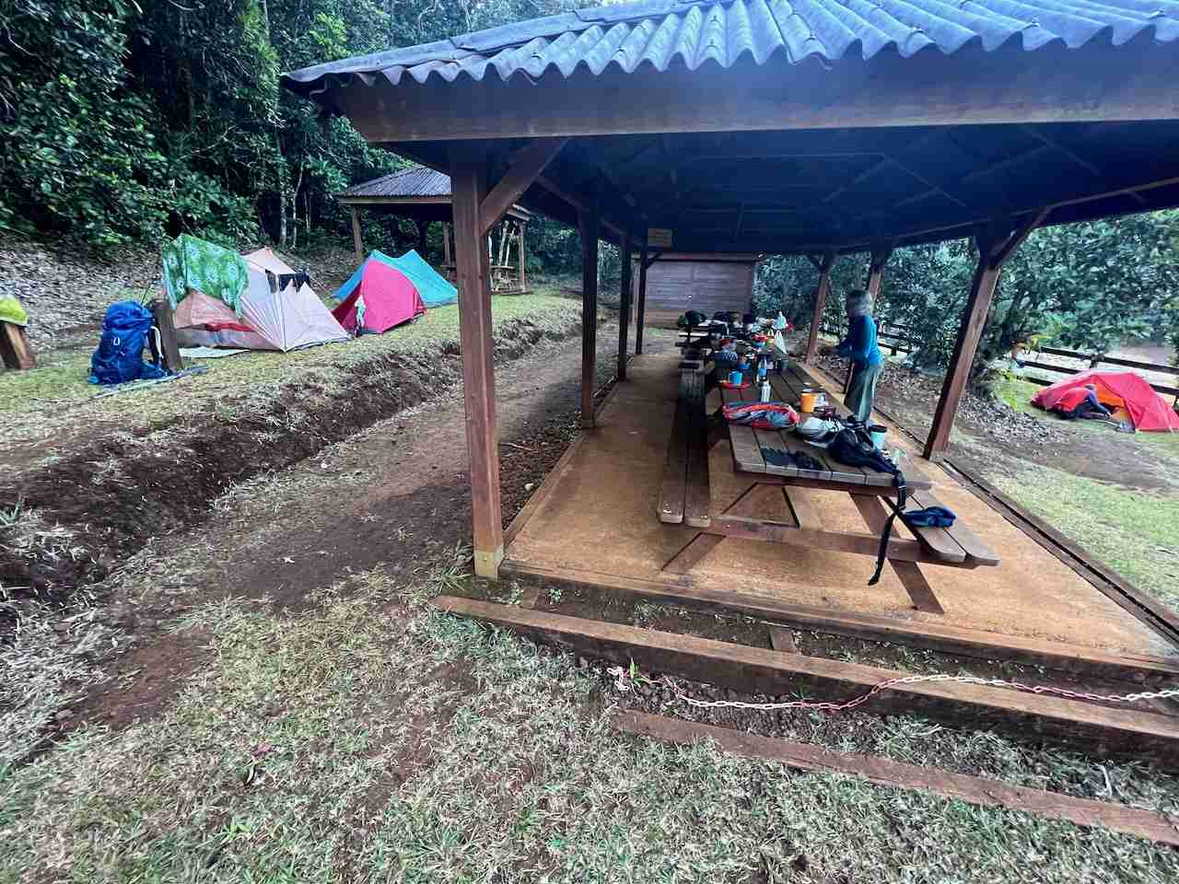Pont Saint Germain Rest Area

### 

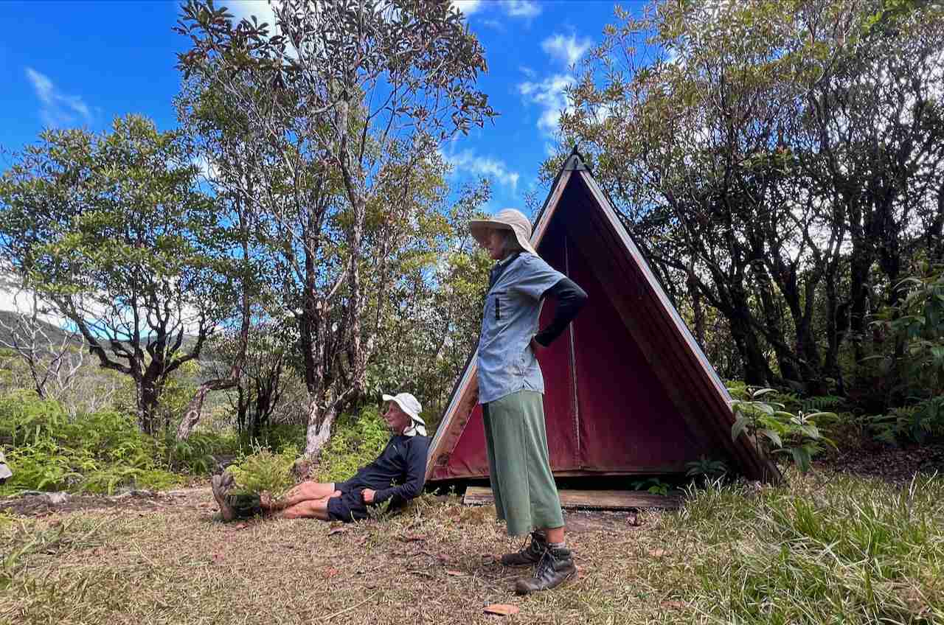Camp des Fougères (Ferns Camp Shelters)

### 

### Then, after a day of rest in Nouméa, we will walk the GR2 in the Northern Province.

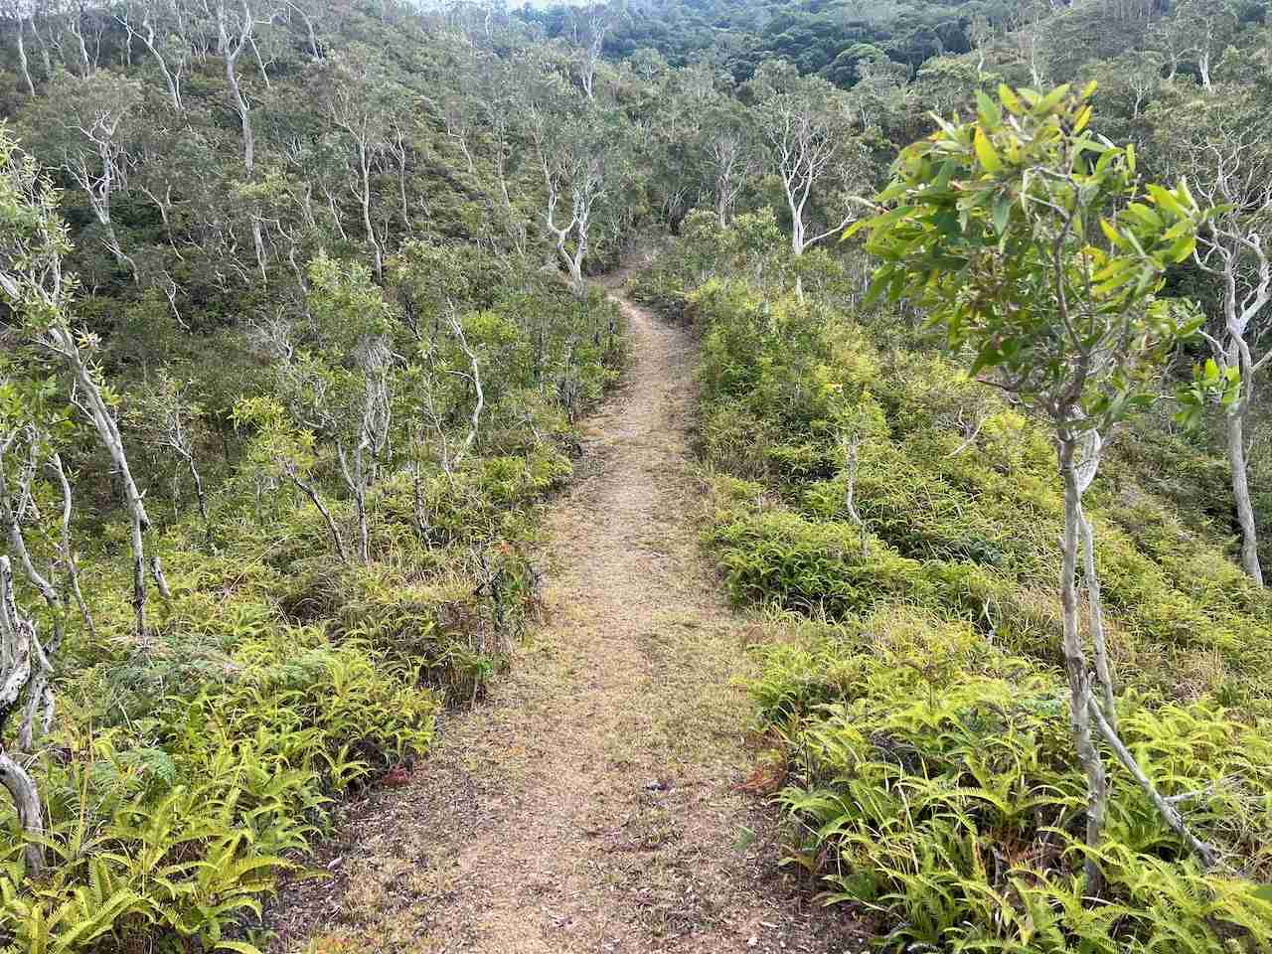GR2 (Grande Randonnée 2)

### In Kanak land.

### "La Coutume" is a Kanak tradition that allows you to show your respect and humility when arriving at your host's home.

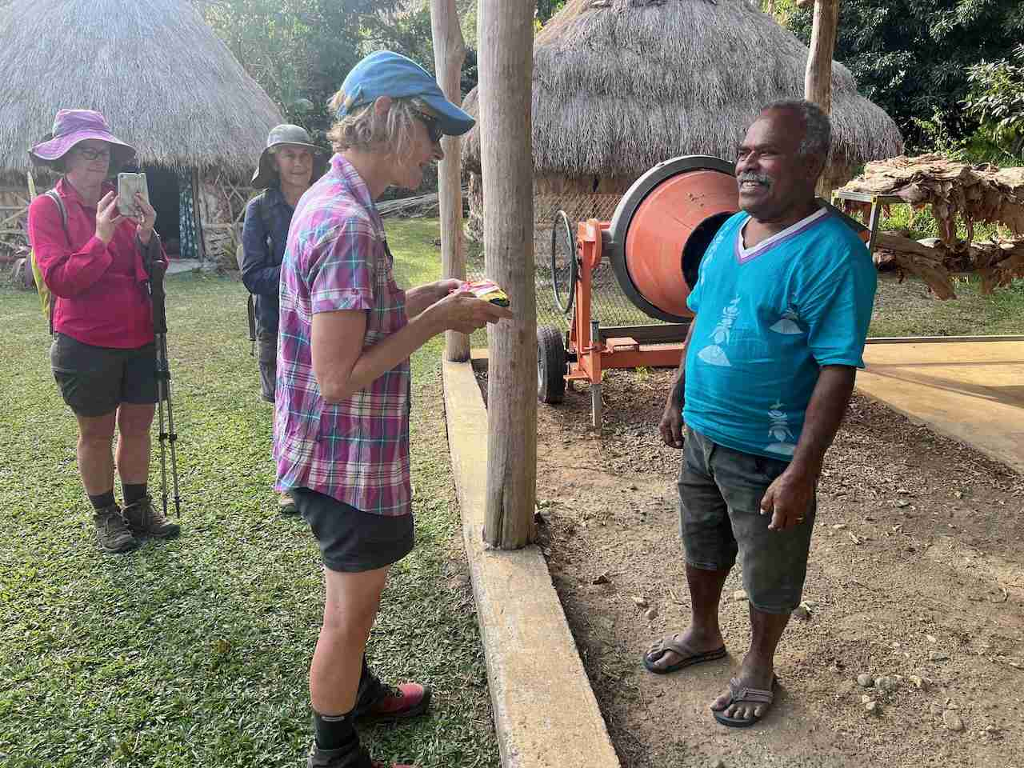Kate is doing La Coutume in Jacky's land at Ouanache.

### At the end of our walk, we have dinner with our hosts in the evening. “Bougna” is a traditional Kanak dish made with yam, tarot, sweet potatoes, banana, deer meat and more. It can be cooked in a pot or in a more ancestral way on hot stones.

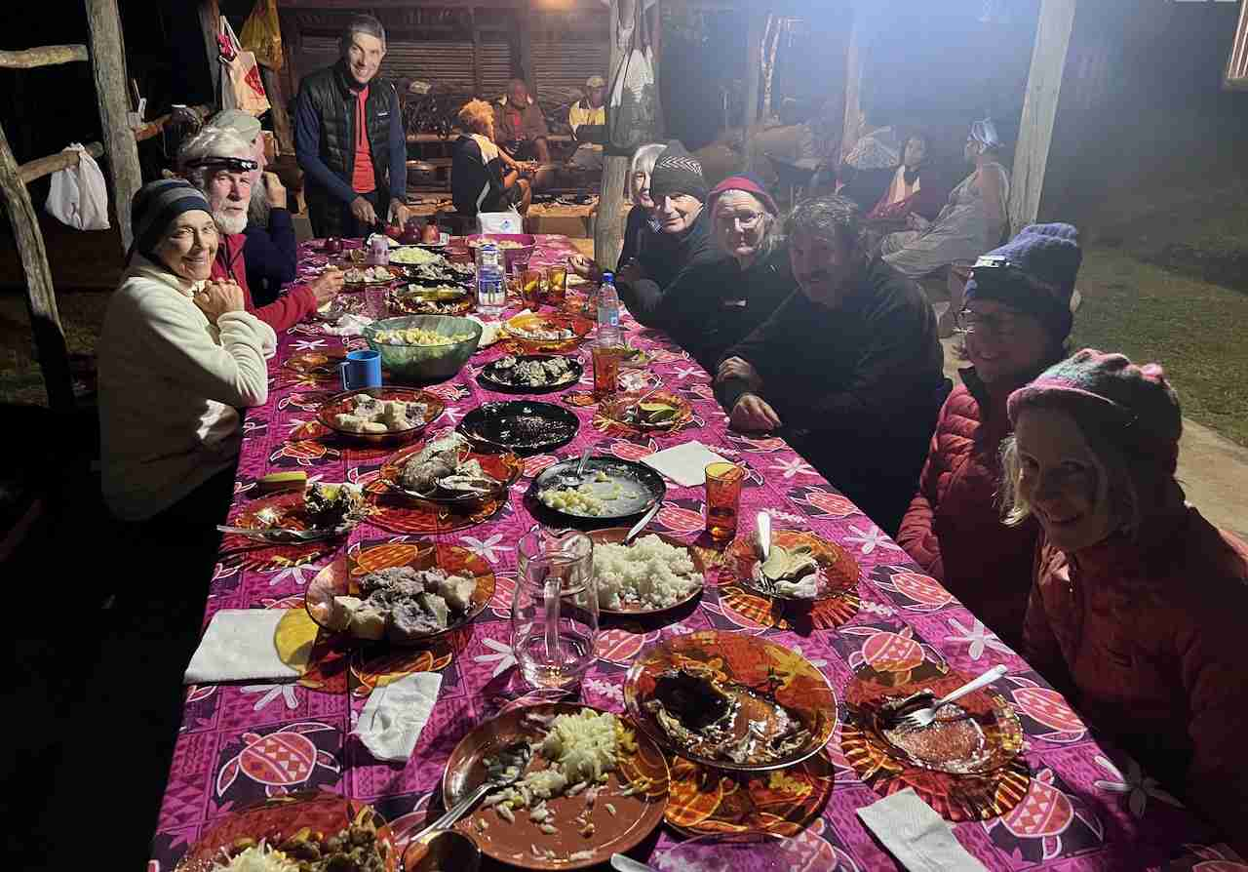"Bougna Marmite" at Napoepa in Michel's home.

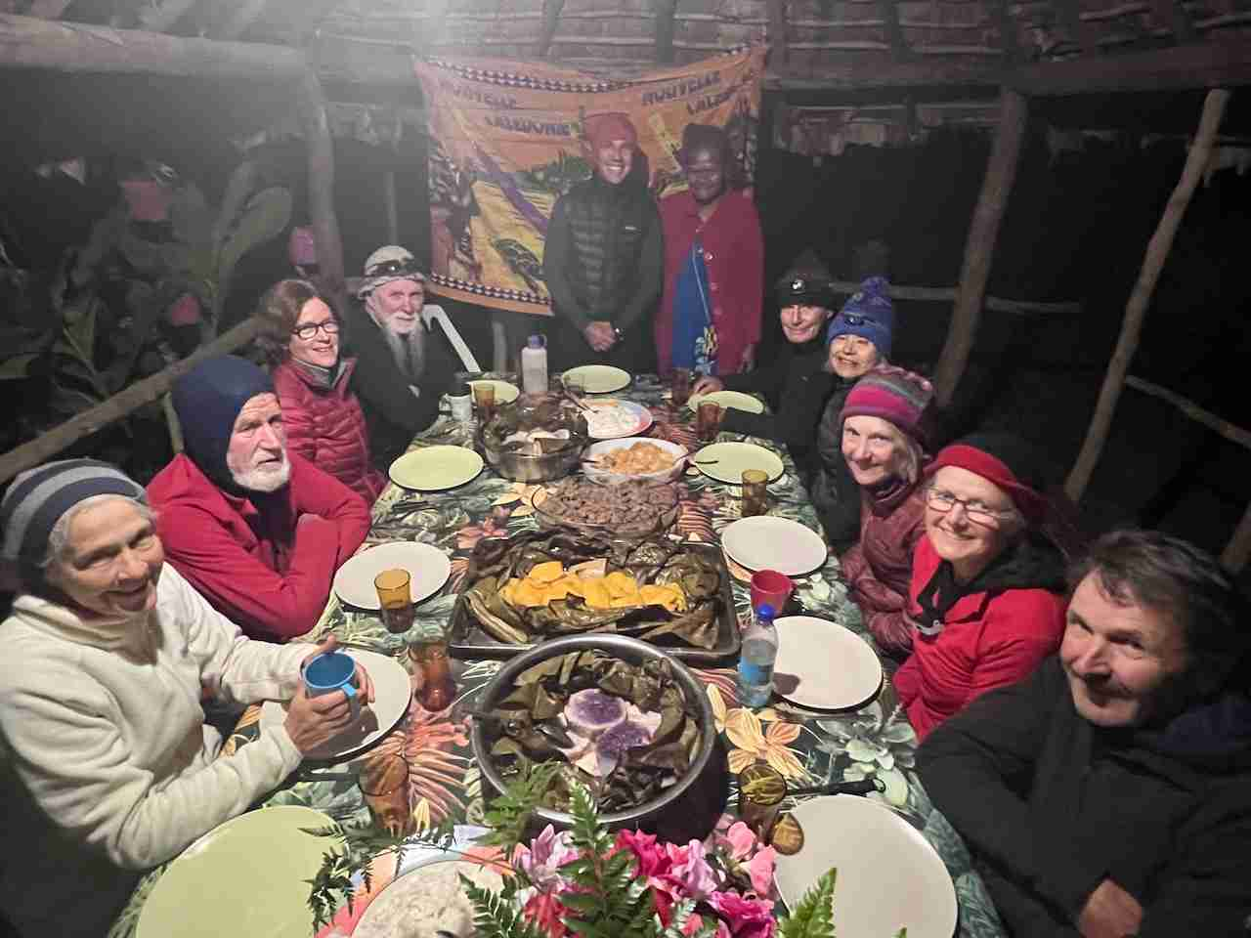"Bougna Traditionel" at Tchamba in Helen's home.  From left to right, Diana, Wayne, Anne, Bryce, John, Helen (Our host), Graeme, Merrily, Kate, Lynette and Jeff.

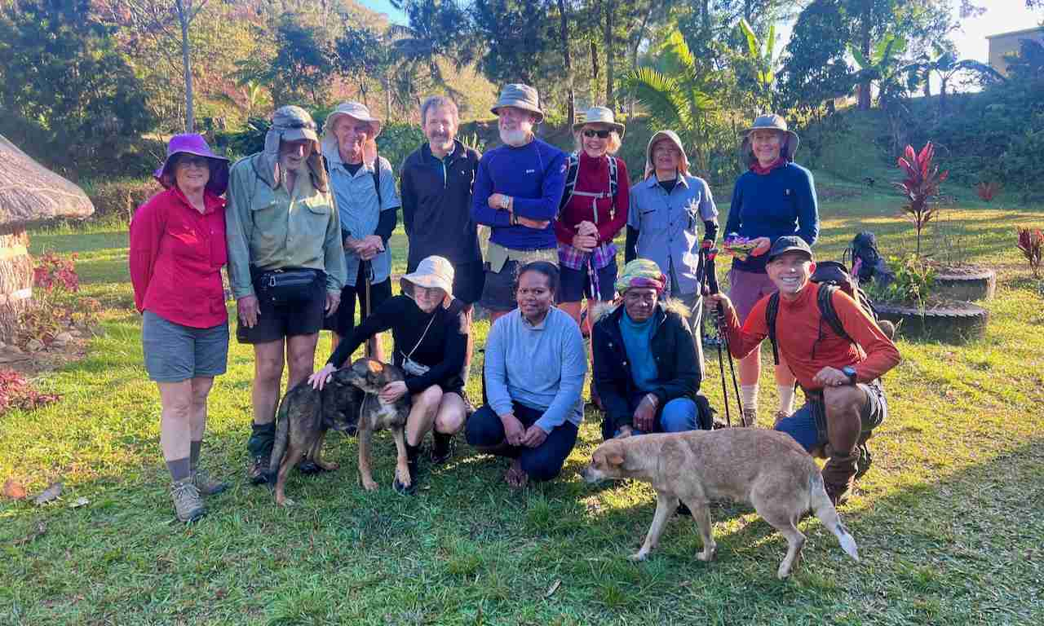With Iréne and Christina in Pombeï.

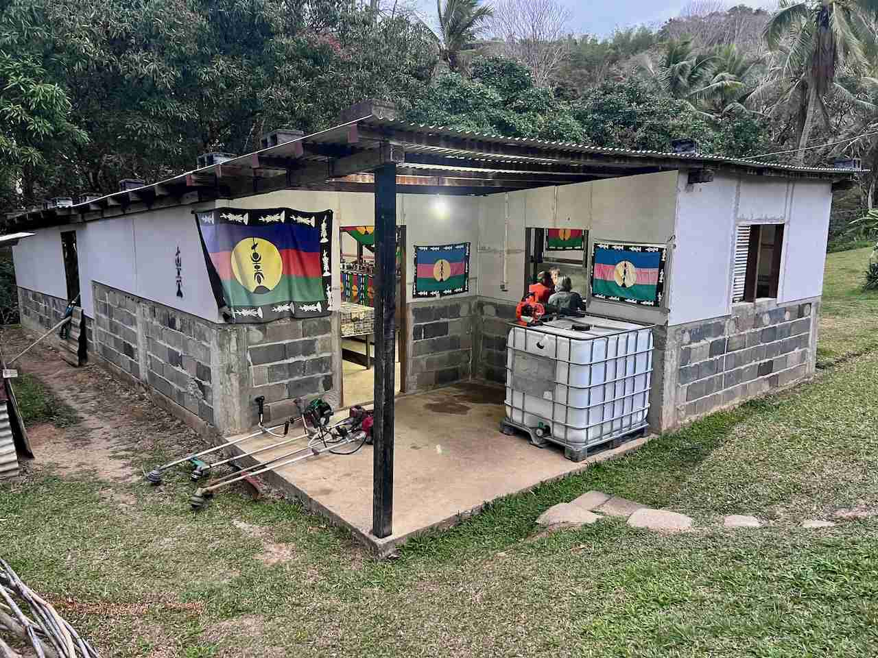Jean's home in Tiwae.

The Kanak flag covers Jean's home in Tiwae.

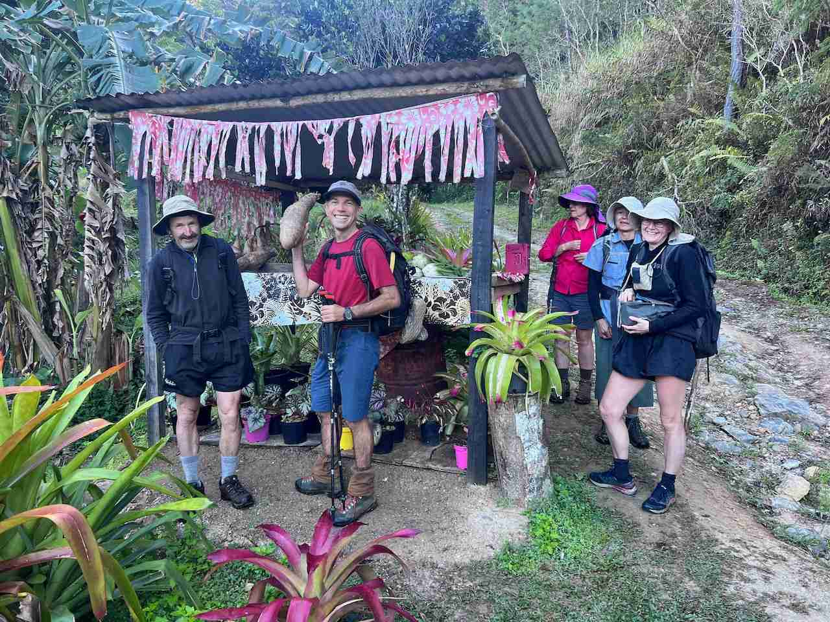Honesty Box near Pombeï.

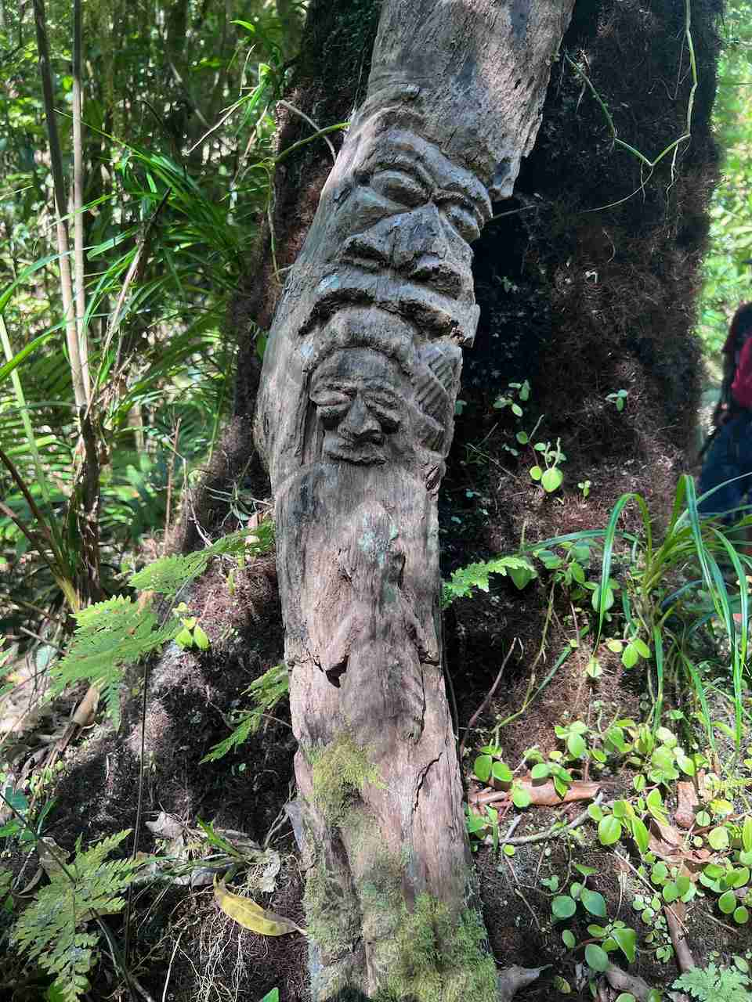Kanak Totem along the walking track.

### pot or in a more ancestral way on hot stones.

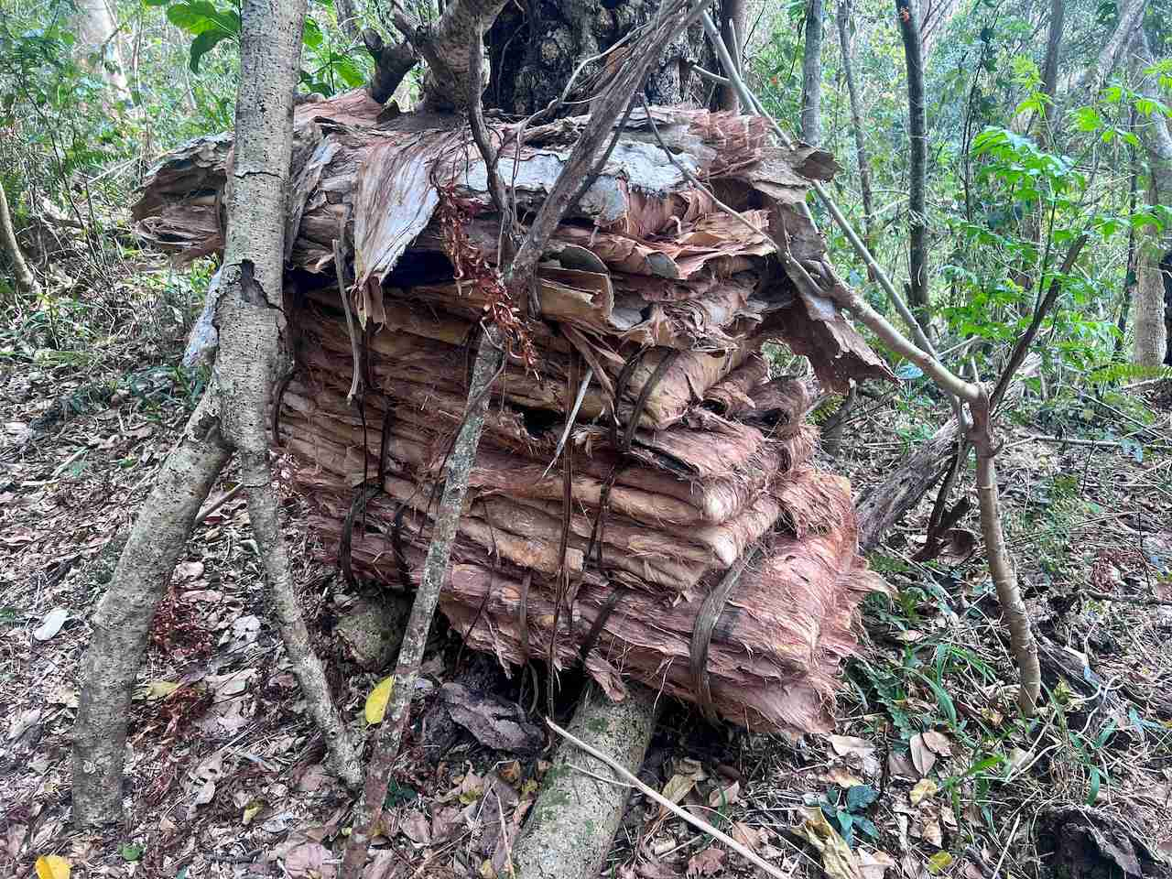"Naouli Bark" (Melaleuca bark) is collected for the construction of the farés (Traditional Kanak Home) or for other construction purposes.

### 

### The Kanak villages are beautiful and very well maintained.

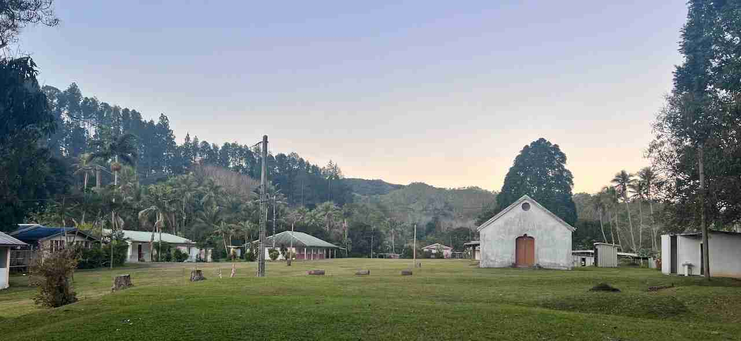Tchamba Village

### We keep going wading rivers as we did on GR1

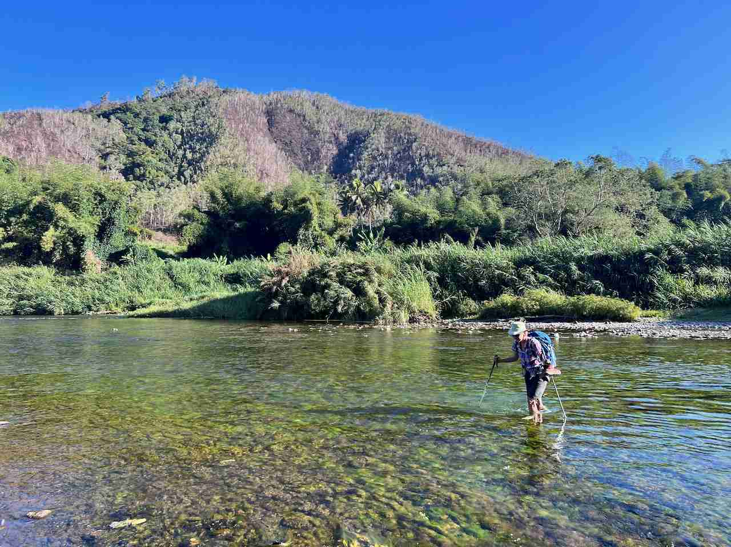Kate wading the Pombeï River.

### We keep going wading rivers as we did on GR1

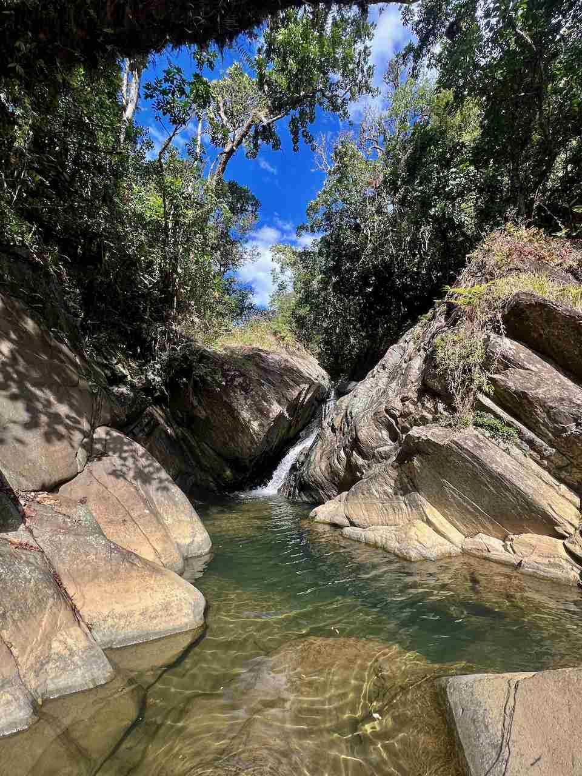

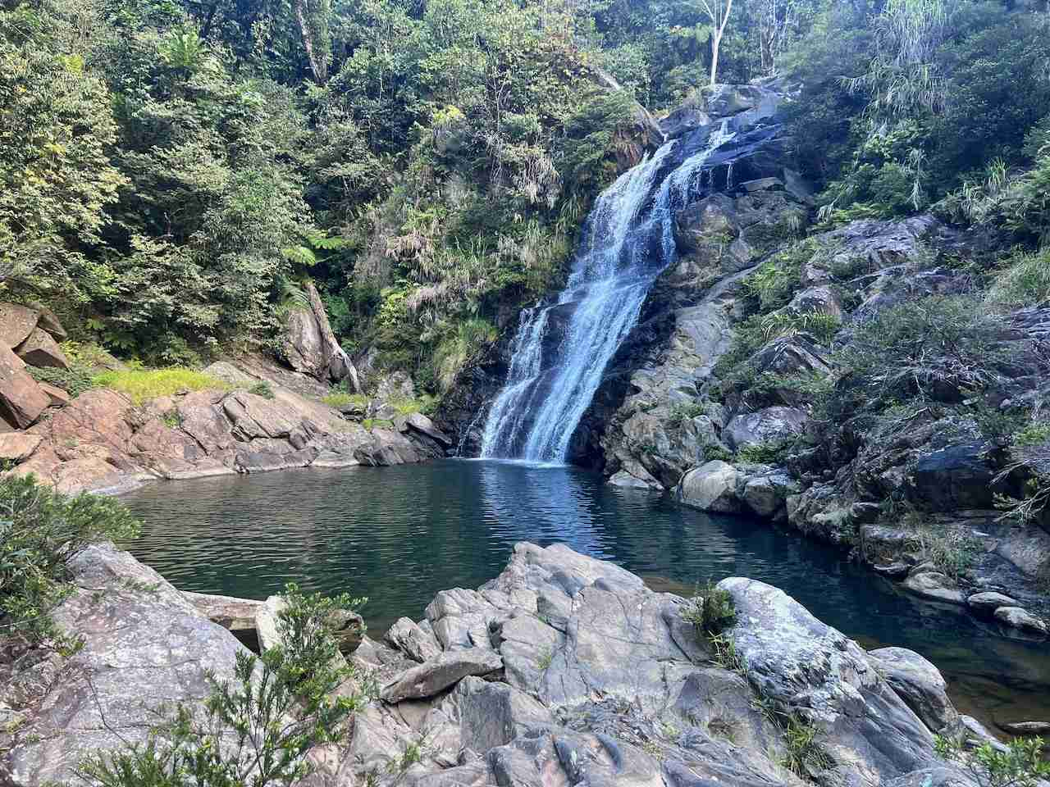Saint-Thomas Cascade

### We keep going wading rivers as we did on GR1

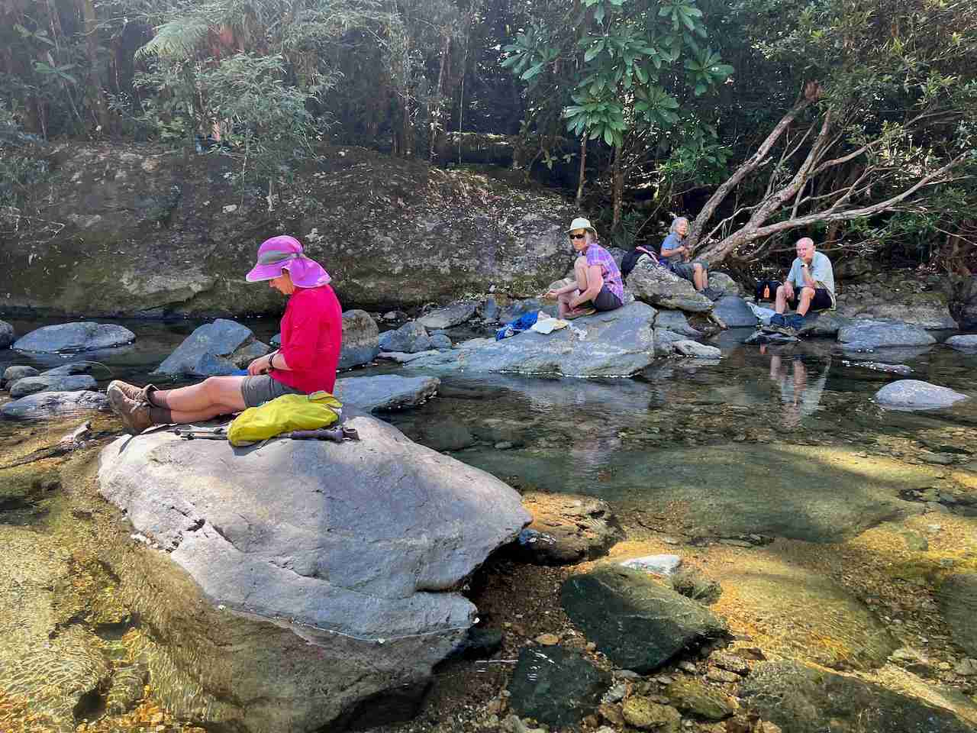Eating lunch on the Dihén Tipwoï river.

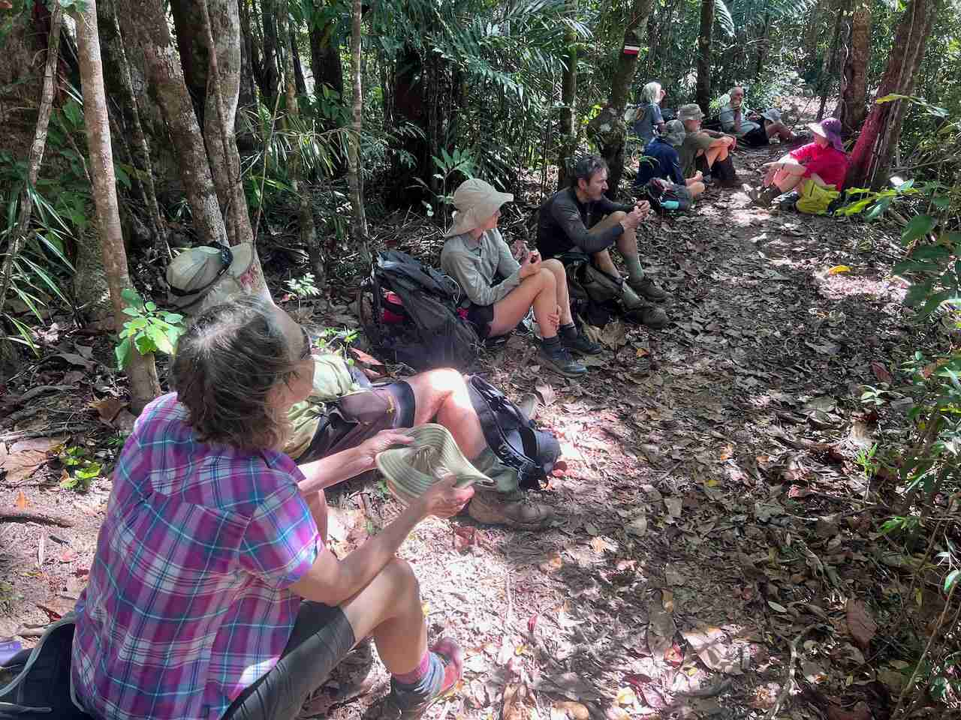Or along the track!