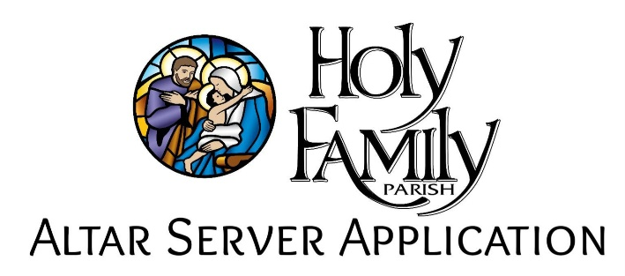

**School Year 2025-2026**

Name ________________________________________________________________________

Address ______________________________________________________________________

City __________________________ State __________________ Zip______________________

Parent Name __________________________________________________________________

Parent Email (will be shared on altar server contact list) ________________________________

Parent Phone (will be shared on altar server contact list) _______________________________

School Attending____________________________ Present Grade_______________________

Do you have any family members that are liturgical ministers? Yes___ No___

If yes, fill in the following information:

Name: __________________________ Ministry: _______________________________

______________________________ ____________________________________

______________________________ ____________________________________

What Mass or Masses does your family usually attend? (please circle)

4:00pm 8:00am 10:00am 12:00pm

Comments (Is there anything we should know about you, for example, any allergies?) _______________________________________________________________________________________________________________________________________________________________________________________________________________________________________

*Please answer the questions on the reverse side of this sheet before turning in the application!*

1. As server of the Lord’s table are you willing to try to be a “good example” when not serving?
2. Are you willing to take the responsibility to serve at ALL Masses that you are scheduled for, and if you cannot, get a substitute to take your place?
3. Are you willing to serve at the altar with dignity and prayerfulness?
4. What can Holy Family Parish do to help you in your Catholic journey?

____________________________________________________________________________________________________________________________________________________________________________________________________________________________________________________________

1. Give a short reason for wanting to be a server at Holy Family Church.

_________________________________________________________________________________________________________________________________________________________________________________________________________________________________________________________________________________________________________________________________________________________________________________________________________________________________________________________

*You will be notified by letter when you have been accepted for*

*“Server in Training” with more details to follow.*