|  |
| --- |
|  |
| First Reconciliation and First Communion Preparation Handbook  First Reconciliation: Monday, April 20, 2026 at 7:00 p.m.  First Communion: Saturday, May 2, 2026  10:00 a.m. or 1:00 p.m. |

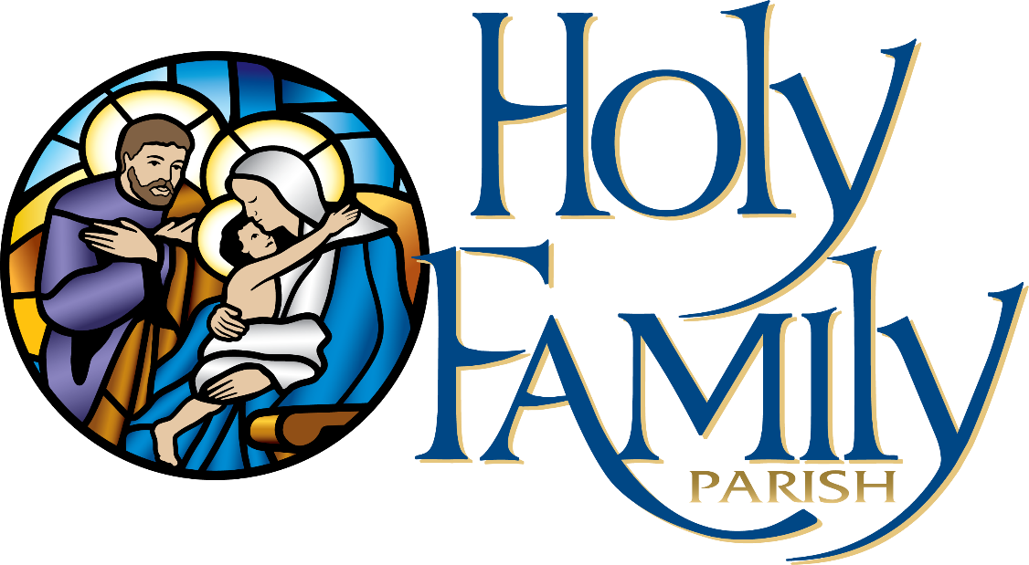

Table of Contents

**General Information for Parents3**

**About the Sacrament of Reconciliation3**

**Child’s Preparation for First Reconciliation**4

Classroom Preparation4

Preparation at Home4

Familiarity with the Rite of Reconciliation (& Prayer of Sorrow)5

**Celebration of First Reconciliation**6

**About the Eucharist**6

**Child’s Preparation for First Communion**7

Formal Preparation7

Preparation at Home8

First Communion Banners8

**First Communion Masses**11

First Communion Pictures (by LA Images)11

First Communion DVD 11

Dress Code12

The Symbolism of First Communion Attire13

Other Notes Regarding First Communion14

**Sacrament** **Gift Stores**14

**I. General Information for Parents**

Your child’s second grade year is an opportunity for parents to reaffirm their commitment to the Catholic faith and to become refreshed and renewed in their faith life. This renewed commitment involves developing a genuine desire to participate in the Eucharist and the sacramental life of the Church as well as a commitment to uphold the **Precepts of the Church**:

1. To attend Mass and rest from servile labor on Sundays and Holy Days of Obligation.
2. To receive the Sacrament of Reconciliation at least once a year, especially if aware of committing a mortal sin.
3. To receive Holy Communion at least once a year, between the First Sunday of Lent and Trinity Sunday.
4. To observe the fast days and abstinence days established by the Church.
5. To contribute to the material support of the Church.

**II. About the Sacrament of Reconciliation**

**From the Catechism of the Catholic Church #1486-1498**

To the eyes of faith, **there is no evil worse than sin**, which wounds God’s honor and love. The forgiveness of sins is conferred by the Sacrament of conversion, confession, penance, or reconciliation.

The **penitent (the one confessing) performs three actions**: repents of sins with contrition (feels sorrow for having done wrong and resolves not to commit those sins again), confesses sins to the priest, and intends to make reparation. **The priest performs three actions**: offers counsel, proposes a penance (actions or prayers to demonstrate the penitent’s repentance), and gives absolution (forgives the sins in the name of the Holy Trinity).

All **grave (mortal) sins** must be confessed. **Lesser (venial) sins** do not need to be confessed, but it is recommended to do so anyway.

Sacramental confession has the following effects:

* Restores the penitent to God
* Reconciles the penitent to the Church
* Remits the eternal punishment incurred by mortal sins
* At least partially remits the temporal punishment resulting from sin (also occurs through purgatory)
* Provides peace of mind and a clear conscience
* Increases spiritual strength for Christian living

Priests take very seriously the seal of the confessional. Canon law strictly prohibits any priest from discussing anything uttered during sacramental confession, and many priests throughout the world have chosen to be imprisoned or killed rather than violate this sacred seal.

____________________________________________________

**III. Child’s Preparation for Reconciliation**

1. **Classroom Preparation**

All Second Grade Students discuss Reconciliation in their classroom sessions, which typically involve mock confession. The parish priest(s) will visit the classrooms as well to discuss Reconciliation and to assure students that priests cannot discuss what anyone confesses.

1. **Preparation at Home**

Take some time to talk with your child about Reconciliation. It is very common for children to be nervous or scared before First Reconciliation, but they typically feel extremely peaceful and relieved afterward. Share your own experiences of Reconciliation: How did you feel the first time you went? How do you feel when you go now?

1. **Familiarity with the Rite of Penance**

Students should be familiar with the Rite of Penance in order to feel more comfortable during their first confession:

**Rite of Penance**

*Penitent*: Forgive me, Father, for I have sinned. This is my first Reconciliation. (In future confessions, say, “It has been [approximate length of time] since my last confession.)

*The penitent now lists the sins that s/he can remember, especially all mortal sins.*

*The priest will counsel you and perhaps give you advice for how to avoid these sins in the future. He will give you a penance, which will be either an action or some prayers. He will then ask you to make an Act of Contrition. Your child should have Prayer of Sorrow/Act of Contrition memorized. The priest will have a card should your child need it.*

*Penitent*: (Pray the Act of Contrition / Prayer of Sorrow) My God, I am sorry for my sins with all heart. In choosing to do wrong and failing to do good, I have sinned against you, whom I should love above all things. I firmly intend, with your help, to do penance, to sin no more and to avoid whatever leads me to sin. Amen.

*The priest then pronounces the Words of Absolution, and the penitent makes the Sign of the Cross.*

Thank the priest, and go do your penance.

**IV. Celebration of First Reconciliation**

**Date, Time, Location:** Monday, April 20, 2026 at 7 p.m. at Holy Family Church.

**Arrival:** Please arrive no later than 6:30 p.m. so that we can begin on time.

**Dress Code:** Dress for First Reconciliation is dress-casual (no jeans). Please dispose of gum before entering the church.

**Procedure:** Teachers and catechists will direct the children to one of the priests for their Reconciliation. Please share you “Letter of Love” (which you will receive at the parent meeting) at home as a family. Certificates will be available for each child.

**Video/Photos:** Please refrain from taking any videos or pictures during First Reconciliation.

_____________________________________________

**V. About the Eucharist**

**From the Catechism of the Catholic Church #1407-1419**

The Eucharist is the **source and summit of the Christian life**; it is Jesus himself. In this sacrament, we become what we receive: the Body of Christ. At Mass, Jesus acts through the ministry of the priest to offer the sacrifice of our salvation.

“**Transubstantiation**” is a theological term that describes the complete change of the substance (what something is in its deepest being) of bread into the substance of Jesus Christ. While the substance changes, the accidents (external features) remain the same—what looks like bread, tastes like bread, and crumbles like bread is actually Jesus. Because of this change in substance, it is proper to offer the Eucharist worship.

The effects of receiving the Eucharist are:

* An increased and deepened union with Jesus
* Forgiveness of venial (lesser) sins
* A strengthening to avoid future mortal (serious) sins
* A reinforced union with all other believers, who are the Church
* A preparation of the body for bodily resurrection

The Church encourages the faithful to receive the Eucharist every time they attend Mass. Strictly speaking, receiving the Eucharist is only “required” at least once a year. Anyone aware of having committed mortal sin must go to **sacramental confession before receiving Jesus** in the Eucharist.

Out of respect and reverence for Jesus in the Eucharist, there are several small ways to prepare for Mass. The Church proscribes a **one-hour fast** (this includes gum and coffee) before receiving the Eucharist as a way to remind ourselves that we are about to receive the Son of God. Another way to keep in mind the importance of the Eucharist is to wear respectful clothing to church.

____________________________________________________

**V. Child’s Preparation for First Communion**

**A. Formal Preparation**

All Second Grade students will discuss the meaning of the Eucharist in their classroom sessions. They will also practice how to receive the Eucharist as well as all the music for their First Communion Mass. There are two additional parts of the parish’s formal preparation for First Communion:

**First Communion Retreat**

Sunday, March 22nd, 2:00-4:00 p.m. at St. Paul, New Middletown. Participation is required. Parent/Guardian must also attend.

**First Communion Practices**

For the 10 a.m. Mass – Tuesday, April 28, 4:45–5:45 p.m. at Holy Family

Church.

For the 1 p.m. Mass – Wednesday, April 30, 4:45–5:45 p.m. at Holy

Family Church.

**B. Preparation at Home**

Take some time to talk with your child about the Eucharist. Ask what s/he is learning in the classroom. Ask what s/he thinks about it. Share your own memories of your First Communion. Take your family to Mass every Sunday and talk about it afterward. Did you like the music, the homily, or anything from the readings?

**C. First Communion Banners**

As part of our tradition of celebrating First Communion at Holy Family Parish, we ask that you and your child create a banner that will be displayed in the gathering area of the church. In your kit you will find the felt that will be used to make your First Communion banner. The hem is at the top so that a tension rod can be run through them to be hung in the windows of the gathering area. When designing your banner, please make sure the hem is at the top and avoid using materials that are very heavy.

The banner is intended to be a family project that your 2nd grader is actively involved in and that is meaningful to him/her. With your guidance, he/she should design the banner using information & art pertaining to the Eucharist. You can also include a picture of your child and his/her name. Please make sure your child’s full name is on the back of the banner so that we can return it. You can find many examples using a Google image search for “First Communion banner.”

**Banner felt will be distributed in April 2025.**

Some appropriate Eucharistic symbols that may give you ideas for designing your banners are below:

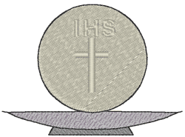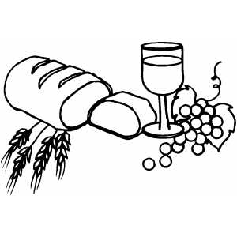

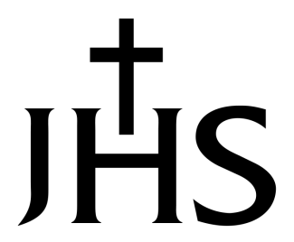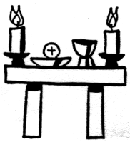

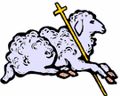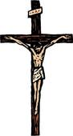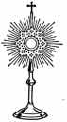

Some appropriate quotes from Scripture that you may choose to put on your banner include the following:

Take and Eat Do this in memory of me

Take and Drink This is my Body

I am the Resurrection. This is my Blood

I am the Bread of Life I am the Way, the Truth, and the Life

These are only a random sampling of ideas. You may think of something that is even more creative. A simple Google search can give you ideas as well.

**________________________________________________**

**VI. First Communion Masses**

**First Communion Mass Request Form**

First Communion Masses are filled on a first-come-first-served basis. To ensure that you are assigned to the Mass that you want, please hand in your First Communion Registration as soon as possible. Anyone who has not handed in a form *by September 28th* will be assigned to a Mass at our discretion.

**Arrival:**

* **If you are not having pictures taken** by LA Images, please have your child to the church at 9:30 a.m. for the 10:00 a.m. Mass, or 12:30 p.m. for the 1:00 p.m. Mass.
* **If you are having pictures taken** by LA Images, please have your child to the Parish Center at 8:30 a.m. for the 10:00 a.m. Mass, or 11:30 a.m. for the 1:00 p.m. Mass. Bring your child to the church after their pictures have been taken.

**Professional Pictures – LA Images**

*LAimages.net* – LA Images will be contacting you directly with picture information. The photographer will take a formal group picture after each Mass and asks that you wait until s/he has finished before you take your own group picture.

**Personal Pictures**

Please do not take any flash pictures during the Mass, and please do not come forward to take a picture when your child is receiving Communion for the first time as this is very distracting to the priests and the children. As noted above, please wait until the photographer has taken a formal group picture after Mass before taking your own group picture.

**Videographer – Jim Stickel Productions**

More information about First Communion DVDs will be sent out in April. No orders will be placed without accompanying payment. DVDs and Engraved flash drives will be available for purchase.

**Dress Code**

Girls

* White or ivory dress
* Sleeveless dresses are ok; spaghetti straps, tank-top styles, or strapless tops will need to be covered with a sweater during Mass
* Socks or stockings should be worn with appropriate dress shoes
* No purses or gloves during Mass
* Veils or wreaths are acceptable; no hats, please
* Veils and/or ribbons from the headpiece should be manageable for your daughter, fingertip or shorter
* WARNING: Sprayed in sparkles can flake into a girl’s eyes and cause distress and tears
* Students will not be permitted to carry anything (prayer books, rosary beads, etc.) into church

Boys

* Dress shirt and tie, or dress shirt and vest, or sweater and dress pants
* Suits or sport coats are optional, though most boys wear them
* Most boys wear black or navy suits. Any color shirt and tie is acceptable.
* Socks must be worn with appropriate dress shoes
* Students will not be permitted to carry anything (prayer books, rosary beads, etc.) into church

**The Symbolism of First Communion Attire**

The traditional color of First Communion attire—gowns and suits—is white. For girls, First Communion is one of three major events that calls for a white gown. All three are sacraments, holy events, in the Catholic Church: her baptismal day, her First Communion day, and—if she is called to marriage—her wedding day. So why do they all involve a white gown?

The baptismal gown that is given to boys and girls symbolizes purity, joy, and new life. The white color symbolizes that the newly baptized has put on Christ, and it also recalls John’s vision in the Book of Revelation*: “they have washed their robes and made them white in the blood of the Lamb”* (Revelation 7:13). The white also symbolizes one of the effects of Baptism, the washing away of all sins, including original sin. As God says through the Prophet Isaiah, *“Though your sins be like scarlet, they may become white as snow; though they be crimson red, they may become white as wool.”* (Isaiah 1:18). So the color of the gown reminds us of God’s incredible mercy and of the purity of soul that results from Baptism.

First Communion gowns and suits/shirts/ties are white on purpose; they are meant to recall all the symbolism of the baptismal gown. First Communion is the second of three Sacraments of Initiation, and so the links with Baptism are very important (white wedding gowns also are intended to recall the symbolism of both Baptism and First Communion). It is often pointed out that white First Communion attire also reminds us of the whiteness of the Eucharistic host that the children will receive.

In Catholic Liturgy, white is a color of celebration and triumph worn during the Christmas and Easter Seasons as well as during other special feast days. So the white attire finally symbolizes the excitement and celebration that should rightfully accompany a child’s First Communion.

With all these elements in mind, you can see how deeply symbolic First Communion attire is. You are not just dressing up your child for a major life event; you are wrapping them up in deep symbolism to present them to their Creator for union with Him and for further initiation into His Church. The gown and the suit are holy and symbolic objects and should modestly reflect their lofty purpose.

**Other Notes Regarding First Communion**

* Please practice the “Jesus in the Eucharist” prayer with your child; the class will recite this prayer together during Mass:

**Jesus in the Eucharist**

Jesus in the Eucharist, we believe in you.

You promised us yourself. What you say is true.

Son of God, we long for you,

Come to us and stay!

Be the Bread that makes us grow

More like you each day.

* If you have received mailings and your child’s name is not spelled correctly, please let us know so that we can correct it.
* Please be certain you have paid the **First Communion fee ($30)**, which pays for the Retreat, and handed in your child’s **Baptismal Certificate** if s/he was not baptized at Holy Family.
* Teachers and Catechists will choose children to read and bring up the gifts during First Communion Masses; please allow them to handle this.
* Please make sure your child has had a good night’s sleep the evening before First Communion and a healthy breakfast that morning.
* **No gum** chewing or candy in the church—children and adults.
* Remember to take home your child’s **First Communion Certificate**, which will be in the gathering space following Mass.

**VII. Sacrament Gift Stores**

JMJ Spiritual Connection

3434 Canfield Rd  
Youngstown, OH 44511  
330-270-5657

St. Pauls Books and Gifts

9351 W. Akron-Canton Road

Canfield, Ohio 44406

330-533-1076