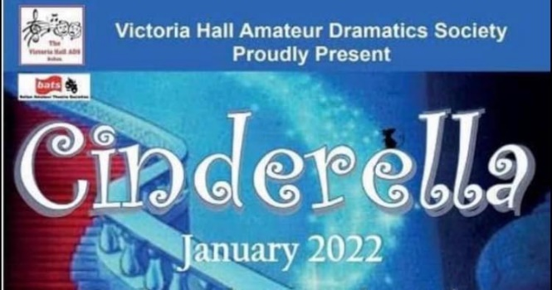
When can we go again??

Hi Everyone,

On Friday 14th January a party of approx. 30 people from our Circuit went to the Victoria Hall, to see a Pantomime ‘Cinderella’, about 20 Children went with their parents / carers and what a time they had.

I think they all had a brilliant time getting in the mood of ‘Panto life’ joining in with the shouting out when Buttons asked them to do so.
Buttons was the main person and was excellent of getting us
all involved.
Well done to all the cast and backstage and front of house crew.

A great time was had by all, friendships were also made and rekindled.

I heard most of the children saying to their Mum and Dads,
“When are we coming again?”

