Please provide a minimum of two weeks’ notice for any request. Bookings are subject to availability and will be confirmed in writing by council staff.

Start Date and Time: | End Date and Time:
Do you need chairs and tables? How many?

Purpose of Hire:

Name or Organisation:

Postal Address:

Person collecting key:

Contact Details (phone number and email):

Venue | Hire Fee | Terms
Half day* Mon-Fri either 8am-12pm or 12pm-4pm | $407.00 | Weekdays only
Full day hire* | $788.00 | Full day
Bond – function without alcohol | $696.00 | Per hire
Bond – function with alcohol | $1597.00 | Per hire
Cleaning fee | $114.00 | Per hour
Key Bond | $100.00 | Per hire
Alarm Callout Fee | $140.00 | Per call out
Acoustic Operation Fee – please contact Barkly Arts for costs - 08 8962 2799.

Declaration:
- On behalf of myself/my organisation I agree to the Terms and Conditions of Venue Hire.
- I hereby agree that any damages or loss of keys will be my/my organisation’s responsibility.
- I have attached a copy of my/our current certificate of insurance for our Public Liability.
- I acknowledge that my booking is not finalised until it is confirmed in writing by council staff and payments have been received.

Name: | Signature: | Date:

Please return this completed form to events@barkly.nt.gov.au – including any required additional documents.

Keys
- Keys must be collected and returned during business hours Monday-Friday 8:15am-4:15pm.
- A key deposit is required before keys will be issued.
- Keys must be returned by 10:00am the day after the event, or next working day.
- If keys are not returned, the deposit will not be refunded.
- Keys must not be given to a third party.

TERMS AND CONDITIONS OF VENUE HIRE
- Half day hire is for Monday-Friday only – either 8:00am-12:00pm or 12:00pm-4:00pm. Keys must be returned within half an hour of the stated end time on booking form.
- Time for cleaning must be included in the hours of the half day hire – if the keys are not returned in time a full day will be charged.
- Organisations must ensure they have provided a current certificate of insurance for Public Liability prior to hiring council facilities.
- Council office hours are between 8:15am-4:15pm Monday-Friday.
- Smoking is NOT permitted within any council buildings.
- Any council furniture, fittings, or equipment must be returned to its original position at the end of hire, or bond may not be refunded.
- We require 48 hours’ notice of cancellation of your booking in writing. If you cancel within that timeframe, you may be subject to a cancellation fee.
- The sale of alcohol is strictly prohibited without prior consent by Council and the NT Liquor Commission. Functions that serve alcohol at the Civic Hall will need to pay the deposit and cleaning fee for that purpose and provide a copy of their current liquor license.
- All outside equipment brought to the venue MUST be removed before departing, unless other arrangements have been approved by the council in writing.
- If at the end of the hire period the venue requires additional cleaning, an additional fee will be charged to the hirer.
- If any damages to council structures/equipment are incurred during the hire period, repair costs will be charged to the hirer.
- Internal rubbish bins must be emptied into the outside bins, located on the library side of the Civic Hall.
- If you wish to collect the keys the day before your event you will be charged for a half day hire. This does not include any weekend events.
- Bonds are refundable after a post event inspection by council staff.

* The following discounts apply to venue hire only:
- Full price to be paid for Businesses/Government bookings.
- 50% discount for residential ratepayers (individual/personal use only), not-for-profits, associations for internal organisation use.
- 90% discount for registered not-for-profits and associations for Community events.
- 100% discount on approved applications to Council (Council means Ordinary Council Meetings, applications require at least 2 months’ notice).
- Bonds are not included in the discount structure and are required for all venue bookings.
- All bookings presented to Council must include:
  - The completed booking form.
  - A copy of your Certificate of Currency for Public Liability Insurance.
  - A request to waive fees form.
  - A letter of request from an authorised representative.

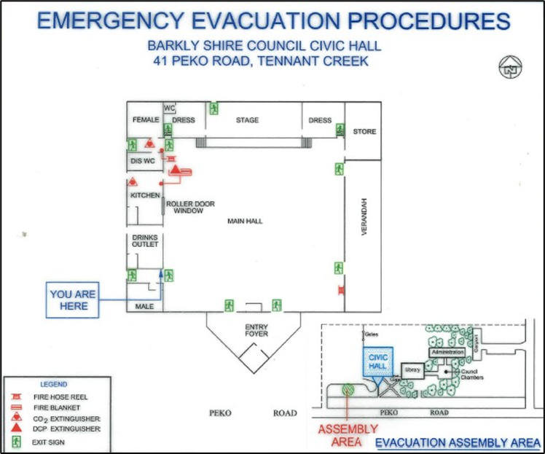

Council would like to advise you of the following:
Organisers of the event must become familiar with the evacuation plans. Council will provide details to you upon collection of the key. At the beginning of an event or upon entry, all attendees must be informed of:
- The locations of the exits. All fire exits must be unlocked and clear of any objects to ensure access.
- The locations of the fire and first aid equipment.
- The assembly points. Located in the car park, away from the entrance.
- Who the emergency contact is.

In an emergency - don’t panic. Follow these standard procedures:
REMOVE - yourself and others from immediate danger.
ALARM - Raise the alarm/alert others. Call Emergency Services on 000.
CONTAIN - In the event of fire – contain the fire/smoke. Use a fire extinguisher (only if safe & trained to do so). Close the doors to contain fire/smoke.
EVACUATE - On being instructed to evacuate or fire alarm sounding. Take others with you and proceed to your evacuation assembly area. Remain there until emergency is over.

Emergency Phone Numbers:
- Fire Brigade/Police/Ambulance 000
- Police Station 08 8962 0944
- Fire Station 08 8962 0903
- Ambulance 08 8963 2800
- Hospital 08 8962 4399
- Ronin Security 08 8962 1341
- Power and Water Emergency 24hr 1800 245 090
- Poisons Information Centre 13 11 26
- Water and Sewerage 13 20 90
- Barkly Regional Council 08 8962 0000

First Aid Kit: Located in kitchen near servery. Please advise Council on return of keys, of any items which have been used from the First Aid Kit.

Security Alarm Process:
- Upon entry you MUST disarm in approximately 2 minutes.
- Upon exit, you MUST arm security alarm and leave before 2 minutes; otherwise, the alarm will be activated.
- A Security officer will arrive if the alarm is activated.

